KICCS Portal User guide

  - User Guide to request a citizen (CIT) account and provider or STARS QEI online features

The KICCS Provider Launch Site at http://chfs.ky.gov/dcbs/dcc/kiccsportal/ will be the location given to CIT users who want to request an account. The “Log in” link(s) will navigate to the Kentucky Online Gateway.
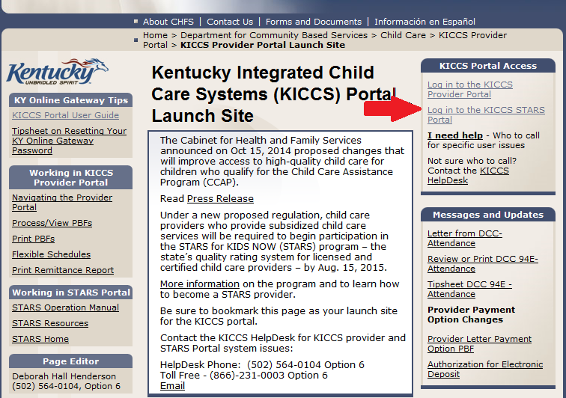

To create an account:
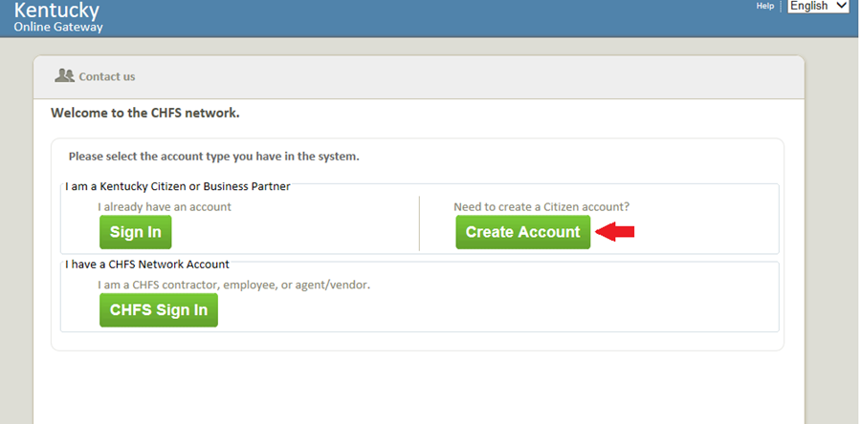
Click on the green “Create Account” button.

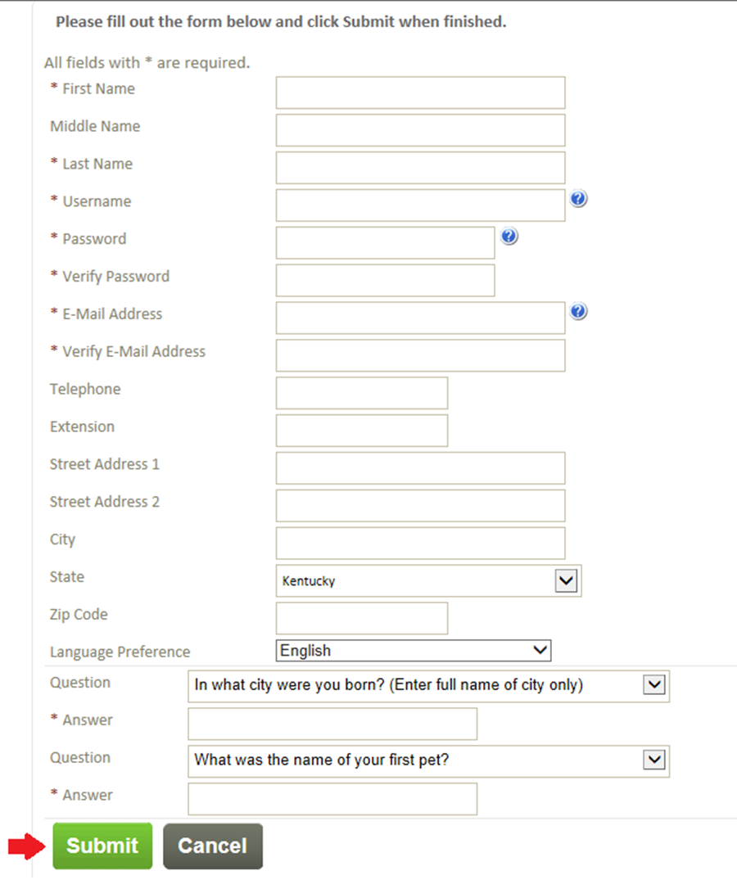
Complete the form. Items marked with an * must be answered. Click the green “Submit” button when the form is completed. Be sure to note user name and password.

A message will be displayed that informs that the request is pending email verification.
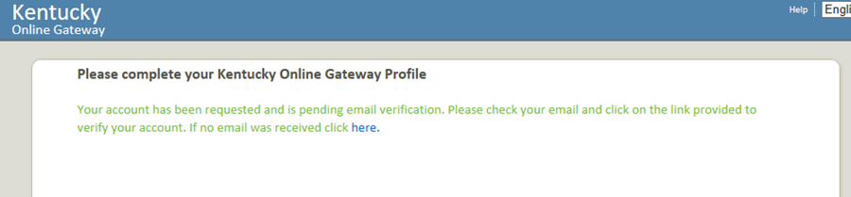

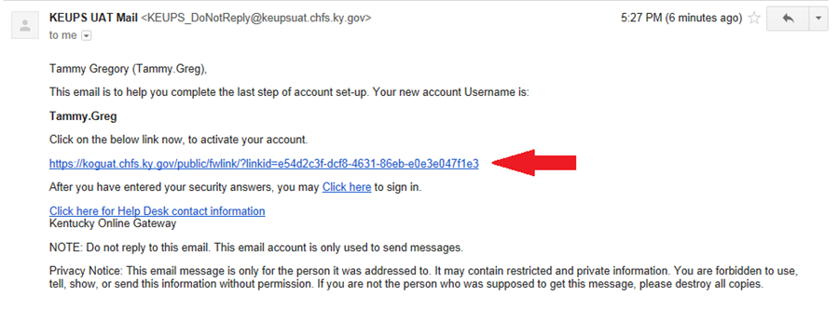
Locate email from Kentucky online Gateway and click on the link provided to verify the account.

Answer the security questions and click the green “Verify Account” button.
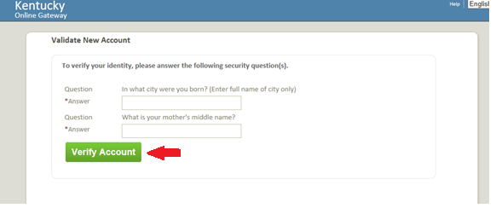

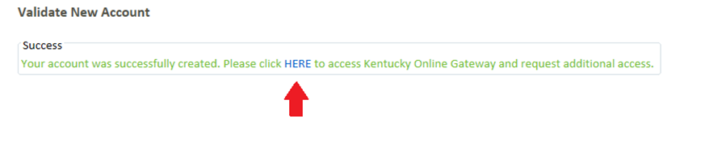
Click “HERE” to request further access.
Log in using your user name and password.

Enter your username and password and click Log In
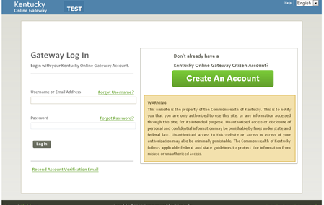

Click on “Request access here.”
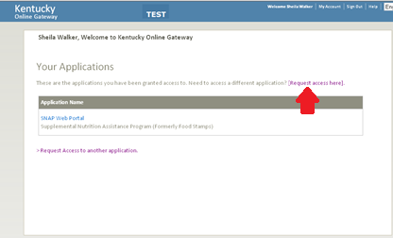

From the list, click the green “Select” button beside the KICCS Provider Portal.
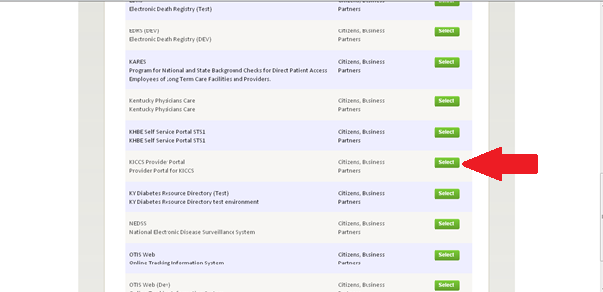

Child-care providers should choose as many roles as need from “provider roles” (Print_PBF, Print_Remittance, Process_Prov_ren_Chng_CMP_POC, Save_PBF, Send_PBF, View_PBF). QEI/STARS staff should choose one or both from the “STARS/QEI roles” (STARS_Application, Technical_Notes_Assistance). Users that choose from the “provider roles” will not be able to choose from the “STARS/QEI roles.” Likewise, users that choose one or both of the “STARS/QEI roles” will not be able to choose from the “provider roles.”
After choosing the appropriate role(s), click on the green “Next” button.
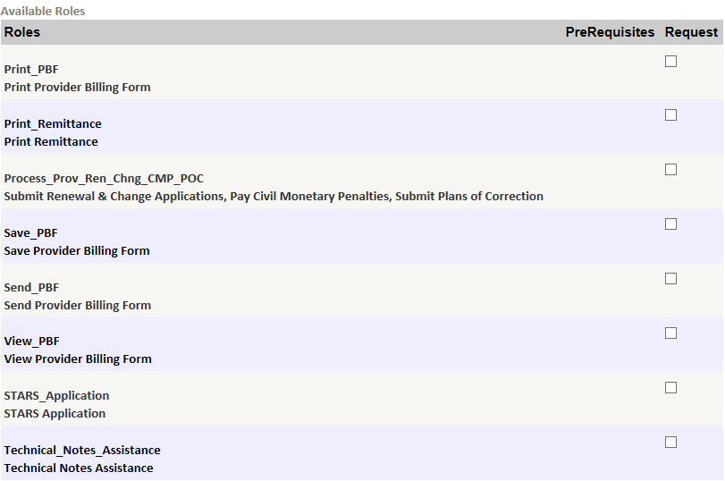

Complete the required credential information and click the green “Next” button.
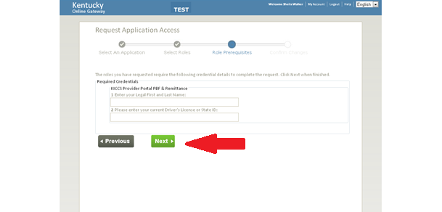
Review request and click the green “Submit Request” button. You will need to fax or mail proper documentation as indicated below. 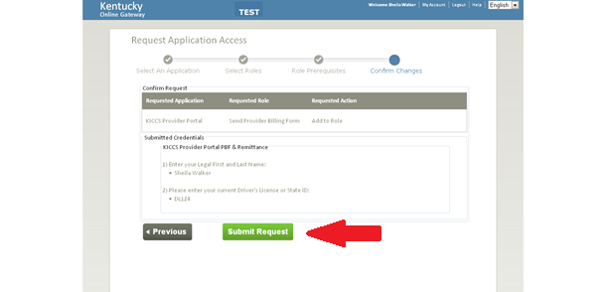

An email will be sent when access to the KICCS Provider Portal has been approved.
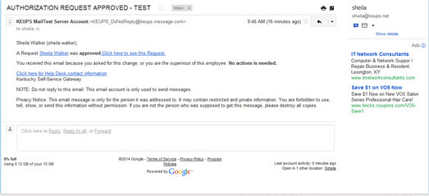

For future access to the KICCS Provider Portal, bookmark the Provider Launch Site at http://chfs.ky.gov/dcbs/dcc/kiccsportal/. Sign in with user name and password. Choose KICCS Provider Portal from the list of “Your Applications.”
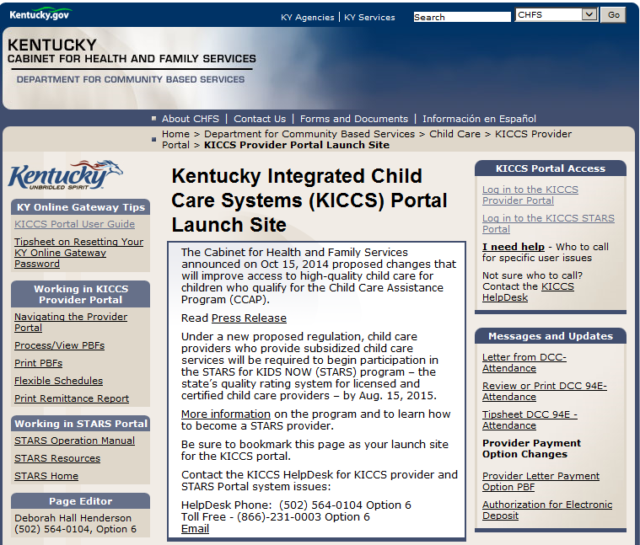
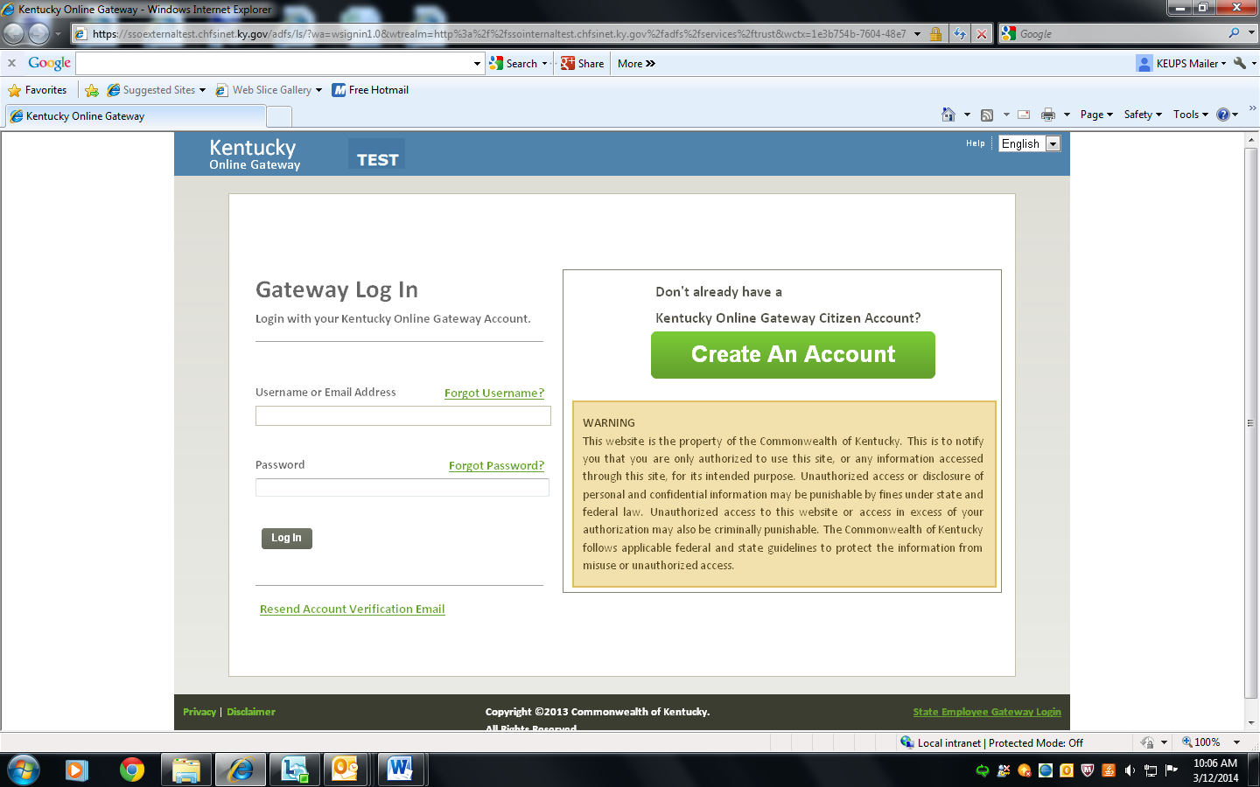

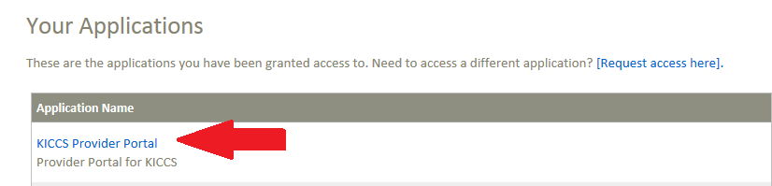

Documentation Required for Child Care Providers or Representatives:
- Signed User Agreement
- Copy of driver’s license or photo state identification

Documents may be sent to the Division of Child Care by:
- Email (Preferred Method)
Send scanned documents by e-mail to:
portal.access@ky.gov.
In the e-mail subject line, type New Account Request and your CLR number.

- Fax
Fax documents to:
Fax # 502-564-3464
ATTN: CCAP Portal Administrator
(Helpful Tip: Enlarge and lighten when making a copy of your driver’s license or photo ID to make it more legible)

- Mail
Mail documents to:
Division of Child Care,
ATTN: CCAP Portal Administrator
274 E. Main St, 3C-F
Frankfort, KY 40621

Important:
If you do not send the signed form and a copy of your driver’s license, your request will be denied.

If you need help with any step of the process, the KICCS HelpDesk is available by:

- Phone
  - Toll Free at (866)-231-0003 Option 6
  - Local Call at (502) 564-0104 Option 6

- Email
  - CHFS.KICCSHelpDesk@ky.gov
Documentation Required for STARS QEI Staff:
- Signed User Agreement
- Copy of University of Kentucky photo ID

Documents may be sent to the Division of Child Care by:
- Email (Preferred Method)
Send scanned documents by e-mail to:
portal.access@ky.gov.
In the e-mail subject line, type New Account Request and ATTN STARS ADMIN.

- Fax
Fax documents to:
Fax # 502-564-3464
ATTN: STARS Administrator
(Helpful Tip: Enlarge and lighten when making a copy of your U of KY ID to make it more legible)

- Mail
Mail documents to:
Division of Child Care,
ATTN: STARS Administrator
274 E. Main St, 3C-F
Frankfort, KY 40621

Important: Once your request is approved, you will receive an email from a STARS Administrator. Start at page 7 to access your STARS QEI Portal Account.
If you need help with any step of the process, the KICCS HelpDesk is available by:

- Phone
  - Toll Free at (866)-231-0003 Option 6
  - Local Call at (502) 564-0104 Option 6

- Email
  - CHFS.KICCSHelpDesk@ky.gov

