Inquiry & Reports Menu
Revised 7/01/2021

PROJECT BUDGET REPORT WORKSHEET
FY21 YEAR-END MUNIS REPORT
Due in the Division of FRYSC by August 15, 2021

The MUNIS report should be one page. Please follow the directions on page two under “Instructions for producing FRYSC Report.”

Centers serving more than one school must report expenditures per center, not individual schools served.

NOTE THE FOLLOWING BEFORE COMPLETING:

A separate report must be generated for each center in your school district.

CENTER NAME

Center name must be on the report exactly as it is listed on the approved plan or Funding Request/Invoice Notification of Change form. DO NOT put name(s) of the school(s) served on the report.

REVENUES

The report should not contain Revenues. Only center expenditures should be reflected on this report.
NOTE: The report will be returned if it contains revenues and you will be asked to resubmit.

EXPENDITURES

All expenditures should be reported under Function Code 3300, Community Services. Do not separate expenditures into different categories, i.e., Bus Garage, Health Services, etc. Expenditures are to be reported under the appropriate activity in accordance with the budget (as amended) on file with the contract.

Expenditures attributed to any other revenue sources, i.e., childcare block grant, parent fees, private donations, etc. should not be included on this report.

ENCUMBRANCES
Encumbrances should be reported on the year-end MUNIS report under the encumbrances’ column. Encumbrances not reported can result in more carry-forward funds than anticipated, resulting in reduced receipts for FY21.

JOURNAL REPORT
Do not send a journal report. This report contains more information than we need. All journal reports will be returned and you will be asked to run the report again.
INSTRUCTIONS FOR PRODUCING FRYSC REPORT

Follow the path below to access the Project Budget Report:
Financials >General Ledger Menu >Inquiries and Reports >State Specific Reports >Kentucky >Project Budget Report

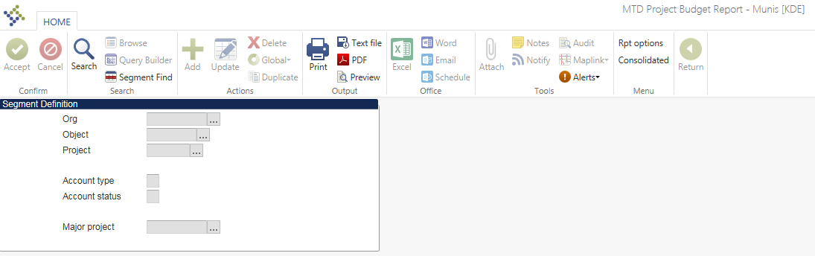

Select Segment Find and the following screen will appear:
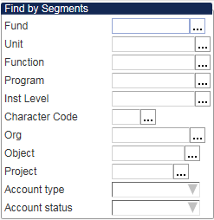

Fund: 2
Unit #: (Enter the location numbers associated with the Family Resource Center or Youth Services Center for which you are generating the report.)
Project Number: (see below)
125X for Family Resource and Youth Services Center
128X for Youth Services Center
129X for Family Resource Center

Note: X corresponds to the year of the grant. Example, 125G = FY21.

Account Type: Expense
Click Accept to complete Segment Find.
Select Rpt Options and the following screen will appear:
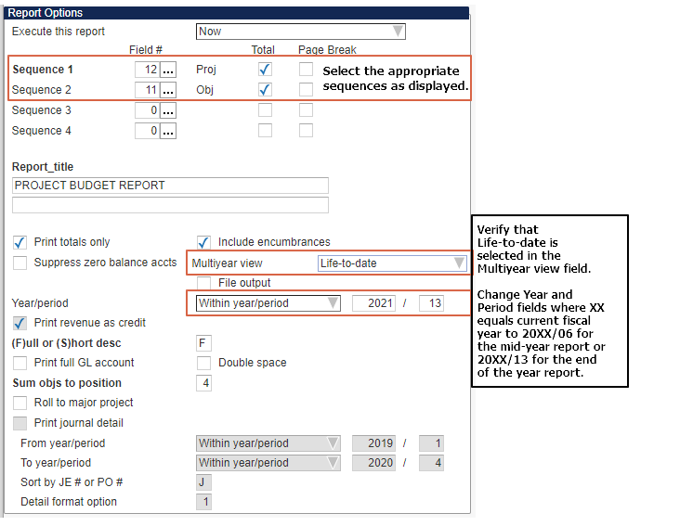
Sequence 1: 12 Proj
Sequence 2: 11 Obj

Report Title: Insert Name of Center this report covers
Print totals only?: Yes
Include Encumbrances: Yes
Multiyear view: Life-to-date
Change Year/Period field to equal:
- 20XX/06 (for mid-year report)
- 20XX/13 (for year-end report) **

Select Accept.

Each MUNIS report must include the center name. Your District should submit one Email with all the MUNIS reports attached for each center in your District to the following e-mail address: CHFS.FryscMunisRpt@ky.gov.
Please put the District name in the “Subject” line of the email. Example: “MUNIS Adair County”

Please do not print and scan as the paper forms do not need to be signed. Scanned copies are much larger than the PDF files generated by the Munis system.

Note, the reporting options will remain the same for Alternative Funding Districts. The only difference is the budget input by the Districts, either the normal allocation budget, or the Alternative Funding District budget. Questions regarding the Alternative Funding District Program should be directed to your Regional Program Manager.

