Kentucky Family Resource and Youth Services Centers -
GEER II Funding

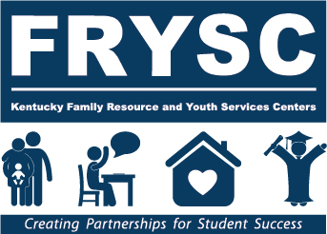

Request for Proposals

2021 - 2023

The Governor’s Emergency Education Relief (GEER) fund, established in the CARES Act, provides states with emergency assistance as a result of the Novel Coronavirus Disease 2019 (COVID-19).

In partnership with the Governor’s office, the Cabinet for Health and Family Service’s Division of Family Resource and Youth Services Centers (DFRYSC) is seeking applications from local Family Resource or Youth Services Centers (FRYSCs) to provide and coordinate specific services and assistance related to the student and family needs associated with this emergency.

FRYSCs may apply for funds to support their ability to continue providing educational
services to students and their families and to support the “on-going functionality” of centers in response to the COVID-19 emergency in the following areas:

- Early childhood education- FRYSCs will provide an integrated approach to home visits, education, and monitoring of child development for new and expectant parents.
  - Example activities: Provide educational home visits; Facilitate parenting knowledge and parent networking by providing caregiver, or caregiver-child groups.

- Childcare: Full time preschool child care for children two (2) and three (3) years of age. FRYSCs will identify, coordinate, and/or develop resources and support for child care.
  - Example activities: Provide access to developmental, vision, and hearing screenings; Connect families with childcare and early childhood learning opportunities during critical early years of development.
- Family Crisis and Mental Health Counseling: FRYSCs will increase self-management and coping strategies by assisting students and families with mental health needs and/or other crises through the identification and coordination of services for various challenges (e.g., grief, illness, bullying, incarceration, dating/domestic violence, loss of income, trauma, isolation, anxiety)
- Example activities: Coordinate Youth Mental Health First Aid training for staff; connect students with necessary mental health services by contracting with mental health providers, develop Sources of Strength peer lead suicide and violence prevention program.
Grants of $100,000 will be awarded to approximately 150 applicants across the state. Applicants will submit a two year plan for grant activities to be completed by September 30, 2023.

Who is eligible to apply?
- Single centers
- A consortium of centers within the same school district. If multiple centers apply, a single point of contact must be identified.

Each $100,000 award will be considered a separate application.

Submission instructions
Find and download the request for proposal at the Division of FRYSC webpage. The instructions and applications can be found under the Additional Information heading. Follow the instructions to complete each section of the application. Upload the completed proposal (one document) by June 1, 2021 using the following link https://forms.gle/E2cLfrwcYWL6u7Be8.
The Division of FRYSC will host an informational webinar prior to the submission deadline. Technical assistance from Division staff will be provided upon request by emailing CHFS.DFRYSC@KY.GOV.

Proposal Instructions

I. Application Cover Page

II. Overview
The overview should briefly summarize the major elements of the proposal, specify the population(s) served, and identify the needs that will be addressed related to pandemic relief and recovery efforts. This should be a broad, general overview so that the reviewer can conceptualize the overall implementation of the project.
Suggested length: 1-2 pages

III. Statement of Need
Provide a description of the schools, communities, and neighborhoods to be served by the project and how these populations are impacted by COVID-19. Using available data sources, include information pertaining to the identified needs. Local data will help to define the project areas of focus, highlight resources and strengths, and serve as baseline data for evaluation.
Suggested length: 1-2 pages

IV. Collaboration and Engagement Plan
Process for Community Engagement: Provide a narrative that describes the process to be used for developing collaborative relationships with community agencies and organizations that will provide services, programs and/or activities for the project. Preference is given to proposals that include working with non-profit organizations or community agencies.
Process for Participant Engagement: Briefly describe a plan with strategies for generating optimal participant involvement in the project. The plan should address how parents and students will be engaged in the delivery of specific services and assistance related to the student and family needs associated with this emergency.
Suggested length: 1-2 pages

V. Proposed Project Activities and Timelines

Proposal packet includes table for this section. Applicants can add additional rows as needed.
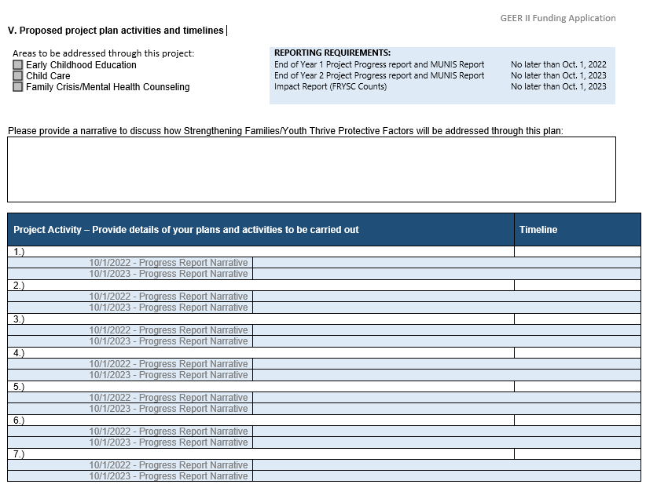

VI. Evaluation Plan
Each center or consortium will be required to collect baseline and outcome data relating to the planned project.
The Impact Report section of FRYSC Counts will be used for documentation of grant related outcomes. Reports should be submitted at the end of the grant period (no later than Oct. 1, 2023).
Please describe how data collection and evaluation of project effectiveness will be incorporated into the plan. Consider how existing data sources or other evaluation tools such as pre- and post-surveys may be utilized.
Suggested length: 1-2 pages

VII. Program Budget and Narrative
Proposal packet includes table for this section. Applicants can add additional rows as needed.

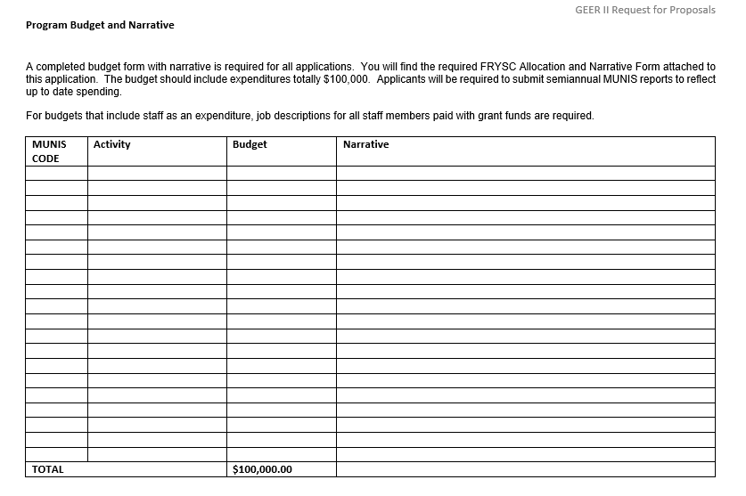FRYSC Allocation and Narrative Form
A completed budget form with narrative is required for all applications. The budget should include expenditures totaling $100,000. Applicants will be required to submit semiannual MUNIS reports to reflect up to date spending.
For budgets that include staff as an expenditure, job descriptions for all staff members paid with grant funds are required.

VIII. Attachments
- Other Supporting Documentation: Following this page, the applicant may insert other documentation that is felt to be beneficial to the application.
- Any Relevant Job Descriptions

21-23 Application Scoring Criteria
Scoring Procedures – applications eligible for review will be rated on specific proposal items, with one to five points awarded on the following basis:
- Poor – the item is insufficiently addressed in the application.

- Fair – the item is minimally addressed in the application.

- Satisfactory – the item is addressed with adequate detail and clarity.

- Good – the item is more than adequately addressed. Content for the element is well-organized and presented in an understandable and logical fashion.

- Excellent – the item is fully addressed. Content for the element is exceptionally well-organized and thorough, creativity and/or innovation is presented.
Each of the application scoring items is weighted with a point value of 1-3 depending upon its criticality to overall center implementation and operations. Total points awarded for each item may vary from 1-15.

21-23 Grant Application Review Form

Please score each of the following application elements with a point value of 1-5. Each item to be scored corresponds to a specific element that is required to be addressed in the GEER II Funding Application. Each of the items has been assigned a weight value of 1-3 depending on its criticality to the grant application process and implementation. To derive the total points scored for each item, multiply the score assigned by the pre-assigned weight value. Add the total points score for each item to derive the application’s total points. Enter the application’s total score at the bottom of the last page of the review form.
School District: ____________________________
Name of Center(s) included in plan: ______________________________
Date of Review: _____________________ Application #: __________ Reviewer #:________

1: Poor 2: Fair 3: Satisfactory 4: Good 5: Excellent
____________________________________________________________________________________

Item | Score | X | Weight | = | Total Points | Application  Section
- The applications overview briefly summarizes the major elements of the project, connects the identified needs to the population to be served and captures the project concepts. |  | x | 2 | = |  | II. Overview
- The description identifies the service participants and the impact on them due to COVID 19. |  | x | 3 | = |  | III. Statement of Need
- The application identifies data sources and needs of the population to be served. |  | x | 2 | = |  | III. Statement of Need
- The applicant identifies the project area of focus and highlights resources and strengths. |  | x | 2 | = |  | III. Statement of Need
- The applicant identifies baseline data for future data collection. |  | x | 1 | = |  | III. Statement of Need
- The community narrative describes the collaborative relationship process with community agencies and organization |  | x | 3 | = |  | IV. Collaboration and Engagement
- The project includes non-profit collaboration. |  | x | 3 | = |  | IV. Collaboration and Engagement
- The project plan includes engagement, service delivery and participant needs based assistance. |  | x | 1 | = |  | IV. Collaboration and Engagement
- Project is addressing one or more of the required areas. |  | x | 1 | = |  | V. Proposed Project Activities and Timelines
- The application uses the protective factors with in the plan |  | x | 1 | = |  | V. Proposed Project Activities and Timelines
- The application describes a timeline that connects to the project discussed in the narrative. |  | x | 1 | = |  | V. Proposed Project Activities and Timelines
- The center or consortium propose a plan to collect baseline data and outcome data relevant to the project. |  | x | 1 | = |  | VI. Evaluation Plan
- Budget and narrative form are complete and total $100,000. The narrative must describe expenses. |  | x | 1 | = |  | VII. Program Budget and Narrative
- The budget and narrative form include expenditures that are relevant to the proposed activities within the application. |  | x | 1 | = |  | VII. Program Budget and Narrative
- Supporting documentation and relevant job descriptions are provided and appropriate |  | x | 1 | = |  | VIII. Attachments
TOTAL APPLICATION SCORE: _________

