[](https://pixabay.com/illustrations/dna-genetic-material-helix-proteins-3539309/)

Instructions for Completing Cause of Death for a Kentucky Death Certificate

|  |  |  |
| --- | --- | --- |
| WHY Accurate cause-of-death information is important?  To the public health community in evaluating and improving the health of all citizens, and often to the family, now and in the future, and to the person settling the decedent's estate.  Who should sign the certificate?  KRS 213.076 (3) …The physician, advanced practice registered nurse, physician assistant, dentist, or chiropractor in charge of the patient's care for the illness or condition which resulted in death, except when inquiry is required by KRS 72.400 to 72.475. | FAMILIES CANNOT PROCEED WITH  BUSINESS WITHOUT A COMPLETED DEATH CERTIFICATE. IT IS NEED FOR:   * Probating estates * Insurance claims * Social Security * Veterans’ benefits * Retirement benefits   PUBLIC HEALTH USES   * Monitor the leading causes of death * Unintentional injury, suicide, and homicide related deaths * Infant deaths * Occupation-related deaths |  |

Cause of Death

The cause-of-death section consists of two parts. Part I consists of the immediate cause of death to include the chain of events in sequential order that led directly to a death (the final disease, injury, or complication directly causing the death) on Line A. and the underlying cause of death (the disease or injury that initiated the chain of morbid events that led directly and inevitably to death) on Line D.

Part II is for reporting all other significant diseases, conditions, or injuries that contributed to the death but did not result in the underlying cause of death given in Part I. The cause-of-death information should be YOUR best medical OPINION. A condition can be listed as “probable” even if it has not been definitively diagnosed.

|  |  |
| --- | --- |
| ***Completing the death certificate is one of the last things the Medical Certifier can do for the patient*** |  |

|  |  |
| --- | --- |
| Medical Certifiers complete  items 30 – 50  The Office of Vital Statistics cannot register a Certificate of Death if Items 30 - 50 are not completed. Items 39 - 45 must be completed if the death was due to any type of injury (accident, suicide, homicide, etc. anything other than natural).  ***KRS 213.041*** *(1) In order to promote and maintain nationwide uniformity in the system of vital statistics, the forms of certificates and reports required by this chapter, or by administrative regulations adopted hereunder, shall include, as a minimum, the items recommended by the federal agency responsible for national vital statistics.*  *(2) Each certificate, report, and other documents required by this chapter shall be on a form or in a format prescribed by the cabinet with due consideration for national uniformity.*    **All certificates shall be completed electronically through KY-EDRS, except for physicians licensed in another state, who will complete a drop-to-paper (hard copy) certificate written legibly and signed in unfading blue or black ink**.  *(3) No certificate shall be held to be complete and correct that does not supply all items of information called for therein or satisfactorily account for their omission, except as provided in KRS 199.570(3). If a certificate is incomplete, the local registrar shall immediately notify the responsible person and require that person to supply the missing items, if that information can be obtained.*  *(4) All vital records shall contain the date required for registration.*  *(5) No person shall charge or collect from any member of a family in which a birth or death occurs, any fee for completing and filing a report, or any other act of* *duty imposed upon them by this chapter.* | what causes of death must be reported to the  coroner? (KRS 072.025)   * Homicide * Deaths due to violence * Suicide * Child Abuse * Presence of drugs or poisons * Motor vehicle accidents * Bodies found near roadway or railway * Deaths in police custody, mental institutions, or penal institutions * Death from fire or explosion * Finding human remains/skeletons * Drowning * Sudden Infant Deaths (SIDS) * Death of person under age 40 with no past medical history to explain the death * When body is to be cremated and no past medical history to explain the death * Worksite death * Sudden and unexplained deaths * Any other deaths other than natural   Death occurs more than 36 hours after the decedent was last treated or attended by a physician, dentist, or chiropractor (KRS 213.076). |
|  |  |

|  |  |
| --- | --- |
| What if i am not sure about the final cause of death?  Cause of death should be recorded based on your best medical opinion. Terms such as “probable”, “possible”, etc. can be used when the certifier is not comfortable with an exact diagnosis. All significant conditions can then be listed as necessary.  Who signs the certificate when the patient dies at home?  The coroner completes medical certification when the patient dies at home unless the coroner determines that the attending physician has sufficient information to state cause of death.  ***KRS 72.465*** *(1) The coroner shall in his sound discretion determine the extent of inquiry to be made into any death occurring under natural circumstances and falling within the provisions of KRS 72.410 to 72.470, and if inquiry reveals that the physician of record has sufficient knowledge to reasonably state the cause of death occurring under natural circumstances, the coroner may authorize that physician to sign the certificate of death. In all other instances, the coroner shall sign the death certificate in coroner’s cases.*  *(2) In the event an autopsy is performed under the provisions of KRS 72.410 to 72.470 subsequent to the time that a death certificate has been filed with the Cabinet for Health and Family Services, Vital Statistics Branch, the coroner shall notify the Vital Statistics Branch of any change that may be necessary in the original certificate.*    How long do I have to complete A death  certificate?  The medical certification shall be completed, signed, and submitted to the Office of Vital Statistics within five working days after presentation.  ***KRS 213.076*** *(3)… within five working days after presentation to the physician, dentist, or chiropractor in charge of the patient’s care for the illness or condition which resulted in death, except when inquiry is required by KRS 72.400 to 72.475. In such cases, and if the cause of death is unknown or under investigation, the cause of death shall be shown as such on the certificate. A supplemental report providing the medical information omitted from the original certificate shall be filed by the certifier with the state registrar within five days after receiving results of the inquiry as required by KRS 72.400 to 72.475. The supplemental report shall be made a part of the existing death certificate. This report shall be considered an amendment, and the death certificate shall be marked “Amended”.* | Who is Responsible for medical INFORMATION?  For a death record to be accepted for filing, certain medical items must be completed. The medical certifier’s signature on the record indicates concurrence that all medically related information provided is accurate and true, to the best of his or her knowledge. The physician and funeral director must work together to ensure a complete record is filed.  C:\Users\melissaa.hall\Pictures\Death Certificate.jpg |

Examples of properly completed medical certifications

Example 1 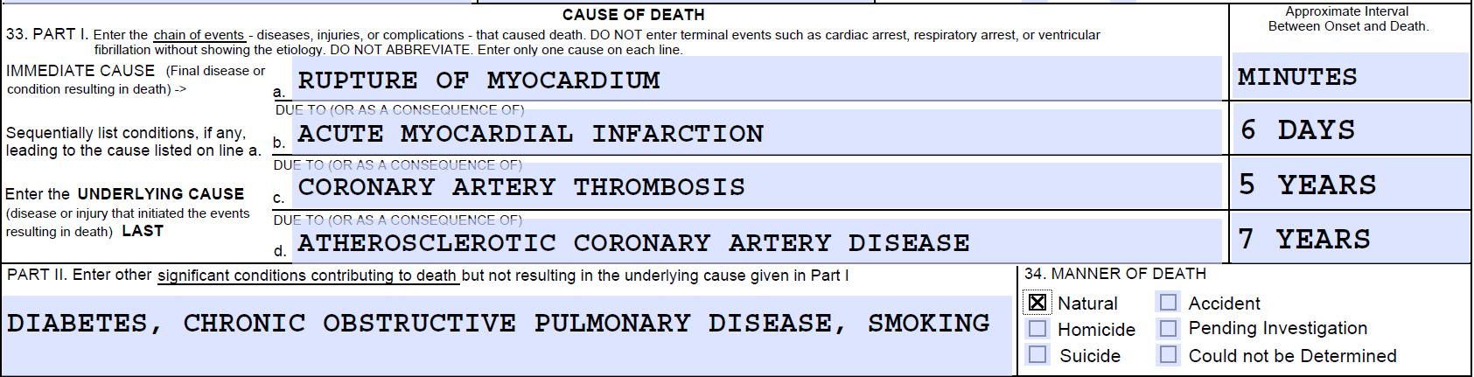

Example 2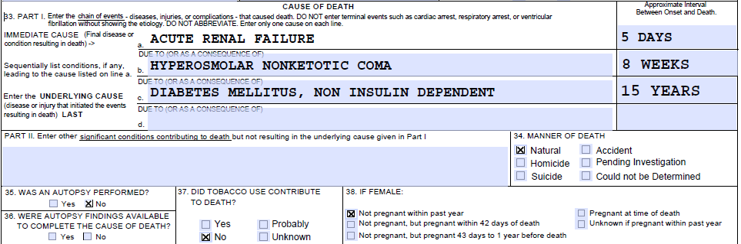

ITEM 33 - CAUSE OF DEATH

* Do not abbreviate conditions entered in section.

Part I (Chain of events leading directly to death)

* Only one cause should be entered on each line. Line A. MUST ALWAYS have an entry. DO NOT leave blank. Additional lines may be added if necessary.
* If the condition on Line A. resulted from an underlying condition, put the underlying condition on Line B., and so on, until the full sequence is reported. The underlying cause of death should be the final entry in Part I.
* For each cause indicate the best estimate of the interval between the presumed onset and the date of death. The terms “unknown” or “approximately” may be used. General terms, such as minutes, hours, or days, are acceptable, if necessary. DO NOT leave blank.
* The terminal event (e.g., cardiac arrest or respiratory arrest) should not be used. If a mechanism of death seems most appropriate to you for Line A., then you must always list its cause(s) on the line(s) below it (e.g., cardiac arrest due to coronary artery atherosclerosis or cardiac arrest due to blunt impact to chest).
* If an organ system failure such as congestive heart failure, hepatic failure, renal failure, or respiratory failure is listed as a cause of death, always report its etiology on the line(s) beneath it (e.g., renal failure due to Type I diabetes mellitus).
* When indicating neoplasms as a cause of death, include the following: 1) primary site or that the primary site is unknown, 2) benign or malignant, 3) cell type or that the cell type is unknown, 4) grade of neoplasm, and 5) part or lobe of organ affected. Example: a primary well-differentiated squamous cell carcinoma, lung, left upper lobe.

Part II (Other significant conditions)

* Enter all diseases or conditions contributing to death that were not reported in the chain of events in Part I and that did not result in the underlying cause of death. (See Example 1 on Page 4)

CHANGES TO CAUSE OF DEATH

* If additional medical information or autopsy findings become available that would change the cause of death originally reported, the original death certificate should be amended by the medical certifier by immediately reporting the revised cause of death to the State Vital Records Office via a Supplemental Report of Death (VS-33). Records amended within one (1) year from the date of the event will not show as amended, except for amending the cause of death from “Pending Investigation”.

ITEM 34 - MANNER OF DEATH

* Always check Manner of Death, which is important for:
  + 1) Determining accurate causes of death
  + 2) Processing insurance claims
  + 3) Statistical studies of injuries and death
* Indicate “Could not be determined” ONLY when it is impossible to determine the manner of death.

ITEMS 35 and 36 - AUTOPSY

* 35 - Enter “Yes” if either a partial or full autopsy was performed, otherwise enter “No.”
* 36 - Enter “Yes” if autopsy findings were available to complete the cause of death; otherwise enter “No.” Leave item blank if no autopsy was performed.

ITEM 37 - DID TOBACCO USE CONTRIBUTE TO DEATH?

* Check “Yes” if, in your opinion, the use of tobacco contributed to death. Tobacco use may contribute to deaths due to a wide variety of diseases. For example, tobacco use contributes to many deaths due to emphysema or lung cancer and some heart disease and cancers of the head and neck. Check “No” if, in your clinical judgment, tobacco use did not contribute to this death.

ITEM 38 - IF FEMALE, WAS DECEDENT PREGNANT AT TIME OF DEATH OR WITHIN PAST YEAR?

* If the decedent is a female, check the appropriate box. If the female is either too old or too young to be pregnant, check the “Not pregnant within past year” box. If the decedent is a male, leave the item blank. This information is very important in determining pregnancy-related mortality.

Common problems in death certification

* The elderly decedent should have a clear and distinct etiological sequence for cause of death, if possible. Terms such as senescence, infirmity, old age, and advanced age have little value for public health or medical research. Age is recorded elsewhere on the certificate. When numerous conditions resulted in death, the medical certifier should choose the single sequence that, in his or her opinion, best describes the process leading to death, and place any other pertinent conditions in Part II. If after careful consideration the medical certifier cannot determine a sequence that ends in death, then the medical examiner or coroner should be consulted about investigating or providing assistance in completing the cause of death.
* The infant decedent should have a clear and distinct etiological sequence for cause of death, if possible. "Prematurity" should not be entered without explaining the etiology of prematurity. Maternal conditions may have initiated or affected the sequence that resulted in infant death, and such maternal causes should be reported in addition to the infant causes on the infant's death certificate (e.g., Hyaline membrane disease due to prematurity, 28 weeks due to placental abruption due to blunt trauma to mother's abdomen).

For more information contact us at:

**State Office of Vital Statistics  
275 E. Main St. 1 E-A  
Frankfort, KY. 40621  
STATLINE 866-451-3781  
(502) 564-4212**

<https://chfs.ky.gov/agencies/dph/dehp/vsb/Pages/kyedrs.aspx>

