Obesity

Obesity is defined as a body mass index (BMI) of 30 or greater. BMI is calculated from a person's weight and height and provides a reasonable indicator of body fatness and weight categories that may lead to health problems. Obesity is a major risk factor for cardiovascular disease, certain types of cancer, and type 2 diabetes. For adults, overweight and obesity ranges are determined by BMI. BMI is used because, for most people, it correlates with their amount of body fat.
- An adult who has a BMI between 25 and 29.9 is considered overweight.
- An adult who has a BMI of 30 or higher is considered obese.

Size of the Problem:
Obesity is increasing rapidly in the United States, affecting children, adolescents, and adults of all races, ethnicities, and income levels. More than one third of U.S. adults - more than 72 million people, and 16% of U.S. children are obese. Since 1980, obesity rates for adults have doubled and rates for children have tripled. Obesity is associated with increased health-care costs, reduced quality of life, and increased risk for premature death. As of 2007, no state had met the Healthy People 2010 objective to reduce to 15% the prevalence of obesity among U.S. adults.

67% of Kentucky adults are obese or overweight - 36.5% of Kentucky adults are overweight (BMI 25 – 29.9) and 30% are obese (30 – 99.8) (CDC BRFSS, 2008). 29% of non-Hispanic white adults, 45% of non-Hispanic black adults in Kentucky are obese (CDC BRFSS, 2008). 36% of low-income adults are obese and 29% have less than a high school degree and 34% have some high school degree or G.E.D. (CDC BRFSS, 2008). The obesity rate among Kentucky adults has almost doubled between 1995 and 2008 (CDC BRFSS, 1995, 2008). See Figure I. Currently, Kentucky (29%) ranks higher than the national average (26%) in terms of obesity.

Figure I
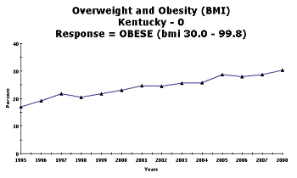

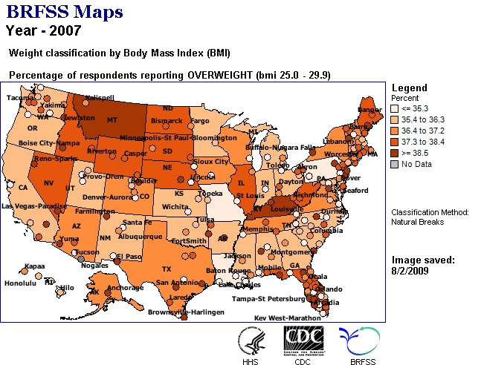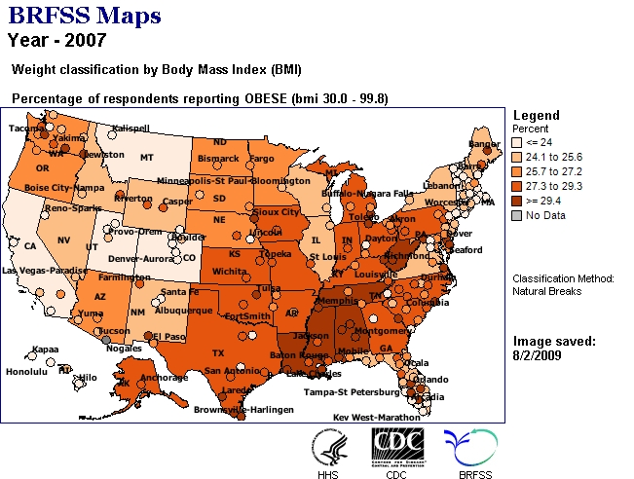

Weight classification by Body Mass Index (BMI)
Age: |  | Neither overweight nor obese (bmi le 24.9) | OVERWEIGHT (bmi 25.0 - 29.9) | OBESE (bmi 30.0 - 99.8)
18-24 | %  CI  n | 38.8  (30.4-47.2)  113 | 41.1  (31.9-50.3)  76 | 20.1  (13.8-26.4)  50
25-34 | %  CI  n | 34.0  (28.9-39.1)  253 | 40.7  (35.2-46.2)  214 | 25.3  (20.8-29.8)  197
35-44 | %  CI  n | 27.3  (23.4-31.2)  338 | 41.1  (36.2-46.0)  359 | 31.6  (26.9-36.3)  315
45-54 | %  CI  n | 26.7  (23.4-30.0)  342 | 37.9  (34.2-41.6)  455 | 35.4  (31.7-39.1)  466
55-64 | %  CI  n | 24.9  (21.8-28.0)  371 | 40.4  (36.9-43.9)  575 | 34.7  (31.2-38.2)  515
65+ | %  CI  n | 37.4  (34.5-40.3)  764 | 41.5  (38.6-44.4)  780 | 21.1  (18.7-23.5)  430

Gender: |  | Neither overweight nor obese (bmi le 24.9) | OVERWEIGHT (bmi 25.0 - 29.9) | OBESE (bmi 30.0 - 99.8)
Male | %  CI  n | 20.2  (17.8-22.6)  500 | 50.8  (47.7-53.9)  1078 | 29.0  (26.3-31.7)  694
Female | %  CI  n | 41.4  (39.0-43.8)  1681 | 30.1  (27.9-32.3)  1381 | 28.5  (26.3-30.7)  1279

Race: |  | Neither overweight nor obese (bmi le 24.9) | OVERWEIGHT (bmi 25.0 - 29.9) | OBESE (bmi 30.0 - 99.8)
White | %  CI  n | 31.9  (30.1-33.7)  2074 | 40.0  (38.0-42.0)  2295 | 28.2  (26.4-30.0)  1826
Black | %  CI  n | 17.7  (10.6-24.8)  42 | 43.5  (33.7-53.3)  86 | 38.8  (29.2-48.4)  89
Hispanic | %  CI  n | N/A | N/A | N/A
Other | %  CI  n | N/A | N/A | N/A
MultiRacial | %  CI  n | N/A | N/A | N/A

Income: |  | Neither overweight nor obese (bmi le 24.9) | OVERWEIGHT (bmi 25.0 - 29.9) | OBESE (bmi 30.0 - 99.8)
Less than $15,000 | %  CI  n | 34.0  (28.9-39.1)  264 | 27.9  (22.6-33.2)  234 | 38.1  (33.0-43.2)  332
$15,000- 24,999 | %  CI  n | 29.6  (25.3-33.9)  326 | 37.0  (32.5-41.5)  389 | 33.3  (28.6-38.0)  324
$25,000- 34,999 | %  CI  n | 28.7  (23.2-34.2)  217 | 42.2  (35.5-48.9)  277 | 29.1  (23.4-34.8)  226
$35,000- 49,999 | %  CI  n | 27.3  (22.8-31.8)  234 | 44.1  (38.8-49.4)  328 | 28.6  (24.1-33.1)  218
$50,000+ | %  CI  n | 28.6  (25.1-32.1)  425 | 44.2  (40.3-48.1)  556 | 27.2  (23.7-30.7)  380

Education: |  | Neither overweight nor obese (bmi le 24.9) | OVERWEIGHT (bmi 25.0 - 29.9) | OBESE (bmi 30.0 - 99.8)
Less than H.S. | %  CI  n | 30.2  (26.1-34.3)  414 | 39.1  (34.2-44.0)  456 | 30.7  (26.4-35.0)  416
H.S. or G.E.D. | %  CI  n | 28.8  (26.3-31.3)  841 | 41.4  (38.3-44.5)  1012 | 29.8  (27.1-32.5)  775
Some post-H.S. | %  CI  n | 31.5  (27.6-35.4)  452 | 39.4  (35.1-43.7)  502 | 29.1  (25.4-32.8)  435
College graduate | %  CI  n | 34.1  (30.4-37.8)  460 | 40.7  (36.4-45.0)  486 | 25.1  (21.6-28.6)  342

State: |  | Neither overweight nor obese (bmi le 24.9) | OVERWEIGHT (bmi 25.0 - 29.9) | OBESE (bmi 30.0 - 99.8)
Kentucky | %  CI  n | 30.9  (29.1-32.7)  2181 | 40.4  (38.4-42.4)  2459 | 28.7  (26.9-30.5)  1973
Nationwide (States, DC, and Territories) | Median %  # States | 37.0  54 | 36.7  54 | 26.3  54

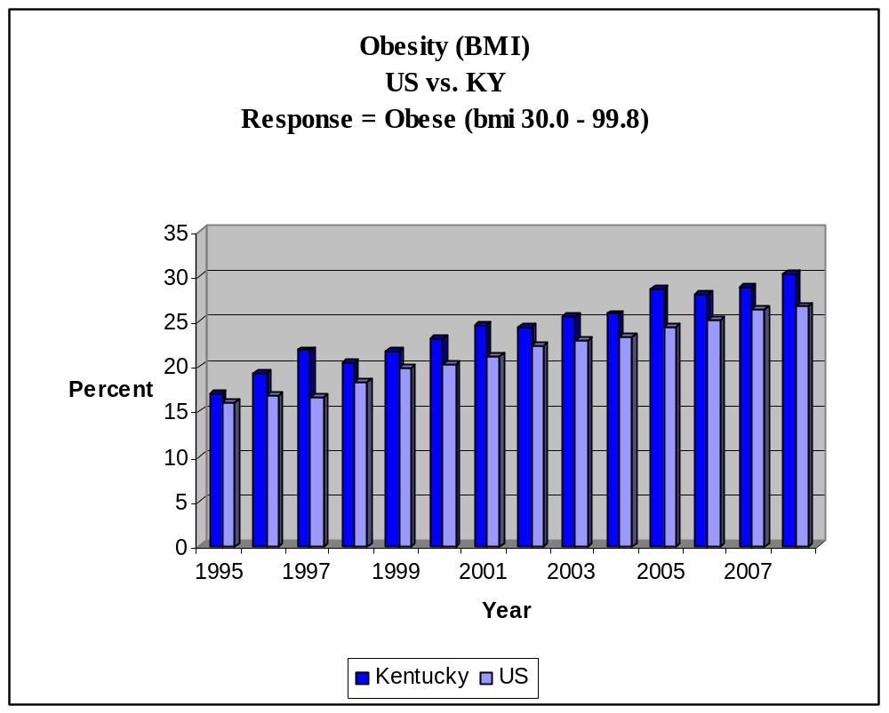

Seriousness/Impact:
Obesity has physical, psychological, and social consequences in adults and children. Children and adolescents are developing obesity-related diseases, such as type 2 diabetes, that were once seen only in adults.
The Health Consequences of Obesity:
- Coronary heart disease
- Type 2 diabetes
- Cancer (endometrial, breast, and colon)
- Hypertension (high blood pressure)
- Dyslipidemia (high total cholesterol or high levels of triglycerides)
- Stroke
- Liver and gallbladder disease
- Sleep apnea and respiratory problems
- Osteoarthritis (degeneration of cartilage and underlying bone within a joint)
- Gynecological problems (abnormal menses, infertility)

Disparities Impact:

The prevalence of obesity in the United States has more than doubled in the past three decades, and certain racial/ethnic populations have been affected disproportionately. An overarching goal of Healthy People 2010 is to eliminate health disparities among racial/ethnic populations. To assess differences in prevalence of obesity among non-Hispanic blacks, non-Hispanic whites, and Hispanics, CDC analyzed data from Behavioral Risk Factor Surveillance System (BRFSS) surveys conducted during 2006 - 2008. In 2008, only one state (Colorado) had a prevalence of obesity less than 20%. Thirty-two states had a prevalence equal to or greater than 25%; six of these states (Alabama, Mississippi, Oklahoma, South Carolina, Tennessee, and West Virginia ) had a prevalence of obesity equal to or greater than 30% (CDC, 2008). Obesity data by by race/ethnicity for 2006 – 2008 show that blacks have the highest rates of obesity. Blacks had 51 percent higher prevalence of obesity, and Hispanics had 21 percent higher obesity prevalence compared with whites. Greater prevalences of obesity for blacks and whites were found in the South and Midwest than in the West and Northeast. Hispanics in the Northeast had lower obesity prevalence than Hispanics in the Midwest, South or West (CDC BRFSS, 1996, 2008).

There are several reasons that might account for the differences in the prevalence of obesity among the different populations. First, racial/ethnic populations differ in behaviors that contribute to weight gain. For instance, compared with non-Hispanic whites, non-Hispanic blacks and Hispanics are less likely to engage in regular physical activity. In addition, differences exist in attitudes and cultural norms regarding body weight. For example, according to one study, both non-Hispanic black and Hispanic women are more satisfied with their body size than non-Hispanic white women; persons who are satisfied with their body size are less likely to try to lose weight. Also, certain populations have less access to affordable, healthy foods and safe locations for physical activity. Evidence suggests that neighborhoods with large minority populations have fewer chain supermarkets and produce stores and that healthy food are relatively more expensive than energy-dense foods, especially in minority and low-income communities. Evidence also indicates that minority and low-income populations have less access to physical activity facilities and resources and that traffic and neighborhood safety might inhibit walking.

Economic Impact:

The costs of treating obesity-related diseases are staggering and rising rapidly.
- In 2004, direct and indirect health costs associated with obesity were $98 billion
- In 2000, obesity-related health care costs totaled an estimated $117 billion.
- Between 1987 and 2001, diseases associated with obesity account for 27% of the increases in medical costs.
- Medical expenditures for obese workers, depending on severity of obesity and sex, are between 29% - 117% greater than expenditures for workers with normal weight.
- From 1979 - 1981 to 1997 - 1999, annual hospital costs related to obesity among children and adolescents increased, rising from $35 million to $127 million.

Capacity/Resources:
Partnership for a Fit Kentucky
The Partnership for a Fit Kentucky is a public/private partnership which supports the Kentucky Department for Public Health’s CDC Obesity Prevention Grant. The focus is on promoting nutrition and physically active communities. There is a website acts as a clearinghouse of the Partnership for a Fit Kentucky’s initiatives. The intent is to link resources, network programs, provide tools that work, and strengthen partnerships in order to develop cutting edge initiatives.

The Obesity Prevention Grant Steering Committee has begun work to organize the state process of developing a plan even as new members are being recruited. The plan will follow the best practices identified by CDC’s Division of Nutrition and Physical Activity and other experts and will take advantage of the many resources already existing in communities throughout Kentucky. Cities that have their own health initiatives are being identified, and the obesity program is networking with them.

A State Physical Activity, Nutrition, and Obesity Prevention Plan in which partners across the state take responsibility for specific target populations or activities. The overarching goal of the state nutrition and physical activity program is to transform the way agencies and organizations throughout Kentucky collaborate to reduce obesity and other chronic diseases.

Interventions:

Identifying Setting-Specific, Evidence-Based Guidelines for Obesity Interventions
In collaboration with the Task Force on Community Preventive Services (the Community Guide), CDC is conducting evidence-based reviews of obesity interventions in three settings - medical care, work sites, and communities.

Translating Practice-Based Evidence and Research
CDC translates practice-based evidence and research findings for use by practitioners, communities, and the public. Recent translation products include the following:
- The Swift Work Site Assessment and Translation (SWAT) (http://www.cdc.gov/swat) evaluation method assesses work site health promotion programs that help employees attain or maintain a healthy body weight.
- Healthy Weight Web site (http://www.cdc.gov/healthyweight) includes a BMI calculator and provides consumers with relevant steps and tools to help them understand how to achieve and maintain a healthy weight for a lifetime.
- The Weight Management Research to Practice Series (http://www.cdc.gov/weightr2p) summarizes the science on various weight management topics, highlighting the implications of the research findings for public health and medical care professionals.

Successes and Opportunities for Population-Level Prevention and Control

Michigan: Building Healthy Communities
Michigan’s Building Healthy Communities Project is designed to improve the environment and change policies to make it easier for residents to be healthy. Local health departments were supported through funding and technical assistance to form community coalitions and develop 3-year plans for creating more opportunities for their residents to engage in healthful eating, physical activity, and tobacco-free lifestyles. Coalitions included representatives from local transportation, zoning and planning departments, law enforcement, the YMCA, hospitals, universities, non-profit organizations, news media outlets, in addition to farmers, residents, public officials, and city engineers.
The Building Healthy Communities Project achieved significant success in making it easier for Michigan residents to be healthy by
- Creating or enhancing 11 trails covering 58.6 miles.
- Enhancing 7 parks with amenities such as new equipment, benches, and lighting.
- Providing residents with 14,000 walking maps.
- Conducting 129 community fitness classes.
- Opening 5 new farmers’ market locations with the ability to process Electronic Benefit Transfer capabilities for processing for food stamps.
- Creating 7 new school and community gardens.
- Distributing 5,000 coupon books to low-income seniors to redeem for fresh fruits and vegetables.

Texas: Farm to Work Delivers
In 2005, less than one quarter of Texas adults ate the minimum amount of fruits and vegetables recommended for good health. To increase access to fresh produce, the Texas Department of State Health Services Nutrition, Physical Activity, and Obesity Prevention Program worked with the department’s Building Healthy Texans Employee Wellness Program to create a Farm to Work program. This program enables employees at 10 Austin-area work sites to purchase fresh local produce, which is delivered weekly to their work site. Coordination with local farmers is handled by the Sustainable Food Center, a nonprofit organization. Participation is easy - employees order on a week-by-week basis, with no subscription required. Orders are prepaid through a secure server so no money is handled onsite. A Farm to Work tool kit was created and disseminated. Other state agencies and private companies in Texas are now implementing similar programs.
Employees took advantage of the program and saved money. In 1 year, 1,700 employees participated; 82,000 pounds of fresh local produce were delivered; and Central Texas farmers made $160,000 in sales. An informal cost comparison showed that grocery store produce was more expensive than the Farm to Work produce.

Recommendations:
The high prevalence of obesity overall in the United States emphasizes the importance of implementing effective intervention strategies in the general population. Effective policies and environmental strategies that promote healthy eating and physical activity are needed for all populations and geographic areas, but particularly for those populations and areas disproportionately affected by obesity. Effective policy and environmental strategies to promote physical activity include developing communication programs and community- and street-scale urban design and land use policies, and creating or enhancing access to places for physical activity. Given the significant disparities in obesity prevalence, public health officials should ensure that those populations with the greatest need are the ones that benefit the most from these efforts and are involved in developing effective strategies for their communities. To reduce disparities among populations in the prevalence of obesity, an effective public health response is needed that includes surveillance, policies, programs, and supportive environments achieved through the efforts of government, communities, workplaces, schools, families, and individuals.

References:
- Centers for Disease Control and Prevention (CDC) Behavioral Risk factor Surveillance System (BRFSS). Obesity Prevalence and Trends Data, 2008 < http://apps.nccd.cdc.gov/brfss/display.asp>
- Partnership for a Fit Kentucky, 2007<http://www.fitky.org/>
- Kentucky Obesity Programs <http://www.obesitydiscussion.com/forums/obesity-programs-by-state/kentucky-obesity-programs-181.html>
- Centers for Disease Control and Prevention (CDC). Overweight and Obesity. State-based Programs <http://www.cdc.gov/obesity/stateprograms/index.html>
- Centers for Disease Control and Prevention (CDC). Obesity: Halting the Epidemic by Making Health Easier <http://www.cdc.gov/NCCDPHP/publications/AAG/obesity.htm>
- Centers for Disease Control and Prevention (CDC). Recommended Community Strategies and Measurements to Prevent Obesity in the United States, Morbidity and Mortality Weekly Report (MMWR). 2009 Jul 24;58(RR-7):1-26. <http://www.cdc.gov/mmwr/preview/mmwrhtml/rr5807a1.htm>

