LABELING REQUIREMENTS
FOR HOME BASED PROCESSORS

The following information shall be included on the label of each food product:
1. The common or usual name of the food product.
2. The name and address of the home-based processing operation. This shall include the street address, city, state, and zip code.
3. The ingredients of the food product. Ingredients shall be in descending order of predominance by weight.
4. The net weight or volume of the food product by standard measure or numerical count.
5. The following statement in 10-point type: “This product is home-produced and processed”.
6. The date the product was processed.

Example:
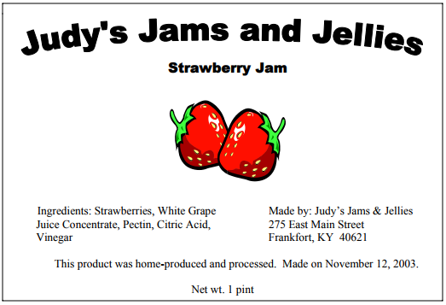
If you have questions, please call the Food Safety Branch at (502) 564-7181.
Home-based Microprocessor labels may be sent to the Food Safety Branch with attention for review at 275 East Main Street HS1CF, Frankfort, KY 40621.

