Automated Growth Chart

SIGN IN SCREEN

This screen is used to sign onto the growth chart system.

- Enter KY number.
- Enter User Name. This is the KY number.
- Enter User Password as assigned.

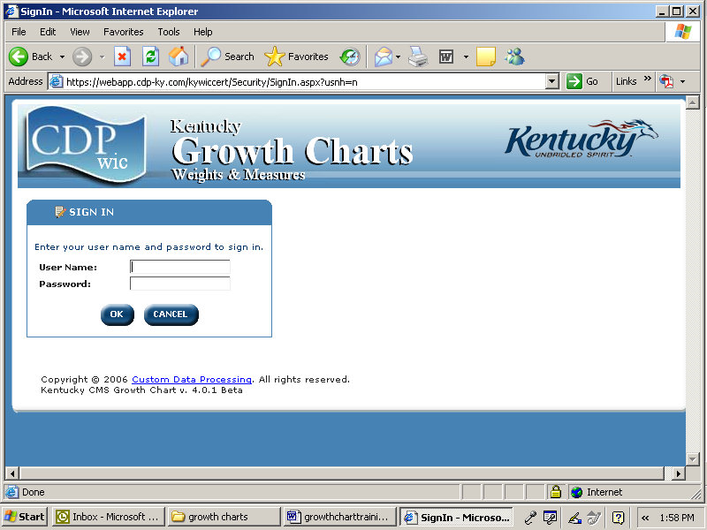

07/07

Page 1 of 16
Kentucky Public Health Practice Reference
Section: Forms and Teaching Sheets
July 1, 2007

DAILY REGISTRATION SCREEN

This screen is used to access the patient who has been registered on the Patient Encounter System/Patient Registration Screen.

- Access patient by:
- Entering the patient number or last name/first name and clicking go. OR
- Clicking on patient name.
The current patent selected shows at the top of the screen.
- Click on the arrows to scroll from page to page. Single arrows move to the next page of names. Double arrows move to the last page or the first page depending on the direction. Movement can be backwards or forwards depending on the arrows direction.
- Click on the line under the patient number to put the patients in numerical order. OR Click on the line under the last name to put the names in alphabetical order.

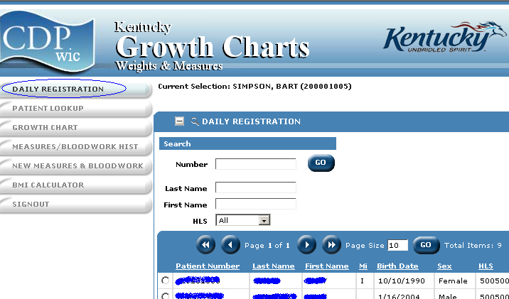

07/07

Page 2 of 16
Kentucky Public Health Practice Reference
Section: Forms and Teaching Sheets
July 1, 2007

PATIENT LOOKUP

This screen is used if the patient cannot be found on the Daily Registration Screen.
- Select Patient Lookup.
- Type in the Patient’s Number (ID number) or name.
- Click the Go button.

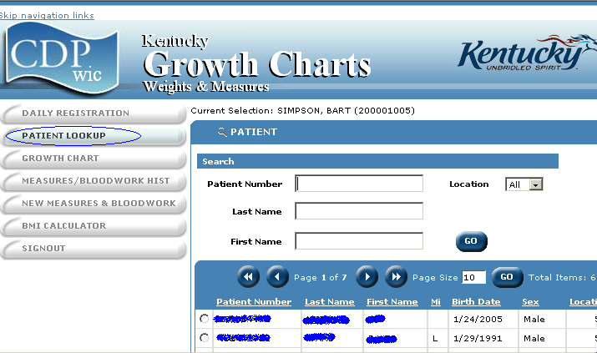

07/07

Page 3 of 16
Kentucky Public Health Practice Reference
Section: Forms and Teaching Sheets
July 1, 2007

NEW MEASURES AND BLOODWORK

This screen is used to enter measures.
- Once the patient has been selected from either the Daily Registration Screen or the Patient Lookup. Click on New Measures and Bloodwork.
- The Service Date and Status will already be completed from the Registration Screen. Change the Service Date, if the date of service is other then the date displayed.
Height/Weight
- The Date of Measures will be pre-filled from the Registration Screen. Change the Date of Measures, if the measurements were done on another date such as with a referral. To change the date of Measures type the new date in the box or click on the calendar icon to choose a new date.
- Enter the height in feet and inches or just inches. Example 5’ 4’ or 64” Click on the Convert button, if the measurements have been received in centimeters. A box will appear to enter the centimeters. Enter the measures and click convert. The English measures will automatically be filled in to the height boxes.
- If the height is unknown or could not be obtained i.e. when a child is in a wheelchair, click on Unknown Height. The measure will appear as a 99 in the system. An invalid measure will not plot on the growth chart.
- If the child is less then 3 and is measured laying down, click on the box Recumbent (Y). This child will be plotted on the 0-36 month growth chart.
- Enter the weight in pounds and ounces. Click on the Convert button, if the measurements have been received in kilograms. A box will appear to enter the kilograms. Enter the measures and click convert. The English measures will automatically be filled in the weight boxes.
- If the weight is unknown or could not be obtained, click on Unknown Weight. The measure will appear as a 99 in the system. An invalid measure will not plot on the growth chart
- Enter Head Circumference in centimeters. Click on the Convert button, if the measure was received in inches. The measurement in centimeters will automatically be filled in the box. Head circumference is not required for WIC. Leave this field blank if head circumference was not measured.
- BMI will be automatically calculated once height and weight are entered.
- Enter Comments, if desired. These comments will display on the growth chart comments section.
Bloodwork
- The Date of Measures will be pre-filled from the Registration Screen. Change the Date of Measures, if the bloodwork was done on another date such as with a referral. To change the date of Measures, type the new date in the box or click on the calendar icon to choose a new date.
- The Lead Measures Date will be pre-filled from the Registration Screen. Change the Lead Measures Date, if the lead test was done on another date. To change the date of Measures type the new date in the box or click on the calendar icon to choose a new date.
- Enter either the Hemoglobin in grams per deciliter or the Hematocrit in percentage.
- If the hemoglobin and the hematocrit are unknown or could not be obtained, click on Unknown Hemoglobin/Hematocrit. The measure will appear as a 99 in the system.
07/07

Page 4 of 16
Kentucky Public Health Practice Reference
Section: Forms and Teaching Sheets
July 1, 2007

- Enter Lead Count in µg/deciliter. Lead Count is not required for WIC however, if a lead count was obtained in the last 12 month and is entered in this field, nutritional risk for lead will be assessed. Leave this field blank if the lead count is unavailable.
- If the visit is a WIC certification, click Calculate Nutritional Risk for WIC to continue with the automated risk program.
Or
If the visit is not a WIC certification, click Save for the information to be saved to history. Then click the Growth Chart button to retrieve and print the growth chart.

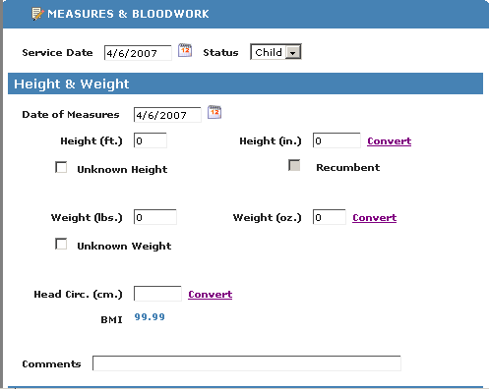
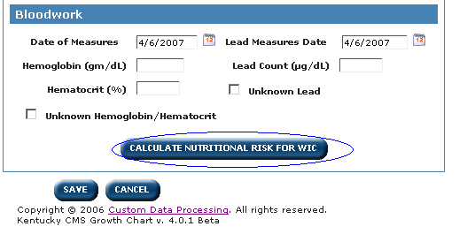

07/07
Page 5 of 16
Kentucky Public Health Practice Reference
Section: Forms and Teaching Sheets
July 1, 2007

NEW MEASURES FOR THE STAUS OF INFANT

This screen is used to access the record for new measures for infants and the parents’ data.

Click Add Record from the History Screen. This screen will allow you to add the birth information.

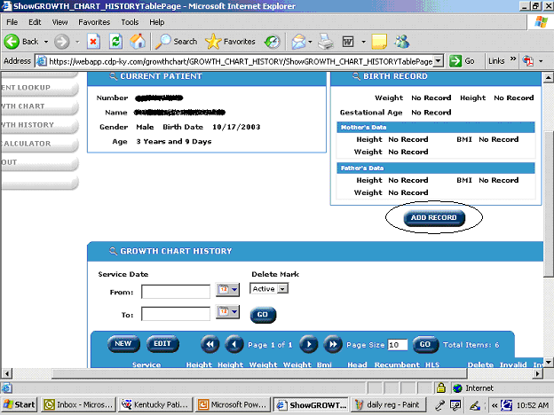

07/07

Page 6 of 16
Kentucky Public Health Practice Reference
Section: Forms and Teaching Sheets
July 1, 2007

ADDING BIRTH MEASURES INFORMATION

This screen is used to enter the birth measures and parents’ data.
Add Birth Record
- Enter Gestational Age in Weeks and Days in the boxes. Days cannot be more then 6. If the child was born at less then (<) 40 weeks of age or more then (>) 40 weeks of age then the gestational age will be adjusted accordingly.
Birth Measures
1. Enter Birth weight in pounds and ounces. Ounces cannot be more then 15.
2. Enter Birth Length in inches.
3. If the length or weight is unknown or could not be obtained. Click on Unknown Height or Unknown Weight as appropriate. The measure will appear as a 99 in the system.
Parent Data
- Enter Parent Data when it is available).
- Enter Father’s Stature in feet and inches or feet or inches.
- Enter Father’s Weight in pounds and ounces.
- Father BMI will be automatically calculated once height and weight are entered.
- Enter Mother’s Stature in feet and inches or feet or inches.
- Enter Mother’s Weight in pounds and ounces.
- Mother BMI will be automatically calculated once height and weight are entered
- If the visit is a WIC Certification, click on the button circled below, Calculate Nutritional Risk for WIC, if no new measures were taken for that infant.
Or
If new measures were taken or it is not a WIC Certification, click Save to retain information in the system.

See next page for screens.

07/07

Page 7 of 16
Kentucky Public Health Practice Reference
Section: Forms and Teaching Sheets
July 1, 2007

ADDING BIRTH MEASURES INFORMATION cont.

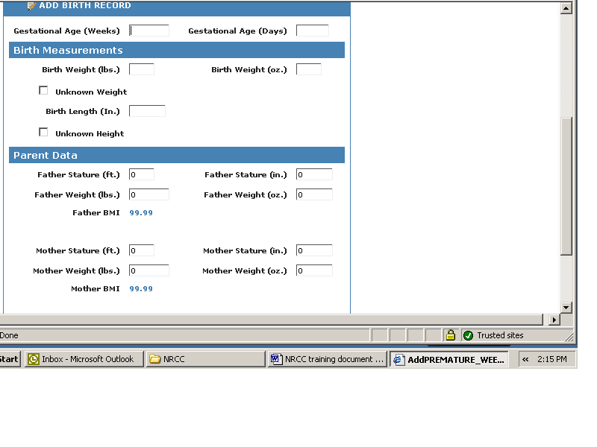

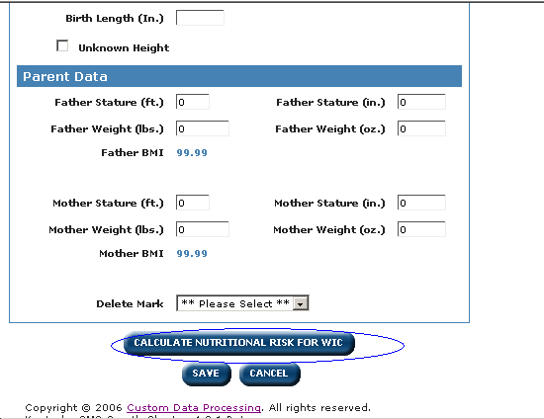
07/07

Page 8 of 16
Kentucky Public Health Practice Reference
Section: Forms and Teaching Sheets
July 1, 2007

NEW MEASURES AND BLOODWORK
FOR STATUS OF
POSTPARTUM OR BREASTFEEDING

This screen is used to enter measures for a woman with the status of
Postpartum or Breastfeeding.

- Ensure the Status of the patient is correct. Change if necessary.
- Enter the Actual Delivery Date, if the patient is breastfeeding or post partum.
- Complete the Pre-Pregnancy Weight in pounds and ounces. Click on the Convert button, if the measurements have been received in kilograms. A box will appear to enter the kilograms. Enter the measures and click convert. The English measures will automatically be filled in the weight boxes.
- If the weight is unknown or could not be obtained, click on Unknown Weight. The measure will appear as a 99 in the system. An invalid measure will not plot on the growth chart.
- Click Calculate Nutritional Risk for WIC if this is for a WIC certification.

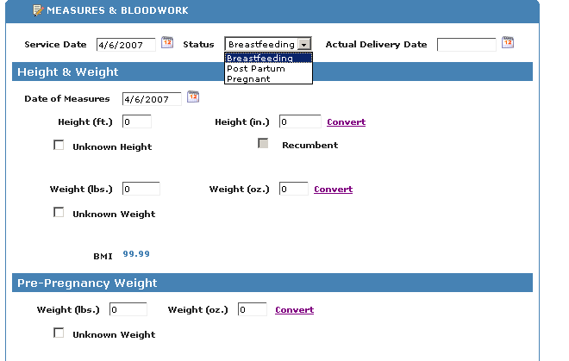

07/07

Page 9 of 16
Kentucky Public Health Practice Reference
Section: Forms and Teaching Sheets
July 1, 2007

NEW MEASURES AND BLOODWORK
FOR A STATUS OF
PREGNANT

This screen is used to enter measures for a woman with the status of Pregnant.
- Ensure the Status of the patient is correct. Change if necessary.
- Enter the Expected Delivery Date, if the patient is pregnant.
- The trimester of pregnancy will automatically be calculated.
- Complete the Height and Weight and Prepregnancy Weight. (See the New Measures and Bloodwork and the New Measures and Bloodwork for Status of Postpartum or Breastfeeding for specifics) These measures will not plot on the growth chart.
- Click Calculate Nutritional Risk for WIC if this is for a WIC certification.
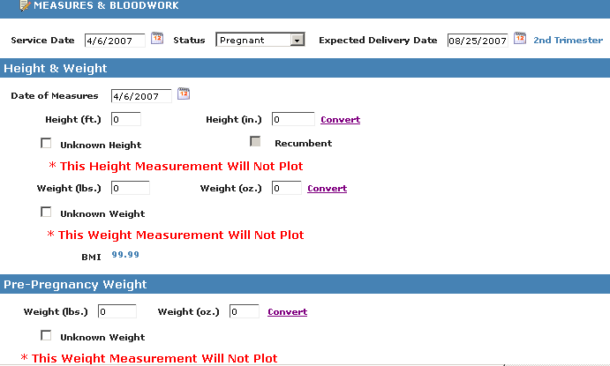
07/07
Page 10 of 16
Kentucky Public Health Practice Reference
Section: Forms and Teaching Sheets
July 1, 2007

GROWTH CHART

This screen enables the printing of the growth chart.
- Click on the Growth Chart button. Then, print the charts needed.

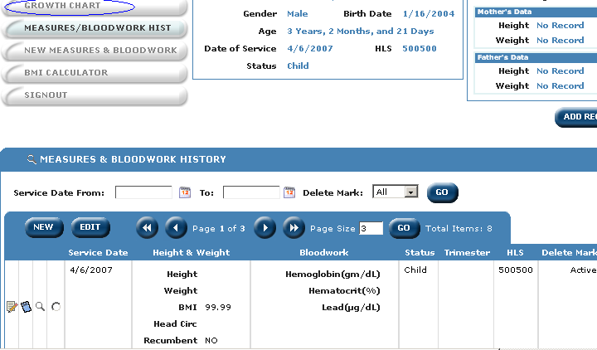

07/07

Page 11 of 16
Kentucky Public Health Practice Reference
Section: Forms and Teaching Sheets
July 1, 2007

Growth Chart Types

This is an example of the types of charts:
- 0-36 months
- 2-20 years

- To move from chart to chart use the directional arrows underneath the Chart Control box or click on the chart name in the Select a Chart box then click the Show button. Single arrows move to the next chart. Double arrows move to the last chart or the first chart depending on the direction. Movement can be backwards or forwards depending on the arrows direction.
- Click on the Print button to print the highlighted charts individually
Or
Choose the appropriate age group under Group Printing and then click on the Print Group button to print all of the available charts for an age group.

Note: Each time a new growth chart is printed the old growth chart will be shredded since history is maintained by the system. However, the last 0-36 month chart should be retained in the medical record once the child is plotted on the 2-20 chart.

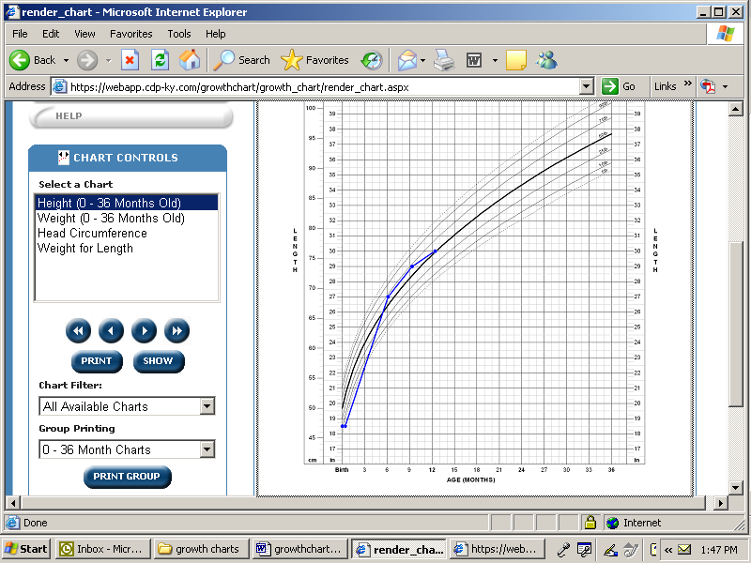

07/07
Page 12 of 16
Kentucky Public Health Practice Reference
Section: Forms and Teaching Sheets
July 1, 2007

MEASURES AND BLOOD WORK HISTORY

To edit a record:
  - Click on the Icon circled below.
  - Correct the measures
  - Click the Save button.

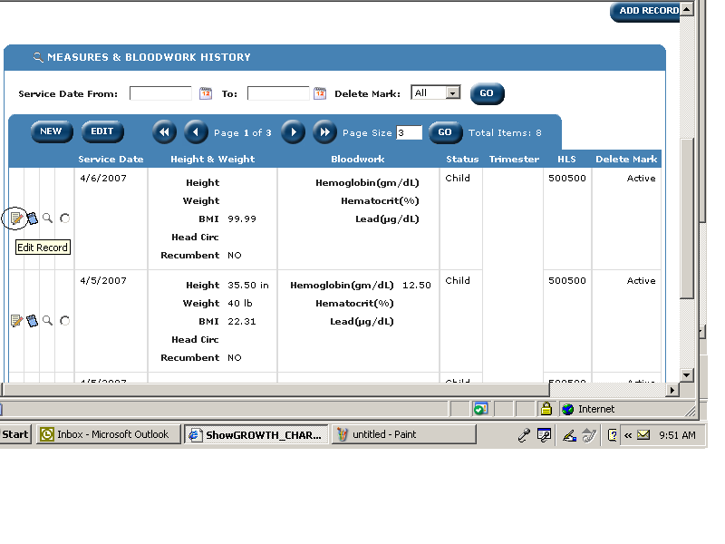

07/07

Page 13 of 16
Kentucky Public Health Practice Reference
Section: Forms and Teaching Sheets
July 1, 2007

MEASURES AND BLOOD WORK HISTORY cont.

Invalid Measures

Measures for a pregnant woman or measures that have been marked invalid will be highlighted on the history screen.
Growth charts will not be plotted for the following reasons:
- A pregnant woman.
- Any measures that are invalid.
- An infant that was born at less then 40 weeks gestational age.
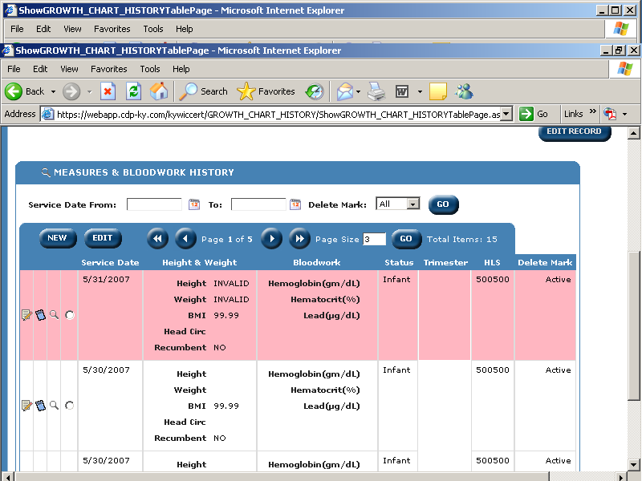

07/07

Page 14 of 16
Kentucky Public Health Practice Reference
Section: Forms and Teaching Sheets
July 1, 2007

BMI CALCULATOR

The BMI Calculator screen is an extra tool that can be used for those patients that need a BMI but are not plotted on the growth chart. This is only a tool. The information is not stored.
BMI Calculator
- Enter the Height in feet and inches or in feet or inches.
- Enter the Weight in pounds.
- The BMI will be calculated. Document the information in the medical record, as appropriate.
Status (Adult and Pregnant) – Provides the weight status i.e. normal, overweight, etc based upon the BMI calculated.

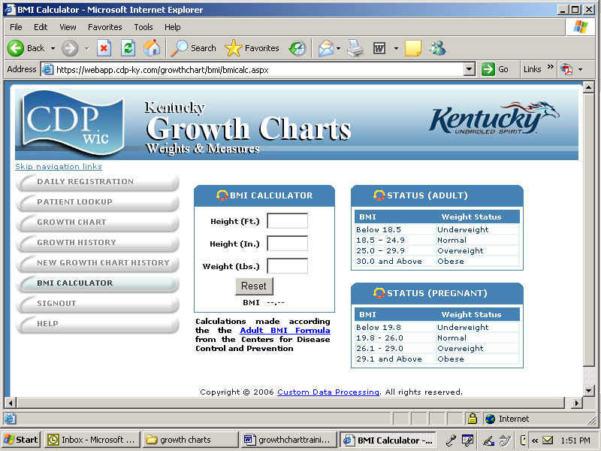

07/07

Page 15 of 16
Kentucky Public Health Practice Reference
Section: Forms and Teaching Sheets
July 1, 2007

Offsite Growth Charts

When offsite growth charts are performed, use the following procedure.
  - Place the paper growth chart in the participant’s medical record.
  - Enter height and weight into the New Measures and Bloodwork.
  - Click Save to retain all of the information entered into the system.

Procedure for System Down

When the system is down, use the following procedure.
  - Retain the paper growth chart in the participant’s medical record.
  - Enter the information obtained into the automated system when it is available.
  - Do not print a growth chart until the next visit.

07/07
Page 16 of 16
Kentucky Public Health Practice Reference
Section: Forms and Teaching Sheets
July 1, 2007

