Tuberculosis (TB)

Table of Contents

(ctrl+click on text to go directly to section)

CLINICAL PROTOCOLS

Tuberculosis Matrix 1
Recommendations for Sputum Collection 7
GeneXpert MTB/RIF Assay Testing Protocol 8
Managing Laboratory Data 11
Guidelines for Follow-up Notification 12
Classifying the Tuberculin Skin Test Reaction 13
TST Recommendations for Infants, Children, & Adolescents 14
Indications for Two-Step Tuberculin Skin Tests 15
CASE MANAGEMENT
Risk factors for Progression of Infection to Active TB 16
Treatment Algorithm for Culture Positive/TB 17
Treatment Algorithm for Culture Negative TB 18
Directly Observed Therapy (DOT) 19
KY VDOT Video Directly Observed Therapy 20
Drug Regimens for TB & Drug Resistant TB
Drug Regimens for Culture-Positive Pulmonary TB 21
Doses of AntiTB drugs for Adults and Children 23
Pyridoxine (Vitamin B6) Supplementation 27
Dosage Chart 29
Drug-Drug Interactions Involving the Rifamycins 30
Dosing for Adults with Reduced Renal Function 33
Potential Regimens for Management of Drug-Resistant Pulmonary TB 34
Criteria for Determining When A Patient Is Noninfectious 36
Management of Treatment Interruptions 37
Risk Factors for MTB Infection (LTBI) 38
Directly Observed Preventive Therapy (DOPT) 39
Treatment for Latent TB Infection 40
Planning a Contact Investigation 44
Determining the Infectious Period for a Patient with Active TB Disease 45
Tuberculosis (TB)
Table of Contents Cont.
(ctrl+click on text to go directly to section)
Initial Assessment of Contacts 46
Window-Period Prophylaxis 48
Evaluation, Treatment and Follow-up of TB Contacts 49
References & WHO TB Incidence Link 54

TUBERCULOSIS MATRIX

Condition Assessment Education Follow-up

Classification 0

No TB Exposure Not Infected
Patient TB Risk Assessment (TB-4) with targeting testing of persons in at-risk groups

Persons at Increased Risk for Mycobacterium tuberculosis Infection

- Close contacts of a person known or suspected to have active TB disease
- Foreign-born persons, including children who have immigrated within the last 5 years from areas where TB is prevalent**
- Persons who visits areas with a high TB prevalence, especially if visits are frequent or prolonged
- Residents and employees of high-risk congregate settings
- Health care workers (HCWs) who serve high-risk clients
- Medically underserved, low income populations, homeless
- High-risk racial or ethnic minority populations
- Persons who abuse drugs or alcohol
Complete patient TB Risk Assessment (TB-4) prior to tuberculin skin test (TST) or blood assay for Mycobacterium tuberculosis (BAMT) for all classifications. TSTs are preferred for children aged less than five years.

Tuberculin skin test (TST)
with Purified Protein Derivative (PPD) using the Mantoux method (use
Tubersol antigen)

The TST must be given and read by a nurse per 902 KAR 20:016

A two-step TST is usually recommended initially for:
  - Anyone required to have
regular TB testing, regardless of age

BAMTs are one-step in-vitro tests that assess for the present of infection with M. tuberculosis.
Educate on signs and symptoms of active TB disease, risk factors for Latent TB Infection (LTBI), and risk factors for rapid progression from LTBI to active TB disease

See procedure for TST in this reference. Review CDC TST Video, 2006

Two-step TST:
- If first step TST is positive, consider the person infected.
- If first step TST is negative, give the second step TST 1–3 weeks later.
- If second step TST is positive, consider person infected.
- If second step TST is negative, consider person uninfected.
BAMT reported as positive, consider person infected.
Some groups may need annual TB Risk Assessments (TB-4). Some groups,
  - HCWs may need annual TSTs or
BAMTs in addition to annual TB Risk Assessments (TB-4).

All testing activities should be accompanied by a plan for follow-up care.

Patients should return in 48–72 hours for TST reading, interpretation, and recording by nurse.

Anergy Suspects
Do not rule out TB diagnosis based on negative skin test result; consider anergy
if immunosuppressed; also see other
diseases/conditions that can cause suppression of delayed-type
hypersensitivity (DTH) response.

Delayed type hypersensitivity (DTH) antigen tests are not recommended for administration at LHDs.

    - Infants, children, and adolescents exposed to adults at high-risk for latent TB infection or active TB disease

See TST Recommendations for Infants, Children, and Adolescents, p 14 in this reference

* See Core Curriculum on Tuberculosis (2013) for TB Classification System. **See tables with international TB incidence and prevalence rates in this reference for more information.
MMWR, Targeted Tuberculin Testing and Treatment of Latent Tuberculosis Infection, June 9, 2000

- Each LHD shall have a designated employee responsible for Tuberculosis (TB) services in their county. This person must attend periodic TB updates or keep updated by having the latest educational and scientific materials for the prevention and control of TB from CDC/ATS/ALA, the Southeastern National Tuberculosis Center, and other National Tuberculosis Centers.
- The physician or clinician knowledgeable in the field of mycobacterial diseases shall provide patient care. They shall agree to update themselves through professional meetings, consultations, and review of journal articles. This must be a component of any LHD contract for TB clinician services.
This current classification system of tuberculosis (TB) is based on the pathogenesis of TB. A person with a classification of 3 or 5 should be receiving drug treatment for TB and should be reported to the LHD.*

TUBERCULOSIS MATRIX

(Continued)

Condition Assessment Education Follow-up

Classification 0 (Continued)

No TB Exposure Not Infected

*Targeted Testing for low risk individuals is no longer recommended
(2016 LTBI
Guidelines; pg. e4)
Groups that should be TB Tested (Continued)

Persons at higher risk for developing active TB disease once infected
- Persons with HIV infection
- Infants and children aged less than five (5) years
- Persons recently infected with Mycobacterium tuberculosis (within the past two (2) years.
- Cigarette smokers and persons who abuse drugs or alcohol
- Persons with a history of inadequately treated TB
- Persons with certain medical conditions
Develop a policy that the LHD will repeat TSTs given by other health care providers not trained by the LHD unless their skill is known and trusted by the LHD.

LHDs DO NOT need a similar policy for repeating BAMTs.

TSTs administered by LHDs can be read by staff in other LHDs and do not usually need to be repeated.

  - Persons with HIV infection
  - Persons who are receiving immunosuppressive therapy such as tumor necrosis factor--alpha (TNF-α) antagonists, systemic corticosteroids equivalent to ≥15 mg of prednisone per day, or immune suppressive drug therapy following organ transplantation
  - Silicosis
  - Diabetes mellitus
  - Chronic renal disease
  - Certain hematologic disorders (leukemias and lymphomas)
  - Cancer of the head, neck, or lung
  - Gastrectomy or jejunoileal bypass
  - People receiving immunosuppressive therapy for rheumatoid arthritis or Crohn’s disease
- Low body weight (BMI < 19)

TUBERCULOSIS MATRIX

(Continued)

Condition | Assessment | Treatment | Education | Follow-up
Classification 1  TB Exposure (contact), no evidence of infection | Identify contacts within 3 workdays of suspect/case report, using prioritization and the Concentric Circle Approach (p. 41).  Administer TST or draw blood for BAMT and Examine high-risk contacts within 7 workdays of identification (See pages 37 and 46)  Give TST or draw blood for BAMT for medium and low-risk contacts based on findings from the Concentric Circle Approach (See pages 41 and 46)  Do the following:  - Patient TB Risk Assessment (TB-4)  - Medical History (TB H&P 13 or TB 20 follow up form)  - TST or BAMT (unless there is previously documented positive reaction)  - Chest x-ray, at the same time those  who:  - Have TB symptoms  - Are HIV infected or have other immunosuppressed conditions  - Are < 4 years of age  Posterior–Anterior (PA) chest  x-ray is the standard view used to detect abnormalities  PA and lateral view should be done on those < 5 years of age  If symptomatic, see sputum collection recommendations in this reference and in online forms. | Infants and Children <5 years of age, who are high priority contacts and who have a negative TST or negative BAMT, should be started on window period prophylaxis, with therapy administered by Directly Observed Preventive Therapy (DOPT) until retested in 8-10 weeks.  If repeat TST or BAMT is positive, continue medicines by DOPT (see classification 2)  If repeat TST or BAMT is negative, stop medicine unless contact with infectious case has not or cannot be broken.  Contacts with immunocompromising conditions (e.g. HIV-infected) that have a negative TST or negative BAMT should be started on window prophylaxis therapy by DOPT until retested in 8-10 weeks. If the repeat TST or BAMT remains negative, and an evaluation for active TB disease is negative, a full course of treatment for LTBI should still be completed.  See Medications to Treat LTBI in this reference | Discuss:  - How TB is transmitted  - LTBI versus active TB disease  - Importance and significance of repeat skin test in 8-10 weeks  - Treatment of active TB disease or LTBI  - Importance of taking medicine on a regular basis if indicated  Steps for patient producing a sputum specimen at home:  - Clean & thoroughly rinse mouth with water  - Breathe deeply 3 times  (a tickling sensation at end of breath)  - After 3rd breath, cough hard & try to bring up sputum from  deep in lungs  - Expectorate sputum into a sterile container collecting at  least one teaspoonful  - Perform this in a properly ventilated room, booth, or  outdoors  Provide patient information for an informed consent. | If TST or BAMT is negative, must return 8–10 weeks after contact has been broken, for repeat TST or BAMT.  To avoid difficulty with test interpretation in a contact investigation, the follow-up TB test method for a particular contact, whether TST or BAMT, should preferably be the same test method used for the first TB test. Use of the same test method for repeat testing will minimize the number of conversions that occur because of test differences.
Self-Study Modules on Tuberculosis, Contact Investigation for Tuberculosis, CDC Core Curriculum on Tuberculosis (2013)
MMWR, Targeted Tuberculin Testing and Treatment of Latent Tuberculosis Infection, June 9, 2000

TUBERCULOSIS MATRIX

(Continued)

Condition | Assessment | Treatment | Education |  | Follow-up
Classification 2  Infection without  active TB disease  - Positive TST  (mm induration) or positive BAMT  - Negative bacteriological  studies (if done)  - No clinical bacteriological or  radiographic  evidence of active TB disease. | Candidates for treatment of LTBI  - See TST reaction classification or guidelines for BAMTs, this reference  - Careful assessment to rule out active TB disease is necessary before treatment for LTBI is started  - Immediately get a chest x-ray for patients with symptoms AND a  positive TST or positive BAMT  - Others should be given a chest  x-ray as soon as possible. When TB disease is ruled out, treat for LTBI if  indicated.  - If chest x-ray abnormal, obtain sputum’s, and consider as a suspect case  - Determine history of prior treatment for LTBI or active TB disease  - Determine if there are any medical conditions that are contraindications to  treatment or would increase risk of adverse reactions  - Provide HIV counseling, testing, and referral. If HIV test is refused, reoffer  HIV testing monthly while on LTBI  treatment.  Baseline hepatic measurements recommended for:  - Patients whose initial evaluation suggests a liver disorder or regular use  of alcohol  - Patient with HIV infection  - Pregnant women and those in immediate post-partum period (3 months, especially  Black and Hispanic women)  - Patients with history of chronic liver disease (e.g., hepatitis B or hepatitis C) | See LTBI regimens in this reference  The following groups are considered to be high-risk individuals when it comes to being adherent to taking their medications. If found to have LTBI, these groups must be placed on Directly Observed Preventive Therapy (DOPT):  - Children and adolescents  - Contacts to a case with active TB disease  - Homeless individuals  - Persons who abuse substances  - Persons with a history of treatment non-adherence  - Immunocompromised patients, especially HIV-infected  - Obtain signed DOPT consent TB-15b  For any other persons, DOPT should be used if LTBI treatment is ordered twice weekly (See pages 39 - 43). Call the Kentucky TB Program to discuss twice- weekly treatment of LTBI. | Establish rapport with patient and emphasize:  - Benefits of treatment  - Importance of adherence to treatment regimen  - Possible adverse side effects of medicine(s)  - When to stop medication and call the local health  department (LHD)  - HIV testing with pre- and post-test counseling  Directly Observed Preventive Therapy (DOPT) for LTBI is recommended for any at risk adults who cannot or will not reliably self-administer drugs |  | `
ATTENTION: Medical providers should consult pages 39-43 of this reference about medications to treat LTBI in children and adolescents, doses, and intervals for administration by DOPT, unless medically contraindicated.

Call the KY TB Program to discuss treatment of LTBI in children and adolescents.
Centers for Disease Control and Prevention, Core Curriculum on Tuberculosis (2013)
Targeted Tuberculin Testing and Treatment of Latent Tuberculosis Infection, MMWR, June 9, 2000

TUBERCULOSIS MATRIX

(Continued)
Condition | Assessment | Treatment | Education | Follow-up
Classification 3  TB disease, clinically active  Tuberculosis Case Definition:  Positive Lab Test Mycobacterium tuberculosis culture  M. tuberculosis complex demonstrated in Nucleic Acid  Amplification (NAA) test or PCR test  -or- Clinical Case:  - Positive TST or  positive BAMT  - Abnormal changing chest x-ray or  clinical evidence of disease  - Placed on 2 or more antitubercular  antibiotic drugs  - Completed diagnostic evaluation to include a patient TB risk assessment  (TB-4) | See Contact Investigation and the Concentric Circle approach in this reference  Should be seen by local health department (LHD) physician as soon as possible if LHD is supplying TB medications  Case Management  - Assignment of responsibility  - Systematic regular review  - Plans to address barriers to adherence  - Provide HIV counseling, testing, and referral. If HIV test is refused, reoffer  HIV testing monthly while on treatment  for active TB disease.  Adherence  - Non adherence is a major problem in TB control  - Use case management and directly observed therapy (DOT) to ensure  patients complete treatment. If more  than 3 doses are missed, contact KY DPH TB staff.  - Initially order AST, ALT, Bilirubin, Alkaline phosphatase, serum creatinine,  and platelets for adults. Visual acuity and color vision as baseline if on EMB, question vision status monthly  - Obtain baseline weight and monitor weights monthly  Determine the Patient’s clinical condition:  - Immediately if not hospitalized  - Within 3 days of notification if hospitalized (best to visit in hospital)  - Basic physical exam done within  7 days of notification | Basic Principles of Treatment: Kentucky endorses Regimen 1 initially (The  4 drug TB antibiotic therapy; pg. 19)  - Provide safest, most effective therapy in shortest time  - Multiple drugs to which the organisms are susceptible  - Never add single drug to failing regimen  - Ensure adherence to therapy  - DOT is the standard of care for all cases of active TB disease  Management of HIV related active TB disease is complex; care should be provided by a consultant expert in both HIV and TB  - Obtain signed DOT consent TB-15a  Pregnant Women  - 9 month regimen - RIF, INH, and EMB  - SM is contraindicated  - In HIV-positive pregnant women, consult an expert, (SNTC Hotline  1-800-4TB-INFO) Notify the State TB Program about the prescribed regimen.  Infants  Treat as soon as tuberculosis is suspected.  See regimens in this reference for  treatment of adults, children, and those with extrapulmonary tuberculosis  Tuberculosis caused by Drug Resistant Organisms  Treatment should be done by, or in close consultation, with an expert in the  management of these difficult situations  Vitamin B6 10–25mg for those with certain conditions (e.g. HIV infection) | Instruct patient about:  - Active TB disease and how it is spread  - Importance of taking medications on a regular basis  - Medication side effects and instructions to immediately  report adverse reactions  - Proper times and way to collect/mail sputum specimens  - The taking of other medications and the potential  risks of drug interactions  - Importance of good nutrition  - Tobacco cessation and nicotine replacement therapy  See Kentucky TB Control Law KRS 215  Patients shall be placed in isolation until deemed noninfectious (See criteria pg 36)  Confinement and/or restriction of activities must be addressed (TB Control Law, KRS 215.540)  KRS 215.531 states drug susceptibility test on initial TB isolates from patient with active TB disease must be ordered by the physician  Ensure that all initial positive TB cultures from independent labs have drug susceptibility studies ordered by private physicians | - Monitor for Adverse Reactions  - See Recommendations for Sputum Collection  - Chest x-rays initially, at 2 months after starting therapy, and at 0 to 60 days after  completion of therapy. Clinical cases also need chest x-ray after 2 months of  multiple drug therapy  - All efforts to follow-up must be documented in the patient’s chart  - A home visit must be done  - Consult with DPH if the patient’s status changes while on treatment  Directly Observed Therapy (DOT)  - Health Department health care worker must watch patient swallow each dose of medication  - DOT shall be the Kentucky standard of care for all cases of active TB disease  - DOT must be used with all intermittent regimens  - DOT can lead to reductions in relapse and acquired drug resistance  - Use DOT with other measures to promote adherence  - Court ordered DOT may be necessary  - See DOT in this reference  - For Video DOT protocols, see page 19 TB isolate from all specimens with a  positive TB culture shall be sent to the  Kentucky Department of Laboratory Services (DLS) for drug susceptibility and  genotyping tests. LHD TB staff shall  contact hospital labs, independent labs, or national reference labs to coordinate  shipment of TB isolate to DLS. 902 KAR 2:020  http://www.lrc.ky.gov/kar/902/002/020.htm

Centers for Disease Control and Prevention, Core Curriculum on Tuberculosis (2013)

TUBERCULOSIS MATRIX

(Continued)

Condition | Assessment | Treatment | Education | Follow-up
Classification 4 | TB no longer clinically active |  | Teach patient signs and symptoms of possible recurrence of active TB disease
Classification 5 | TB suspected. Diagnosis pending. Should not have this classification for more than three (3) months  Results of a positive Nucleic Acid Amplification (NAA) test, e.g. Gen-Probe, on a sputum sample can help determine active TB disease with Mycobacterium tuberculosis (MTB) | If NAA test on sputum is positive, treatment should begin with a 4-drug regimen until TB is ruled out | Teach patient signs and symptoms of possible recurrence of active TB disease. | As indicated

Centers for Disease Control and Prevention, Core Curriculum on Tuberculosis (2013)

Recommendations for Sputum Collection

Purpose |  | Frequency | Number of Specimens
Baseline for TB suspects | Initial |  | 3 samples that are collected 8 – 24 hours apart. Recommend at least one sample collection be observed by health care worker.  Obtain sputum samples BEFORE initiating tuberculosis therapy.
NAA testing should be performed on at least one respiratory specimen from each patient with signs and symptoms of pulmonary TB for whom a diagnosis of TB is being considered but has not yet been established, and for whom the test result would alter case management or TB control activities.*
Monitoring for smear and culture conversion (AFB Smear positive Culture positive) | Every 2 weeks after 2 weeks of therapy have been completed, until 3 consecutive AFB smears are negative.  After 2 months of uninterrupted therapy.  Note: 3 negative smears are required per 902 KAR 20:200  and 902 KAR 20:016 |  | 1 sample – Recommend collection be observed by health care worker  3 samples on consecutive days. Recommend collection be observed by health care worker  If still positive, treatment regimen must be re-evaluated
Monitoring during treatment for culture conversion  (AFB Smear negative  Culture positive) | Every 2 weeks until  2 consecutive specimens are negative on culture. |  | 3 samples on consecutive days. Recommend at least one be observed by health care worker  - Patients who have positive cultures after  4 months of treatment should be treated as  treatment failures (MMWR, June 20, 2003)
Monitoring after culture conversion to negative (or a clinical case) | Monthly until treatment is completed. Patient may not be able to produce sputum at this point |  | 1 sample. Recommend collection be observed by health care worker  Frequency of collections may be increased if there is a recurrence of symptoms or treatment interruption. Patients with MDR-TB or HIV infection and TB may require additional sputum testing to monitor their clinical course  Send specimens to the state lab and instruct private hospitals and physicians to use the state lab
Obtain three (3) consecutive sputum samples for any patient who has evidence of worsening clinical signs / symptoms of active TB disease (i.e. new cough, hemoptysis, fever, sweats, or worsening chest x-ray findings)**

Source: *MMWR 2009; 58(01):7-10
**SNTC Clinical Consultation – July 2010

CHFS DPH DLS TB Lab (2014)

GeneXpert MTB/RIF Assay TESTING PROTOCOL

Intended Use

The GeneXpert MTB/RIF Assay is intended for use with sputum specimens from patients for whom there is clinical suspicion of tuberculosis (TB). This test is intended as an aid in the diagnosis of pulmonary tuberculosis when used in conjunction with clinical and other laboratory findings. The GeneXpert MTB/RIF Assay must also be used in conjunction with mycobacterial culture to address the risk of false negative results and to recover the organisms for further characterization and drug susceptibility testing.

Sample Criteria

Sputum samples (raw sputum or concentrated sediments prepared from induced or expectorated sputum) from a patient with first time positive acid-fast bacilli (AFB) sputum-smear results will be tested with the GeneXpert MTB/RIF assay. Exceptions to this protocol include:

- grossly bloody specimens,
- non-sputum specimens (e.g., blood, CSF, gastric aspirate, stool, tissue, urine, etc.) except for specimens obtained by BAL ,
- patients that have been treated for M. tuberculosis complex within the last year,
- patients that have been on anti-tuberculosis treatment or have been on therapy more than 3 days prior to collection of the specimen.

Sample Storage

- Sputum specimens may be stored for a maximum of 3 days at room temperature (maximum temperature not to exceed 35°C or 95°F) or up to 10 days at refrigerated (2-8°C) temperature from collection.
- Sputum sediment may be stored up to 7 days from collection at refrigerator (2-8°C) temperature.

Testing

Testing will be performed within 24 hours from the time a positive AFB sputum-smear result is reported. Please contact the DLS TB lab at 502-564-4446 x 4422 or 4423 as soon as possible if a sample is anticipated to arrive to the DLS in the mid to late afternoon. This advance notification will help the TB staff in their planning on whether to perform the test beyond the standard operating hours of 8 AM until 4:30 PM (Eastern Time Zone) and to prepare necessary reagents/supplies for GeneXpert MTB/RIF assay testing.

Specimens from patients with negative AFB sputum-smear results are not routinely tested by the GeneXpert MTB/RIF assay. Medical providers should contact the State TB program for consultation concerning testing of patients with negative AFB sputum- smear results and with signs and symptoms of active TB disease. The State TB program will discuss criteria and provide guidance on a case-to-case basis with the submitter and will gladly provide consultation on any suspected TB case. Only smear negative specimens approved through the state TB Program will be tested. If approved, three early morning or induced sputum specimens may be sent to DLS. The sensitivity of the GeneXpert MTB/RIF assay for detection of M. tuberculosis from AFB-smear negative specimens is 76.1%.

State TB Program contacts

- Maria Dalbey, RN, BSN; Maria.Dalbey@ky.gov, Ph: 502-564-4276 x4292, Fax: 502-564-3772

- Emily Anderson RN, BSN; EmilyA.Anderson@ky.gov, Ph: 502-564-4276 x 4298

- Robert L. Brawley, MD, MPH, FSHEA ), Robert.Brawley@ky.gov,
Ph: 502-564-3261 x4235

Limitations

- GeneXpert MTB/RIF Assay is not a test of cure and should not be performed on patients who have received more than 3 days of treatment. Previously treated patients must be off anti-tuberculosis therapy for at least 1 year for valid testing.
- A negative test does not exclude the possibility of isolating MTB-complex from the sputum sample. The GeneXpert MTB/RIF Assay must be used in conjunction with mycobacterial culture to address the risk of false negative results and to recover the organism for further characterization and susceptibility testing.
- A positive test does not necessarily indicate the presence of viable organisms.

- The GeneXpert MTB/RIF Assay does not differentiate between the species of the MTB-complex (e.g., Mycobacterium tuberculosis, M. africanum, M. bovis,
M. bovis BCG, M. canettii, M. caprae, M. microti, or M. pinnipedii)

Because the detection of MTB-complex is dependent on the number of organisms present in the sample, accurate results are dependent on proper specimen collection, handling, and storage. Erroneous test results might occur from improper specimen collection
- The performance of the GeneXpert MTB/RIF Assay has not been evaluated with samples from pediatric patients.

- The test is FDA approved only for sputum specimens (induced or non-induced).
Testing on other respiratory specimens (e.g., BAL) will be reported with a disclaimer. No other specimens will be tested by this method.

INTERFERING SUBSTANCES

Potential inhibitory effects of substances that may be present in samples processed with the GeneXpert MTB/RIF Assay include, but are not limited to, blood, pus, mammalian cells, and hemoglobin. Interference may be observed in the presence of Lidocaine (>20% v/v), mucin (>1.5% w/v), Ethambutol (>5 μg/mL), Guaifenesin (>2.5 mg/mL), Phenylephrine (>25% v/v), or tea tree oil (>0.008% v/v).

Note: Please call the TB Lab for any questions or guidance on entering any TB testing request orders in the DLS Psyche Outreach LIMS System. Please include thorough patient clinical history and administration of any current and past drug treatment for tuberculosis. When entering orders for patient specimens in Outreach it is important to search for previous orders on that particular patient. If the patient has previous orders, select that patient to bring up all the patient demographics onfile and proceed with edit clinical order. This links the patient data that is crucial for patient history, surveillance, and tracking patient results. This information is helpful for the state TB program and for the DLS lab to better serve the patient and submitter in public health’s goals of expedited treatment, TB control, and in the national and global efforts to eliminate TB.

Sources:
- http://www.cdc.gov/mmwr/preview/mmwrhtml/mm6241a1.htm?s_cid=mm6241a1_e
- Xpert MTB/RIF assay [package insert]. Sunnydale, CA: Cepheid; 2013

Managing Laboratory Data

- The LHD shall ensure that all culture positive pulmonary and extrapulmonary Mycobacterium tuberculosis isolates from outside laboratories are sent to the State Public Health Laboratory for drug susceptibility and genotype testing. Per the amendments to the Kentucky regulation, “902 KAR 2:020, Reportable disease surveillance,” http://www.lrc.ky.gov/kar/902/002/020.htm, “A medical or national reference laboratory shall submit clinical isolates or, if not available, the direct specimen from” tuberculosis cases to the Division of Laboratory Services (i.e., the State Public Health Laboratory). The amended regulation became effective on February 26, 2015.

- The LHD shall ensure that copies of sputum positive TB culture results, positive TB culture results from any other body site, and positive results for Nucleic Acid Amplification tests (e.g., MTD positive results and PCR positive results) from outside laboratories are sent to the State TB Prevention and Control Program. Copies should be sent to the Kentucky TB Program within one (1) business day of being received by LHD TB Coordinators.

- It is the responsibility of the LHD to ensure that drug susceptibility testing is performed on initial culture positive pulmonary and extrapulmonary TB isolates. Send a copy of the laboratory report about drug susceptibility testing to the State TB Prevention and Control Program. Outside laboratories that report culture positive pulmonary and extrapulmonary TB isolates may need an additional physician order to perform drug susceptibility testing.

- It is recommended that all sputum samples be sent to the State Public Health Lab for testing.

GUIDELINES FOR FOLLOW-UP NOTIFICATION

For active TB cases, suspects, contacts to cases, and individuals receiving directly observed preventive therapy, LHDs shall make at least three attempts to notify patients / parents of missed appointments, abnormal laboratory or radiology tests as follows:

- Initial contact may be made by telephone if the number is available.

- The second contact should be a regular mailed letter with directions for the patient to contact the LHD for follow-up.

- The third contact should be a certified or registered letter with directions for the patient to contact the LHD for follow-up. The letter receipt shall be retained or scanned in the patient’s medical record.

- If the patient cannot be contacted by the above measures, a face-to-face visit shall be attempted.

- If after three of the above measures are made with no response, the LHD should document in the medical record that the patient is lost to follow-up care and notify the KY TB Program for additional guidance.

CLASSIFYING THE TUBERCULIN SKIN TEST REACTION

5 or More Millimeters | 10 or More Millimeters | 15 or More Millimeters
≥ 5 mm is classified as positive in:  - HIV-positive persons  - Recent contacts of a case with active TB disease  - People who have previously had active TB disease  - Persons with fibrotic changes on chest radiograph consistent with old healed TB  - Patients with organ transplants and other immunosuppressed patients (including patients taking a prolonged course of oral or intravenous corticosteroids or tumor necrosis factor alpha (TNF-alpha) antagonists) | ≥ 10 mm is classified as positive in:  - People who have come to the U.S. within the last 5 years from areas of the world where TB is common *  - Injection drug users  - People who live or work in high-risk congregate settings  - Mycobacteriology laboratory personnel  - Children younger than 4 years  - Infants, children, and adolescents exposed to adults in high-risk categories**  - Persons with clinical conditions that place them at high-risk for TB (silicosis, diabetes mellitus, severe kidney disease, certain types of cancer, and certain intestinal conditions) | ≥ 15 mm is classified as positive in:  - Persons with no known risk factors for TB  - Targeted skin testing programs should only be conducted among high-risk groups
A tuberculin skin test conversion is defined as an increase of ≥ 10 mm of induration within a 2-year period, regardless of age.
ATS Diagnostic Standards and Classification of Tuberculosis in Adults and Children. Am. J. Respir. Care Med., 4/00
Core Curriculum on Tuberculosis; What the Clinician Should Know (2013).
*See tables with international TB incidence and prevalence rates in this reference for more information.
**According to Red Book, 2012, >10 mm induration is considered positive for children with increased exposure to adults who are HIV-infected, homeless, users of illicit drugs, residents of nursing homes, incarcerated or migrant farm workers, p. 680.

“TUBERCULIN SKIN TEST (TST) RECOMMENDATIONS FOR INFANTS, CHILDREN, AND ADOLESCENTS1

Children for whom immediate TST or IGRA is indicated2:
  - Contacts of people with confirmed or suspected contagious [active] tuberculosis [disease] (contact investigation)
  - Children with radiographic or clinical findings suggesting [active] tuberculosis disease
  - Children immigrating from countries with endemic infection (e.g., Asia, Middle East, Africa, Latin America, countries of the former Soviet Union) including international adoptees
  - Children with travel histories to countries with endemic infection and substantial contact with indigenous persons from such countries3

Children who should have annual TST or IGRA:
  - Children infected with HIV infection (TST only)
  - Incarcerated adolescents

Children at increased risk of progression of LTBI to tuberculosis disease: Children with other medical conditions, including diabetes mellitus, chronic renal failure, malnutrition, and congenital or acquired immunodeficiency’s deserve special consideration. Without recent exposure, these people are not at increased risk of acquiring tuberculosis infection. Underlying immune deficiencies associated with these conditions theoretically would enhance the possibility for progression to severe disease. Initial histories of potential exposure to tuberculosis should be included for all of these patients. If these histories or local epidemiologic factors suggest a possibility of exposure, immediate and periodic TST or IGRA should be considered. An initial TST or IGRA should be performed before initiation of immunosuppressive therapy, including prolonged steroid administration, use of tumor necrosis factor-alpha antagonists, or other immunosuppressive therapy in any child requiring these treatments.”

A TST can be administered to individuals of any age who are at increased risk for acquiring LTBI or active TB disease, even to newborn infants (See Congenital Tuberculosis in the 2015 edition of the Red Book, p. 826.).

IGRA indicates interferon-gamma release assay; HIV indicates human immunodeficiency virus; LTBI, latent tuberculosis infection.

- Bacille Calmette-Guérin immunization is not a contraindication to a TST.
- Beginning as early as 3 months of age.
- If the child is well, the TST or IGRA should be delayed for up to 10 weeks after return. Reference: Red Book 2015

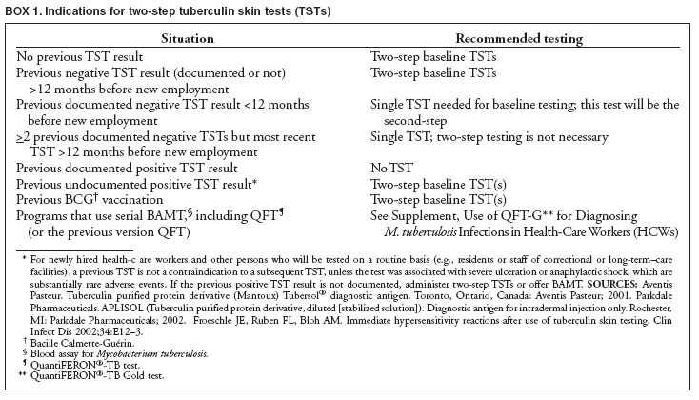

MMWR, December 30, 2005, p. 29

INDICATIONS FOR TWO-STEP TUBERCULIN SKIN TESTS (TSTs)

MMWR Guidelines for Preventing the Transmission of Mycobacterium tuberculosis in Health-Care settings, 2005, p 29.

Page 15 of 55
Core Clinical Service Guide
Section: TB July 1, 2018

  - MANAGEMENT OF TUBERCULOSIS DISEASE

BOX 2. Risk factors for progression of infection to active tuberculosis

Persons at increased risk* for progression of infection to active tuberculosis include

- persons with human immunodeficiency virus (HIV) infection;†
- infants and children aged <5 years;†
- persons who are receiving immunosuppressive therapy such as tumor necrosis factor--alpha (TNF-α) antagonists, systemic corticosteroids equivalent to
≥15 mg of prednisone per day, or immune suppressive drug therapy following organ transplantation;†
- persons who were recently infected with M. tuberculosis (within the past 2 years);
- persons with a history of untreated or inadequately treated active tuberculosis, including persons with fibrotic changes on chest radiograph consistent with prior active tuberculosis;
- persons with silicosis, diabetes mellitus, chronic renal failure, leukemia, lymphoma, or cancer of the head, neck, or lung;
- persons who have had a gastrectomy or jejunoileal bypass;
- persons who weigh <90% of their ideal body weight;
- cigarette smokers and persons who abuse drugs or alcohol; and
- populations defined locally as having an increased incidence of active tuberculosis, possibly including medically underserved or low-income populations

Source: Based on CDC. Targeted tuberculin testing and treatment of latent tuberculosis infection. MMWR 2000;49(No. RR-6).

- Persons with these characteristics have an increased risk for progression of infection to active tuberculosis compared with persons without these characteristics.

† Indicates persons at increased risk for a poor outcome (e.g., meningitis, disseminated disease, or death) if active tuberculosis occurs.

Treatment Algorithm for Culture-Positive Tuberculosis
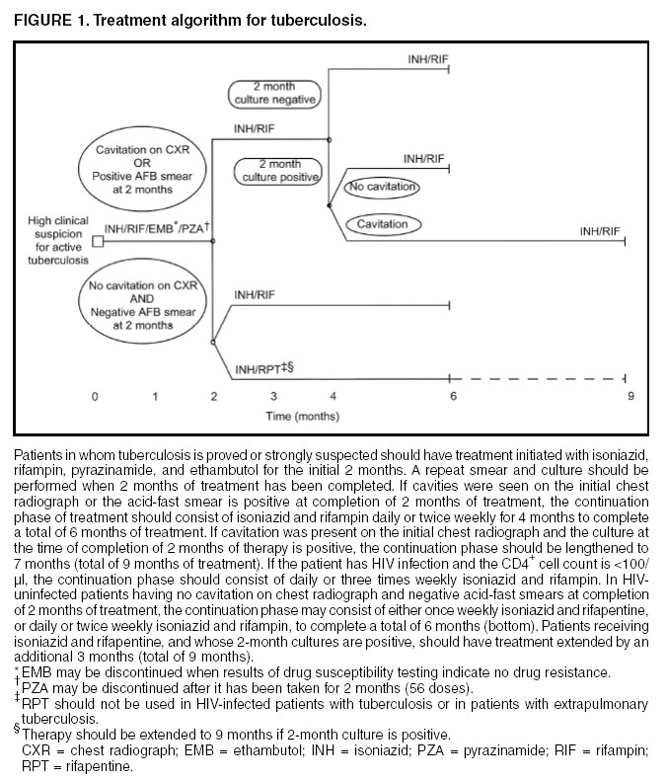

Centers for Disease Control and Prevention. Treatment of Tuberculosis, American Thoracic Society, CDC, and Infectious Diseases Society of America. MMWR 2003;52(No. RR-11): 6.

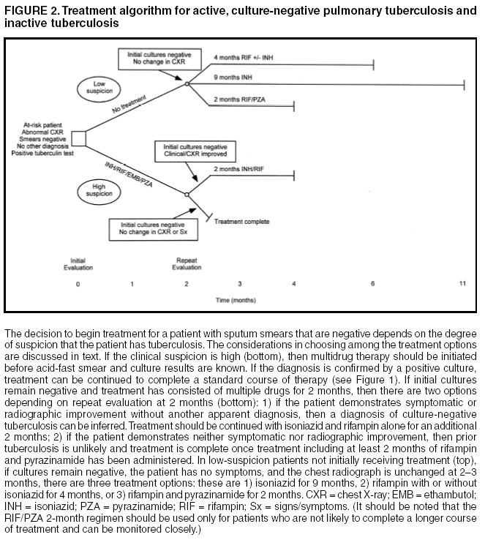
Treatment Algorithm for Active, Culture-negative Pulmonary Tuberculosis and Inactive Tuberculosis

WARNING: Fatal and severe liver injuries have been associated with rifampin (RIF) and pyrazinamide (PZA) for treating LTBI.

CONSULT TB EXPERTS AT SNTC (800-4TB-INFO) BEFORE USING RIF/PZA.

Centers for Disease Control and Prevention. Treatment of Tuberculosis, American Thoracic Society, CDC, and Infectious Diseases Society of America. MMWR 2003;52(No. RR-11): 7.

DIRECTLY OBSERVED THERAPY (DOT)

DOT is a method of ensuring patients’ adherence to therapy. LHD staff must recognize DOT as the Kentucky standard of care. All active TB disease, whether pulmonary or extrapulmonary, shall be treated by DOT. The DOT method must be conveyed with confidence to patients. Always respect the patient’s confidentiality.

The Centers for Disease Control and Prevention (CDC) and the American Thoracic Society (ATS) recommends that all TB patients be considered for DOT because of the difficulty in predicting who will adhere to the treatment regimen.

The following persons must be placed on DOT for treatment of tuberculosis:

  - All patients being treated for suspected pulmonary or extrapulmonary TB.
  - All patients diagnosed with culture positive pulmonary and or extrapulmonary TB.
  - All patients diagnosed as a “clinical case” of pulmonary TB or extrapulmonary TB because of negative TB cultures but who had chest x-ray and / or clinical improvement on antiTB therapy.

DOT means that a specially trained health department health care professional, not related to the patient, watches the patient swallow each dose of TB medication. DOT is never to be delegated to a family member. Kentucky’s TB Control Program does not consider nor count the dosage as DOT if a family observes the patient taking the medication. Such actions could result in prolonged treatment and be considered noncompliance with the DOT agreement.

Be aware of techniques a patient may use to avoid swallowing the medication such as hiding the pills in the mouth, spitting the pills into the fluid used to take them with, or vomiting the pills after leaving the treatment site.

DOT reduces the frequency of treatment failures, of acquiring drug resistance, and in suffering relapse of the disease. Intermittent DOT reduces the total number of doses a patient must take and the number of encounters with LHD personnel. If the patient cannot go to a LHD, LHD staff can arrange another site that is safe, convenient, and agreeable to both patient and staff.

Besides being cost effective, DOT has many other benefits. DOT is a patient-focused service that also provides the health care worker with a better understanding of the patient’s needs, thus placing the worker in position to assist with needed health or social services, and making the appropriate referrals. DOT provides an effective opportunity for education, not only of the patient but also of the patient’s support system. DOT is also advantageous to the community because a patient on DOT becomes noninfectious much more quickly. This reduces the time that a patient is able to spread the disease in the community.

KY V-DOT
Video Directly Observed Therapy

Directly observed therapy (DOT) for tuberculosis increases patient adherence. This increased adherence both reduces the risk of disease recurrence and prevents the development of resistant Mycobacterium tuberculosis strains.

Once the patient has completed eight (8) weeks of medication by DOT (initial phase), video DOT is an option. Video DOT is an option in place of at home/office DOT that local health departments can offer to patients.

During Video DOT, the local health department determines a supply of pre-packaged medication doses that will be given to the patient at each clinic visit. The local health department personnel will arrange a set time for the remote video call with the patient. During the video call, the patient will be expected to display the medications onscreen*. The health worker will then witness the patient swallowing the medication.

All patients participating must agree to the requirements of the Video DOT program and sign a consent form.

*See TB Program teaching sheet TB-14a for Video DOT protocols and consent form TB-14b.

Exclusion Criteria for Video DOT

  - Patient in isolation.

  - Patient with side effects requiring graduated doses.

  - Illegal activities occurring in the home.

  - Video DOT must be accomplished within 15 minutes.

  - Lack of stable environment or lack of telephone at patient location.

  - Less than 90% compliance with therapy during the initial eight (8) weeks of standard DOT.

  - Less than 90% compliance with the treatment regimen or scheduled Video DOT appointments

  - Inability to maintain effective communication via the video call either due to patient disability or language barriers.

  - Inability of the patient to demonstrate effective use of the equipment.

  - MDR TB

DRUG REGIMENS FOR MICROBIOLOGICALLY CONFIRMED PULMONARY TUBERCULOSIS CAUSED BY DRUG-SUSCEPTIBLE ORGANISMS

Preferred Regimen from 2016 Treatment Guidelines:
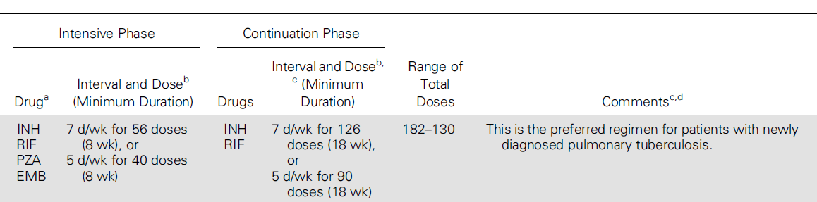

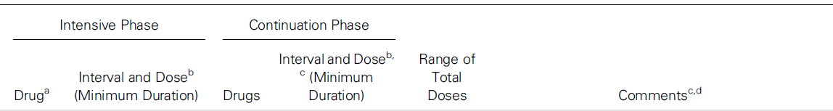
Preferred Alternative Regimen from 2016 Treatment Guidelines;

ATS/CDC/IDSA Clinical Practice Guidelines for Drug-Susceptible TB, Clin Infect Dis. 2016; 63:4

DRUG REGIMENS FOR MICROBIOLOGICALLY CONFIRMED PULMONARY TUBERCULOSIS CAUSED BY DRUG-SUSCEPTIBLE ORGANISMS
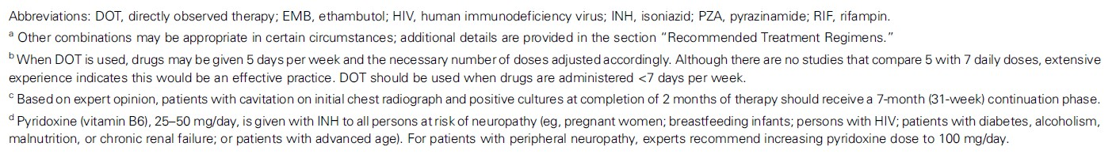
(Continued) Footnotes for 2016 Treatment Regimens on page 21:

Alternative Regimen from 2003 Treatment Guidelines

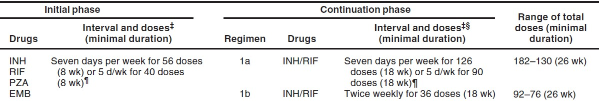

Centers for Disease Control and Prevention. Treatment of Tuberculosis, American Thoracic Society, CDC, and Infectious Diseases Society of America. MMWR 2003;52(No. RR-11): 3.

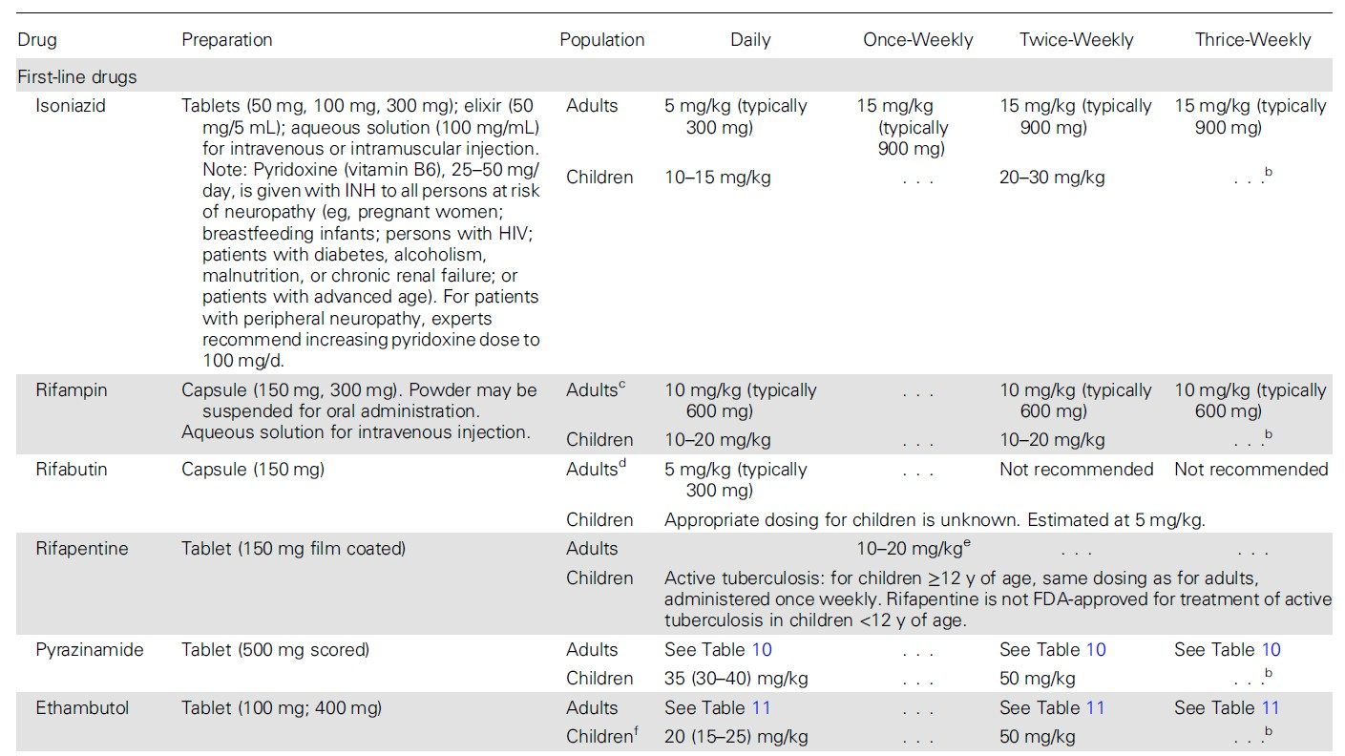

DOSESa OF ANTITUBERCULOSIS DRUGS FOR ADULTS AND CHILDRENb

When using 2016 Treatment Guidelines, Any resistance to first or second line drugs, contact SNTC

ATS/CDC/IDSA Clinical Practice Guidelines for Drug-Susceptible TB, Clin Infect Dis. 2016; 63:5-6

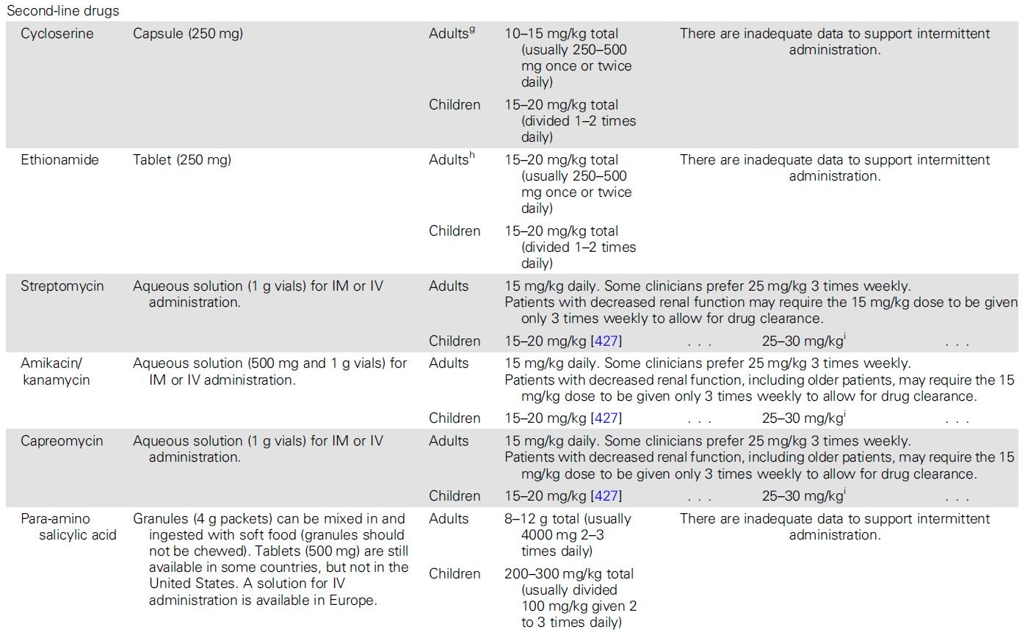

DOSESa OF ANTITUBERCULOSIS DRUGS FOR ADULTS AND CHILDRENb (Continued)

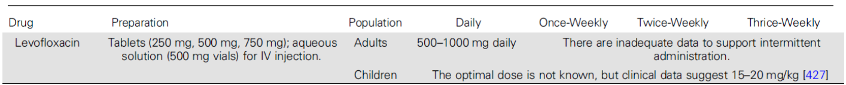
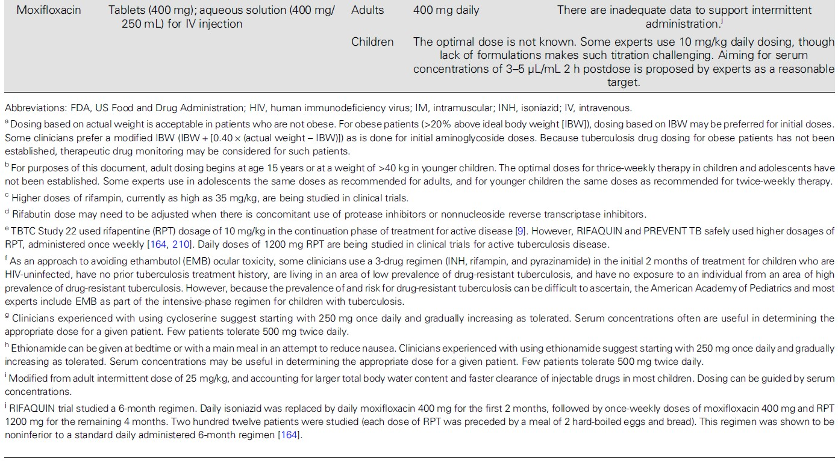
DOSESa OF ANTITUBERCULOSIS DRUGS FOR ADULTS AND CHILDRENb (Continued)

DOSES* OF ANTITUBERCULOSIS DRUGS FOR ADULTS AND CHILDREN†
(Continued)
MMWR, June 20, 2003, p. 5

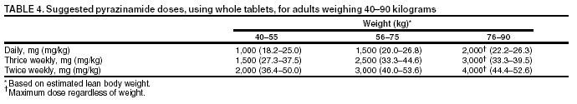

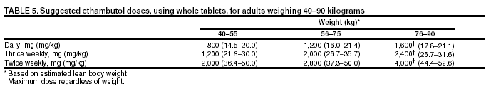

Centers for Disease Control and Prevention. Treatment of Tuberculosis, American Thoracic Society, CDC, and Infectious Diseases Society of America. MMWR 2003;52(No. RR-11): 5.

PYRIDOXINE (VITAMIN B6) SUPPLEMENTATION DURING TREATMENT OF LTBI OR ACTIVE TB DISEASE

Prevention of Peripheral Neuropathy and Central Nervous Symptom Effects of INH Indications for pyridoxine when INH is ordered to treat LTBI or active TB disease:
Adults: Pyridoxine supplementation can be ordered for any adult being treated with INH, unless there is a medical contraindication. Pyridoxine (vitamin B6) supplementation is particularly recommended when INH is used for treatment of LTBI or active TB disease in some adults with medical conditions where peripheral neuropathy is common, such as1, 2, 3:

    - Nutritional deficiencies
    - Diabetes
    - HIV infection
    - Chronic renal failure
    - Alcoholism
    - Persons with seizure disorders
    - Pregnant women
    - Breastfeeding women

Infants, children, and adolescents1, 2, 3, 4, 5, 6: Routine administration of pyridoxine is not recommended for most children and adolescents taking INH4. Pyridoxine is recommended when INH is used for treatment of LTBI or active TB disease in some infants, children, and adolescents at increased risk for peripheral neuritis or other INH adverse effects, such as:

    - Breastfed infants, particularly those who are exclusively breastfed
    - Children and adolescents on meat- and milk-deficient diets
    - Children and adolescents with nutritional deficiencies
    - Children who experience paresthesias while taking isoniazid
    - HIV infection, particularly symptomatic HIV-infected individuals
    - Pregnant adolescents
    - Breastfeeding adolescents

Dose of pyridoxine when INH is ordered to treat LTBI or active TB disease: Adults:
- CDC guidelines – 25 mg/day1
- Wisconsin TB Program guidelines – 10 to 50 mg/day2
- The Harriet Lane Handbook5 – 25 to 100 mg/day

Infants, children, and adolescents:

- The Harriet Lane Handbook5: Child – 1-2 mg/kg/day. Pyridoxine injectable can be compounded with simple syrup to make an oral solution containing 1 mg/mL6.
- 10 mg/day to 25 mg/day1

Prevention of Neurotoxic Effects of Cycloserine (A Second-line TB drug) in Adults: Pyridoxine may help prevent and treat neurotoxic side effects of cycloserine in the treatment of active TB disease and is usually given in a dosage of 100--200 mg/day.1

Recommended Daily Allowances and Recommended Maximum Daily Intake7:
“The daily recommended dietary allowances (RDAs) of vitamin B6 are: Infants 0-6 months, 0.1 mg; Infants 7-12 months, 0.3 mg; Children 1-3 years, 0.5 mg; Children 4-8 years, 0.6 mg; Children 9-13
years, 1 mg; Males 14-50 years, 1.3 mg; Males over 50 years, 1.7 mg; Females 14-18 years, 1.2 mg;
Females 19-50 years, 1.3 mg; Females over 50 years, 1.5 mg; Pregnant women, 1.9 mg; and breast- feeding women, 2 mg. Some researchers think the RDA for women 19-50 years should be increased to 1.5-1.7 mg per day. The recommended maximum daily intake is: Children 1-3 years, 30 mg; Children 4-8 years, 40 mg; Children 9-13 years, 60 mg; Adults, pregnant and breast-feeding women, 14-18 years, 80 mg; and Adults, pregnant and breast-feeding women, over 18 years, 100 mg.”

- Centers for Disease Control and Prevention. Treatment of Tuberculosis. MMWR 2003;52 (No. RR-11),
http://www.cdc.gov/MMWR/PDF/rr/rr5211.pdf
- Centers for Disease Control and Prevention. Targeted Tuberculin Testing and Treatment of Latent Tuberculosis Infection. MMWR 2000;49(No. RR-6), http://www.cdc.gov/MMWR/PDF/rr/rr4906.pdf
- Wisconsin TB Program. “Frequently Asked Questions about Pyridoxine (Vitamin B-6),”
http://www.dhs.wisconsin.gov/tb/resources/guidelines/pyridoxine_faq.pdf
- American Academy of Pediatrics. 2015 Red Book: Report of the Committee on Infectious Disease. Elk Grove
Village, IL: American Academy of Pediatrics, p. 687.
- Robertson J, Shilkofski, N, editors. The Harriet Lane Handbook: A Manual for Pediatric House Officers, 17th
Edition, Elsevier Mosby, 2005 p. 949.
- Nationwide Children’s Hospital, Columbus OH. Pyridoxine Hydrochloride Oral Solution,
http://www.nationwidechildrens.org/Document/Get/79362, accessed Nov 08, 2010.
- National Institutes of Health. Medline Plus: Pyridoxine (Vitamin B6),
http://www.nlm.nih.gov/medlineplus/druginfo/natural/934.html, accessed Nov 08, 2010.

DOSAGE CHART*

Weight in Pounds | Weight in Kilograms | Dosage at 5 mg/kg | Dosage at 10 mg/kg | Dosage at 15 mg/kg | Dosage at 20 mg/kg | Dosage at 25 mg/kg | Dosage at 30 mg/kg
5 | 2.3 | 11.3 | 22.7 | 34.0 | 45.4 | 56.7 | 68.0
10 | 4.5 | 22.7 | 45.4 | 68.0 | 90.7 | 113.4 | 136.1
15 | 6.8 | 34.0 | 68.0 | 102.1 | 136.1 | 170.1 | 204.1
20 | 9.1 | 45.4 | 90.7 | 136.1 | 181.4 | 226.8 | 272.2
25 | 11.3 | 57 | 113 | 170 | 227 | 283 | 340
30 | 13.6 | 68 | 136 | 204 | 272 | 340 | 408
35 | 15.9 | 79 | 159 | 238 | 318 | 397 | 476
40 | 18.1 | 91 | 181 | 272 | 363 | 454 | 544
45 | 20.4 | 102 | 204 | 306 | 408 | 510 | 612
50 | 22.7 | 113 | 227 | 340 | 454 | 567 | 680
55 | 24.9 | 125 | 249 | 374 | 499 | 624 | 748
60 | 27.2 | 136 | 272 | 408 | 544 | 680 | 816
65 | 29.5 | 147 | 295 | 442 | 590 | 737 | 885
70 | 31.8 | 159 | 318 | 476 | 635 | 794 | 953
75 | 34.0 | 170 | 340 | 510 | 680 | 850 | 1021
80 | 36.3 | 181 | 363 | 544 | 726 | 907 | 1089
85 | 38.6 | 193 | 386 | 578 | 771 | 964 | 1157
90 | 40.8 | 204 | 408 | 612 | 816 | 1021 | 1225
95 | 43.1 | 215 | 431 | 646 | 862 | 1077 | 1293
100 | 45.4 | 227 | 454 | 680 | 907 | 1134 | 1361
105 | 47.6 | 238 | 476 | 714 | 953 | 1191 | 1429
110 | 49.9 | 249 | 499 | 748 | 998 | 1247 | 1497
115 | 52.2 | 261 | 522 | 782 | 1043 | 1304 | 1565
120 | 54.4 | 272 | 544 | 816 | 1089 | 1361 | 1633
125 | 56.7 | 283 | 567 | 850 | 1134 | 1417 | 1701
130 | 59.0 | 295 | 590 | 885 | 1179 | 1474 | 1769
135 | 61.2 | 306 | 612 | 919 | 1225 | 1531 | 1837
140 | 63.5 | 318 | 635 | 953 | 1270 | 1588 | 1905
145 | 65.8 | 329 | 658 | 987 | 1315 | 1644 | 1973
150 | 68.0 | 340 | 680 | 1021 | 1361 | 1701 | 2041
155 | 70.3 | 352 | 703 | 1055 | 1406 | 1758 | 2109
160 | 72.6 | 363 | 726 | 1089 | 1451 | 1814 | 2177
165 | 74.8 | 374 | 748 | 1123 | 1497 | 1871 | 2245
170 | 77.1 | 386 | 771 | 1157 | 1542 | 1928 | 2313
175 | 79.4 | 397 | 794 | 1191 | 1588 | 1984 | 2381
180 | 81.6 | 408 | 816 | 1225 | 1633 | 2041 | 2449
185 | 83.9 | 420 | 839 | 1259 | 1678 | 2098 | 2517
190 | 86.2 | 431 | 862 | 1293 | 1724 | 2155 | 2585
195 | 88.5 | 442 | 885 | 1327 | 1769 | 2211 | 2654
200 | 90.7 | 454 | 907 | 1361 | 1814 | 2268 | 2722
205 | 93.0 | 465 | 930 | 1395 | 1860 | 2325 | 2790
210 | 95.3 | 476 | 953 | 1429 | 1905 | 2381 | 2858
215 | 97.5 | 488 | 975 | 1463 | 1950 | 2438 | 2926
220 | 99.8 | 499 | 998 | 1497 | 1996 | 2495 | 2994
225 | 102.1 | 510 | 1021 | 1531 | 2041 | 2551 | 3062
230 | 104.3 | 522 | 1043 | 1565 | 2087 | 2608 | 3130
235 | 106.6 | 533 | 1066 | 1599 | 2132 | 2665 | 3198
240 | 108.9 | 544 | 1089 | 1633 | 2177 | 2722 | 3266
245 | 111.1 | 556 | 1111 | 1667 | 2223 | 2778 | 3334
250 | 113.4 | 567 | 1134 | 1701 | 2268 | 2835 | 3402

*Dosage calculated may have to be adjusted in order not to exceed the maximum dose for any drug being used. Table recalculated in November 2010 with conversion factor of “1 pound = 0.45359237 kilograms.”

Clinically Significant Drug–Drug Interactions Involving the Rifamycinsa
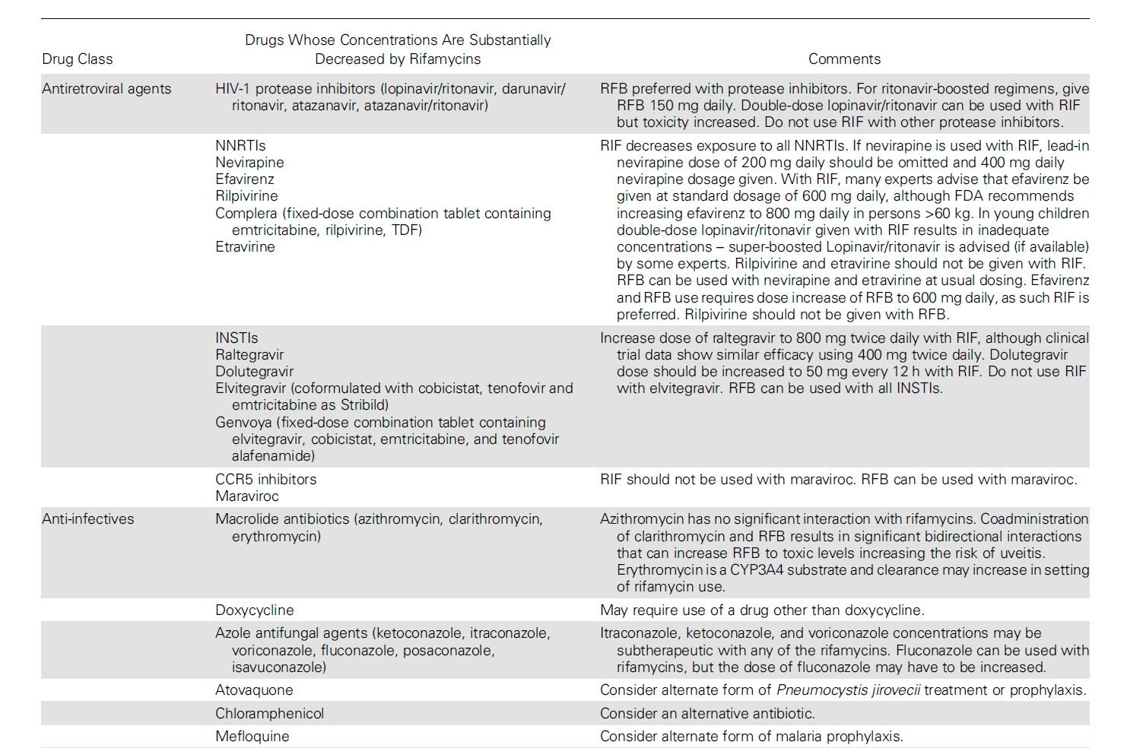

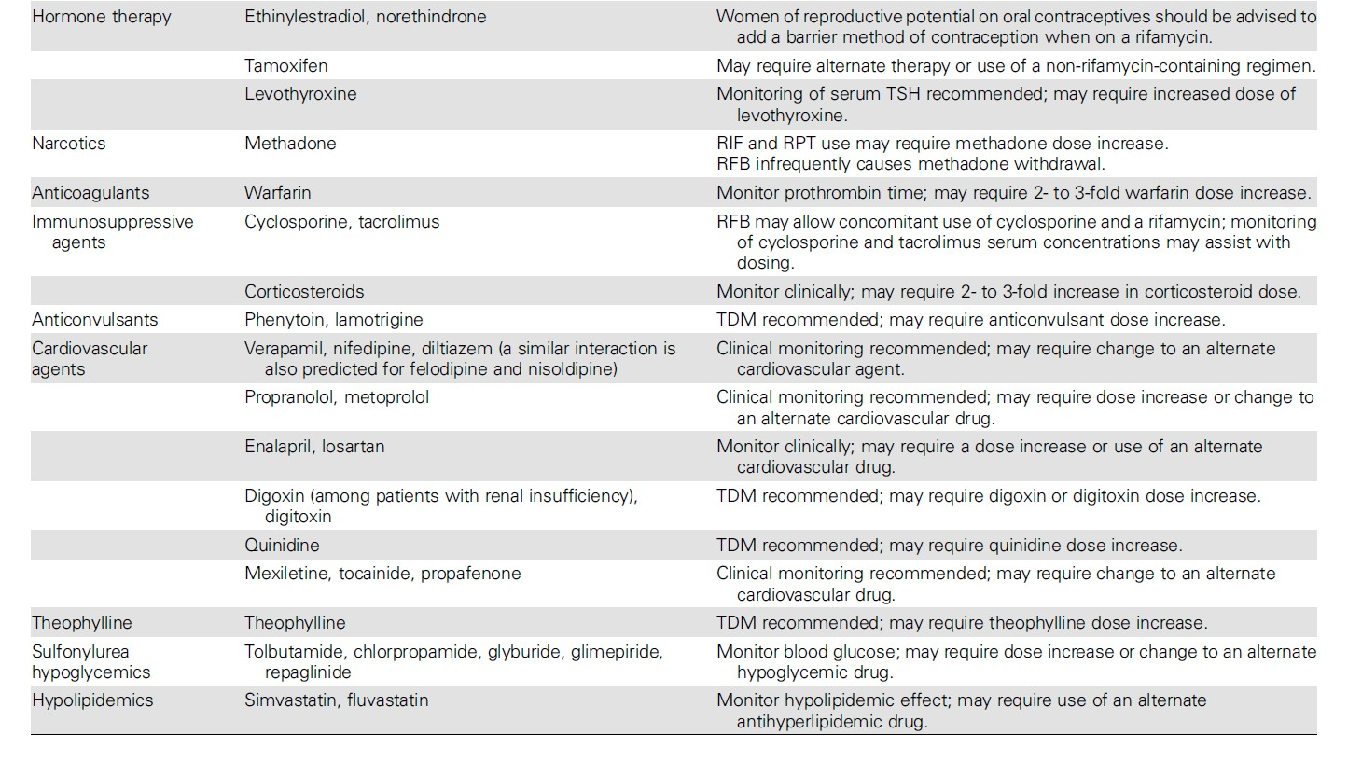
Clinically Significant Drug-Drug Interactions Involving the Rifamycinsa (Continued)

Clinically Significant Drug-Drug Interactions Involving the Rifamycinsa (Continued)

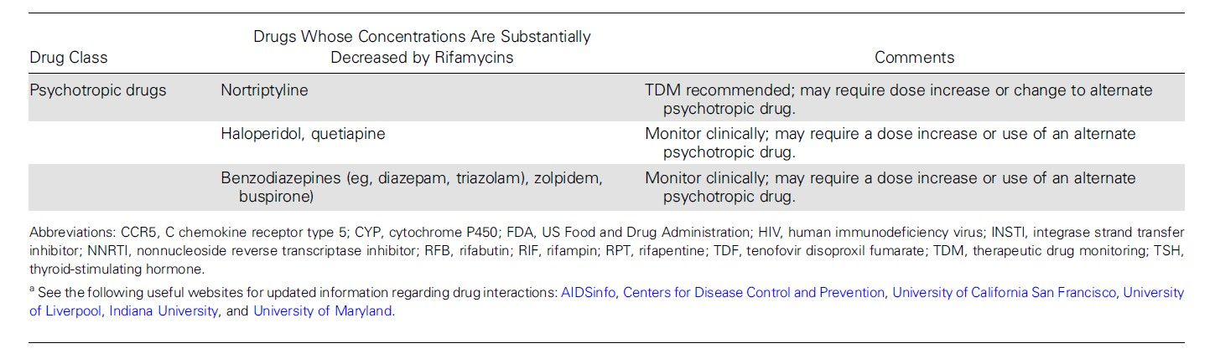

Dosing Recommendations for Adult Patients with Reduced Renal Functiona

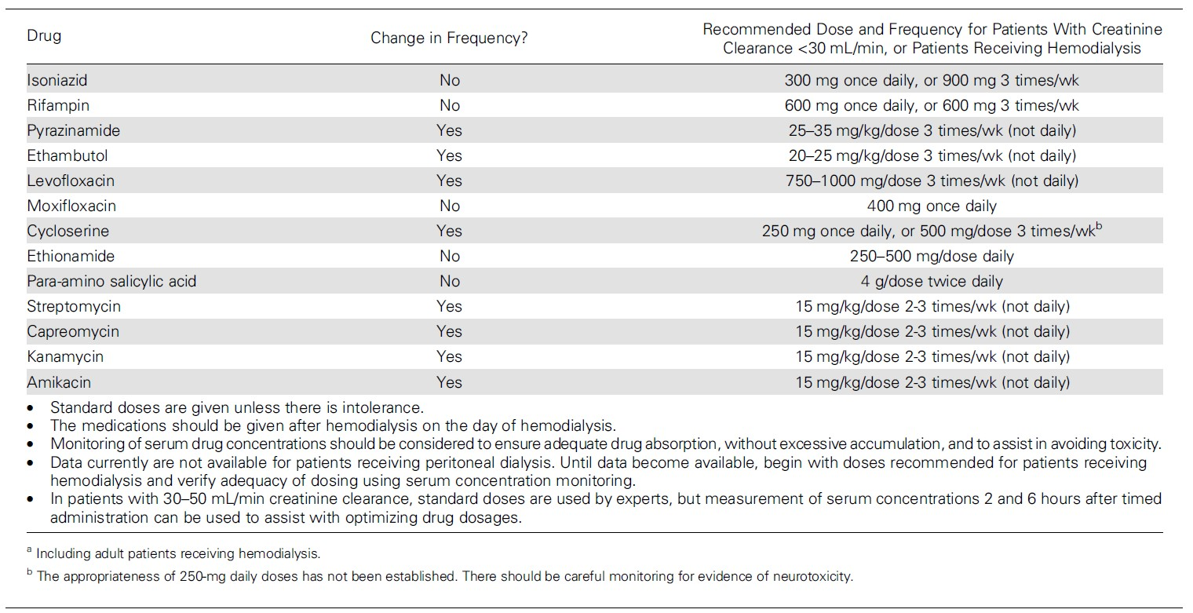

POTENTIAL REGIMENS FOR THE MANAGEMENT OF PATIENTS WITH DRUG-RESISTANT PULMONARY TUBERCULOSIS
WHEN 2003 TREATMENT GUIDELINES ARE USED

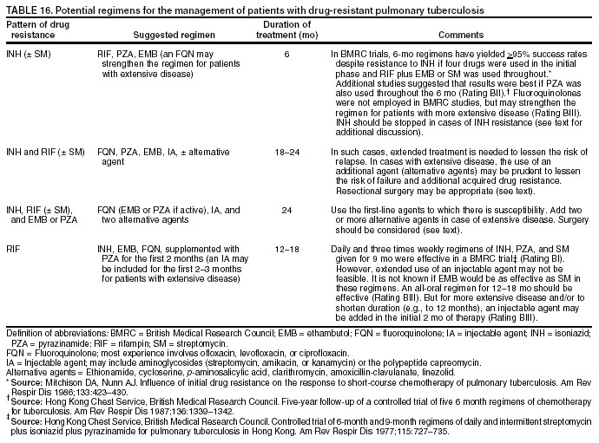
MMWR, June 20, 2003, p. 69

Centers for Disease Control and Prevention. Treatment of Tuberculosis, American Thoracic Society, CDC, and Infectious Diseases Society of America. MMWR 2003;52(No. RR-11): 69.

TB TREATMENT IN SPECIAL SITUATIONS

Treating Culture-Negative Pulmonary TB
Preferred Regimen:  RIF/INH/PZA/EMB (RIPE) | Initial Phase:  RIPE x 2 months 40 (M-F) doses | Continuation Phase:  RIPE x 2 months 40 (M-F) doses
Alternate Regimen:  RIF/INH/PZA/EMB (RIPE) | Initial Phase:  RIPE x 2 months 40 (M-F) doses | Continuation Phase:  RIF and INH x 2 months 40 (M-F) doses

CONSULT TB EXPERTS AT SNTC (800-4TB-INFO) about treatment recommendations for drug-resistant tuberculosis.

Page 35 of 55
Core Clinical Service Guide
Section: TB July 1, 2018

BOX 3. Criteria for determining when, during therapy, a patient with pulmonary tuberculosis (TB) has become noninfectious*

∗ Patient has negligible likelihood of multidrug-resistant TB (no known exposure to multidrug-resistant tuberculosis and no history of prior episodes of TB with poor compliant during treatment).

∗ Patient has received standard multidrug anti-TB therapy for 2–3 weeks. (For patients with sputum acid- fast bacilli [AFB] smear results that are negative or rarely positive, threshold for treatment is 5–7 days.)

∗ Patient has demonstrated complete adherence to treatment (e.g., is receiving directly observed therapy).

∗ Patient has demonstrated evidence of clinical improvement (e.g., reduction in the frequency of cough or reduction of the grade of the sputum AFB smear result).

∗ All close contacts of patients have been identified, evaluated, advised, and, if indicated, started on treatment for latent TB infection. This criterion is critical, especially for children aged <4 years and persons of any age with immunocompromising health conditions (e.g., HIV infection).

∗ While in hospital for any reason, patients with pulmonary TB should remain in airborne infection isolation until they 1) are receiving standard multidrug anti-TB therapy; 2) have demonstrated clinical improvement; and 3) have had three consecutive AFB-negative smear results of sputum specimens collected 8–24 hours apart, with at least one being an early morning specimen. Hospitalized patients returning to a congregate setting (e.g., a homeless shelter or detention facility) should have three consecutive AFB-negative smear results of sputum specimens collected >8 hours apart before being considered noninfectious.

Source: http://www.cdc.gov/MMWR/PDF/rr/rr5412.pdf (Box 3, p 9)

∗ These criteria for absence of infectivity with treatment should be considered general guidelines. Decisions about infectivity of a person on treatment for TB should depend on the extent of illness and the specific nature and circumstances of the contact between the patient and exposed persons.

MANAGEMENT OF TREATMENT INTERRUPTIONS
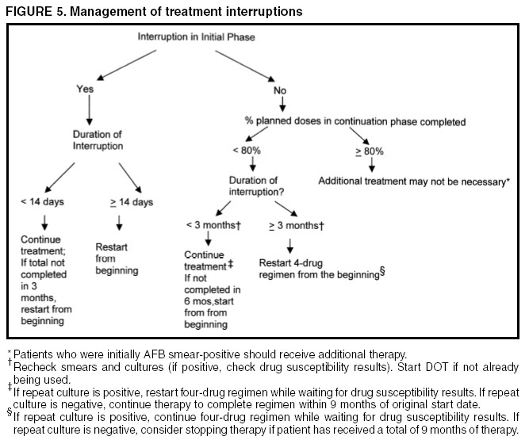
MMWR, June 20, 2003 41

Centers for Disease Control and Prevention. Treatment of Tuberculosis, American Thoracic Society, CDC, and Infectious Diseases Society of America. MMWR 2003;52(No. RR-11): 5.

II. MANAGEMENT OF TB INFECTION

BOX 1. Risk factors for Mycobacterium tuberculosis infection

Persons at increased risk* for M. tuberculosis infection

  - close contacts of persons known or suspected to have active tuberculosis;
  - foreign-born persons from areas that have a high incidence of active tuberculosis (e.g., Africa, Asia, Eastern Europe, Latin America, and Russia);
  - persons who visit areas with a high prevalence of active tuberculosis, especially if visits are frequent or prolonged;
  - residents and employees of congregate settings whose clients are at increased risk for active tuberculosis (e.g., correctional facilities, long-term care facilities, and homeless shelters);
  - health-care workers who serve clients who are at increased risk for active tuberculosis [disease];
  - populations defined locally as having an increased incidence of latent M. tuberculosis infection or active tuberculosis, possibly including medically underserved, low-income populations, or persons who abuse drugs or alcohol; and
  - infants, children, and adolescents exposed to adults who are at increased risk for latent M. tuberculosis infection or active tuberculosis.

Source: Based on CDC. Targeted tuberculin testing and treatment of latent tuberculosis infection. MMWR 2000;49(No. RR-6).

- Persons with these characteristics have an increased risk for M. tuberculosis infection compared with persons without these characteristics.

DIRECTLY OBSERVED PREVENTIVE THERAPY (DOPT) FOR LATENT TB INFECTION

A major step in controlling TB in a community is to make sure that a patient who is being treated for latent TB infection (LTBI) completes a course of treatment. DOPT is the only way to ensure that these patients are adherent to the medication. As Kentucky is experiencing a decline in the number of TB cases, it is time to put a stronger focus on treating latent TB infection.

The Kentucky TB Control Program is advocating that the LHDs provide DOPT to higher risk patients, as well as to children. Children can be the most difficult clients when it comes to taking their medication. By providing DOPT, the health department not only prevents future cases of TB, but also provides a valuable service to families.

Members of the groups below are considered high-risk individuals when it comes to being adherent to taking their medications. If found to have latent TB infection, members of these groups must be placed on DOPT:

  - Children and adolescents
  - Contacts to a case with active TB disease
  - Homeless individuals
  - Persons who abuse substances
  - Persons with a history of treatment non-adherence
  - Immunocompromised patients, especially HIV-infected

MEDICATIONS TO TREAT LATENT TUBERCULOSIS INFECTION: DOSES, TOXICITIES, AND MONITORING REQUIREMENTS
MMWR, June 9, 2000, pp. 28, 29

Oral dose (mg/kg) (maximum dose) Daily Twice weekly*
Drug Adults Children Adults Children Adverse reactions Monitoring Comments

Isoniazid 5
10–20 15
20–40
Rash
Clinical monitoring monthly
Hepatitis risk increases with age and

(300 mg) (300 mg) (900 mg)
(900 mg) Hepatic enzyme
elevation Hepatitis
Peripheral neuropathy
Mild central nervous system effects
Drug interactions
resulting in increased phenytoin (Dilantin) or
Disulfiram (Antabuse)
levels
Liver function tests† at baseline in selected cases‡ and repeat measurements if:
Baseline results are abnormal
Patient is pregnant, in the immediate postpartum
period, or at high risk for
adverse reactions Patient has symptoms of
adverse reactions
alcohol consumption
Pyridoxine (vitamin B6, 10–25 mg/d) might prevent peripheral
neurophathy and central nervous
system effects

Rifampin | 10 10–20 10 | — | Rash | Clinical monitoring at weeks 2, 4, | Rifampin is contraindicated or should
 | (600 mg) (600 mg) (600 mg) |  | Hepatitis | and 8 when pyrazinamide given | be used with caution in human
 |  |  | Fever | Complete blood count, platelets, | immunodeficiency virus (HIV)-
 |  |  | Thrombocytopenia | and liver function tests† at | infected patients taking protease
 |  |  | Flu-like symptoms | baseline in selected cases‡ | inhibitors (PIs) or nonnucleoside
 |  |  | Orange-colored body | and repeat measurements if | reverse transcriptase inhibitors
 |  |  | fluids (secretions, | Baseline results are abnormal | (NNRTIs)
 |  |  | urine, tears) | Patient has symptoms of | Decreases levels of many drugs (e.g.,
 |  |  |  | adverse reactions | methadone, coumadin derivatives,
 |  |  |  |  | glucocorticoids, hormonal
 |  |  |  |  | contraceptives, estrogens, oral
 |  |  |  |  | hypoglycemic agents, digitalis,
 |  |  |  |  | anticonvulsants, dapsone,
 |  |  |  |  | ketoconazole, and cyclosporin)
Might permanently discolor soft contact lenses

Rifabutin | 5  (300 mg)§ | — | 5  (300 mg)§ | — | Rash Hepatitis Fever  Thrombocytopenia Orange-colored body  fluids (secretions,  urine, tears)  With increased levels of rifabutin  Severe arthralgias Uveitis  Leukopenia | Clinical monitoring at Weeks 2, 4, and 8 when pyrazinamide given  Complete blood count, platelets,  and liver function tests† at baseline in selected cases‡  and repeat measurements if  Baseline results are abnormal Patient has symptoms of  adverse reactions  Use adjusted daily dose of rifabutin and monitor for  decreased antiretroviral activity  and for rifabutin toxicity if rifabutin taken concurrently  with PIs or NNRTIs§ | Rifabutin is contraindicated for  HIV-infected patients taking hard-gel saquinavir or delavirdine; caution is  also advised if rifabutin is administered with soft-gel saquinavir  Reduces levels of many drugs (e.g.,  PIs, NNTRIs, methadone, dapsone, ketoconazole, coumadin derivatives,  hormonal contraceptive, digitalis,  sulfonylureas, diazepam, ß-blockers, anticonvulsants, and theophylline)  Might permanently discolor contact  lenses
Pyrazinamide 15–20 |  |  | 50 | — | Gastrointestinal upset | Clinical monitoring at Weeks 2, 4, | Treat hyperuricemia only if patient has
(2.0 g) |  |  | (4.0 g) |  | Hepatitis | and 8 | symptoms
 |  |  |  |  | Rash | Liver function tests† at baseline in | Might make glucose control more

Arthralgias Gout (rare)

*All intermittent dosing should be administered by directly observed therapy.
† AST or ALT and serum bilirubin.
‡ HIV infection, history of liver disease, alcoholism, and pregnancy.
selected cases‡ and repeat measurements if
Baseline results are abnormal Patient has symptoms of
adverse reactions
difficult in persons with diabetes Should be avoided in pregnancy but can be given after first trimester

§ If nelfinavir, indinavir, amprenavir, or ritonavir is administered with rifabutin, blood concentrations of these protease inhibitors decrease. Thus, the dose of rifabutin is reduced from 300 mg to 150 mg/d when efavirenz is administered with rifabutin, blood concentrations of rifabutin decrease. Thus, when rifabutin is used concurrently with efavirenz, the daily dose of rifabutin should be increased from 300 mg to 450 mg or 600 mg. Pharmacokinetic studies suggest that rifabutin might be given at usual doses with nevirapine. It is not currently known whether dose adjustment of rifabutin is required when used concurrently with soft-gel saquinavir. For patients receiving multiple PIs or a PI in combination with an NNRTI, drug interactions with rifabutin are likely more complex; in such situations, the use of rifabutin is not recommended until additional data are available.

QuantiFERON®-TB Gold Plus Test
A blood test for latent tuberculosis infection (LTBI) has been licensed. At this time, the Kentucky State Laboratory is not conducting the test.

QuantiFERON®-TB Gold Plus and T-SPOT®.TB
These two blood assays for Mycobacterium tuberculosis (BAMT) have been licensed by the FDA. At this time, the Kentucky State Laboratory is not performing BAMT tests with either assay.

Centers for Disease Control and Prevention. Targeted tuberculin testing and treatment of latent tuberculosis infection. MMWR 2000;49(No. RR-6):28-29.

Regimen Options for Treatment of Latent TB Infection in HIV-Negative Persons

 | Daily |  | Regimens |  | Twice W | eekly
Drug | Children | Adults |  | Children |  | Adults | Comments
 | Duration | Duration |  | Duration |  | Duration
INH | 9 months | 9 months |  | 9 months |  | 9 months | Minimum of 180 (M-F) or 270 (M-Sun) doses administered within 12 months  Twice-weekly regimens should consist of at least 76 doses administered within 12 months.  Recommended regimen for pregnant women  Contraindicated for persons who have active hepatitis and end- stage liver disease
INH and Rifapentine |  | Once Weekly for 3 months |  |  |  | - | Treatment for:  - Persons 12 years or older  - Must be given by directly observed preventive therapy Once weekly regimen should consist of at least 12 doses  administered within 4 months.  Not recommended for persons who are:  - Younger than 2 years old  - Living with HIV/AIDS taking antiretroviral treatment  - Presumed infected with INH or RIF-resistant M. tuberculosis, and  - Women who are pregnant or expect to become pregnant within the  12-week regimen.

Drug | Regimens |  |  |  | Comments
 | Daily |  | Twice Weekly
 | Children | Adults | Children | Adults
 | Duration | Duration | Duration | Duration
RIF | 4 months | 4 months | Not recommended |  | Minimum of 120 doses administered within 6 months  For persons who are contacts of patients with INH-resistant,  RIF-susceptible TB  May be used for patients who cannot tolerate INH or PZA
WARNING: Fatal and Severe Liver Injuries Have Been Associated With Rifampin (RIF) and Pyrazinamide (PZA) Treatment for LTBI
RIF  and PZA | Not recommended | 2 months | Not recommended | 2 or 3 months | CONSULT TB EXPERTS AT SNTC (800-4TB-INFO) BEFORE USING.  Contraindicated for persons who have active hepatitis and end- stage liver disease. Avoid PZA for pregnant women because of the risk of adverse effects to the fetus.  Minimum of 60 doses to be administered within 3 months.  Twice-weekly regimens should consist of at least 16 doses to be administered for 2 months or 24 doses to be administered for 3 months.  May be used for INH-intolerant patients. This regimen has not been evaluated in HIV-negative persons.

INH – isoniazid, RIF – rifampin, RFB – rifabutin, PZA – pyrazinamide, EMB – ethambutol
 Directly observed treatment of LTBI should be used.
Centers for Disease Control and Prevention, Core Curriculum on Tuberculosis (2013)
Morbidity and Mortality, August 31, 2009, Vol. 50 / No. 34

Regimen Options for Treatment of Latent TB Infection for Persons with HIV Infection

Drug | Regimens |  |  |  |  |  | Comments | Contraindications
 | Daily |  |  | Twice Weekly
 | Children |  | Adults | Children | Adults
 | Duration |  | Duration | Duration | Duration
INH | 9 months |  | 9 months | 9 months | 9 months |  | Minimum of 108 (M-F) or 270 (M-Sun) doses administered within 12 months  Twice-weekly regimens should consist of at least 76 doses administered within 12 months.  INH can be administered concurrently with NRTIs, PIs, or NNRTIs  Directly observed treatment of latent TB infection should be used when twice-weekly dosing is used | History of INH-induced reaction, including hepatic, skin or other allergic reactions, or neuropathy  Known exposure to person who has INH-resistant TB  Chronic severe liver disease
RIF  and PZA* | Not recommended |  | 2 months | Not recommended | 2-3 months |  | Minimum of 60 doses to be administered within 3 months  Twice-weekly regimens should consist of at least 16 doses to be administered for 2 months or  24 doses to be administered for 3 months.  IF RFB is administered, patient should be monitored carefully for potential RFB drug toxicity and potential decreased antiretroviral drug activity.  Dose adjustments, alternative therapies, or other precautions might be needed when rifamycins are used (e.g., patient using hormonal contraceptives must be advised to use barrier methods, and patients using methadone require dose adjustments).  PIs or NNRTIs should generally not be administered concurrently with RIF; in this situation, an alternative is the use of RFB and PZA. | History of a rifamycin-induced reaction, including hepatic, skin or other allergic reaction, or thrombocytopenia  Pregnancy  Chronic severe hyperuricemia Chronic severe liver disease
 |  | WARNING: Fatal and Severe Liver Injuries Have Been Associated With Rifampin (RIF) and Pyrazinamide (PZA) Treatment for LTBI
RFB  and PZA* | Not recommended |  | 2 months | Not recommended | 2-3 months

INH – isoniazid; PZA- pyrazinamide; RFB- rifabutin; RIF- rifampin; DOPT- directly observed preventive therapy; PIs – protease inhibitors; NNRTIs – nonnucleoside reverse transcriptase inhibitors; NRTIs – nucleoside reverse transcriptase inhibitors
*For patients with intolerance to PZA, some experts recommend the use of a rifamycin (RIF or RFB) alone for preventive treatment. Most experts agree that available data support the
recommendation that this treatment can be administered for a short a duration as 4 months, although some experts would treat for 6 months.

PLANNING A CONTACT INVESTIGATION

Confirmed TB Cases:
A contact investigation is required for all confirmed cases that have infectious forms of TB
disease (e.g., TB disease of the lungs, airways, or larynx).

Suspected TB Cases: For suspect cases with AFB-negative sputum smears or sputum smears not performed, the contact investigation process should be started if the case has abnormal chest x-ray findings consistent with TB disease.

For suspect cases with AFB-negative sputum smear results and no pulmonary cavities, a contact investigation should only be considered for certain circumstances, such as if the suspect was identified during an outbreak or source case investigation that included vulnerable or susceptible contacts.

Extrapulmonary TB Disease:
Persons with extrapulmonary TB disease are usually noninfectious unless they also have
pulmonary TB disease, TB disease located in the oral cavity or the larynx, or extrapulmonary disease that includes an open abscess or lesion in which the concentration of organisms is high Pulmonary TB should always be ruled out when there is a diagnosis of extrapulmonary disease.

Initiating a Contact Investigation:
The contact investigation process should be started for persons suspected of having infectious
TB disease, even before confirmation (See “Initial Assessment of Contacts” in this section).Contact Investigations of persons with acid-fast bacilli (AFB)-positive sputum smears, and cavitary TB are assigned the highest priority. However, even if these conditions are not present, contact investigations should be considered if a chest radiograph is consistent with pulmonary TB. A positive result from an approved nucleic acid amplification (NAA) test supports a decision to initiate an investigation. Because waiting for a sputum or respiratory culture result delays initiation of contact investigations, delay should be avoided if any contacts are especially vulnerable or susceptible to TB disease. If it is later determined that the suspect case does not have infectious TB disease, the contact investigation should be stopped.

The Goals of a Contact Investigation:
The goals of a contact investigation are 1) rapid identification of individuals who are high
priority contacts to a known or suspected case of pulmonary, laryngeal, or pleural TB; 2) timely initiation of appropriate treatment for those persons determined to be recently infected or exposed with a significant risk for progression to disease; and 3) identification and treatment of additional individuals found to have suspected TB disease in order to prevent further spread of disease.

Consult the State TB Program if you are planning a contact investigation for more than 10 people
school, college, or large company). For complete guidelines on structuring a contact investigation see the “Guidelines for the Investigation of Contacts of Persons with Infectious Tuberculosis,” MMWR 2005:54 (No. RR-14).

Determining the Infectious Period for a Patient with Active TB Disease

Determining the infectious period for a case with active TB disease focuses the investigation on those contacts most likely to be at risk for infection and sets the timeframe for testing contacts. Because the start of the infectious period cannot be determined with precision by available methods, a practical estimation is necessary. Per CDC guidelines, an assigned start date, that is 3 months before symptom onset or first positive finding consistent with active TB disease, is recommended (Table, p. 50). In certain circumstances, an even earlier start date should be used.
For example, a patient (or the patient's associates) might have been aware of protracted illness (in extreme cases, >1 year). Information from the patient interview and from other sources should be assembled to assist in estimating the infectious period. Helpful details are the approximate dates that TB symptoms were noticed, mycobacteriologic results, and extent of disease (especially the presence of large lung cavities, which imply prolonged illness).

The infectious period is closed when the following criteria are satisfied: 1) effective treatment (as demonstrated by M. tuberculosis susceptibility results) for >2 weeks; 2) diminished symptoms; and 3) mycobacteriologic response (e.g., decrease in grade of sputum smear positivity detected on sputum-smear microscopy). The exposure period for individual contacts is determined by how much time they spent with the index patient during the infectious period. Multidrug- resistant TB (MDR TB) can extend infectiousness if the treatment regimen is ineffective. Any index patient with signs of extended infectiousness should be continually reassessed for recent contacts.

Criteria that are more stringent should be applied for setting the end of the infectious period if particularly susceptible contacts are involved. A patient returning to a congregate living setting or to any setting in which susceptible persons might be exposed should have at least three consecutive negative sputum AFB smear results from sputum collected >8 hours apart (with one specimen collected during the early morning) before being considered noninfectious.

MMWR Guidelines for the Investigation of Contacts of Persons with Infectious Tuberculosis, Recommendations from the National Tuberculosis Controllers Association and CDC, December 16, 2005, Vol. 54, No. RR-15, p 12.

Initial Assessment of Contacts

During the initial contact encounter, which should be accomplished within 3 working days of the contact having been listed in the investigation, the investigator gathers background health information and makes a face-to-face assessment of the person's health. Performing a TB Risk Assessment and administering a TST or drawing blood for a BAMT at this time accelerates the diagnostic evaluation.

The health department record should include:

  - Previous M. tuberculosis infection or active TB disease and related treatment;
  - Contact's verbal report and documentation of previous TST or BAMT results;
  - Current symptoms of active TB disease (e.g., cough, chest pain, hemoptysis, fever, chills, night sweats, appetite loss, weight loss, malaise, or easy fatigability);
  - Medical conditions or risk factors making active TB disease more likely

    - HIV infection
    - Infants and children aged less than five years;
    - Persons who are receiving immunosuppressive therapy such as tumor necrosis
factor--alpha (TNF-α) antagonists, systemic corticosteroids equivalent to ≥15 mg
of prednisone per day, or immune suppressive drug therapy following organ transplantation;
    - Persons recently infected with Mycobacterium tuberculosis (within the past two (2) years;
    - Persons with a history of inadequately treated active TB disease;
    - Persons with silicosis, diabetes mellitus, chronic renal failure, leukemia,
lymphoma, cancer of the head, neck, or lung;
    - Persons who have had a gastrectomy, or jejunoileal bypass;
    - Persons with low body weight (BMI < 19);
    - Cigarette smokers and persons who abuse drugs or alcohol.

  - Mental health disorders (e.g., psychiatric illnesses and substance abuse disorders)
  - Type, duration, and intensity of TB exposure; and
  - Sociodemographic factors (e.g., age, race or ethnicity, residence, and country of birth) (see Data Management and Evaluation of Contact Investigations).

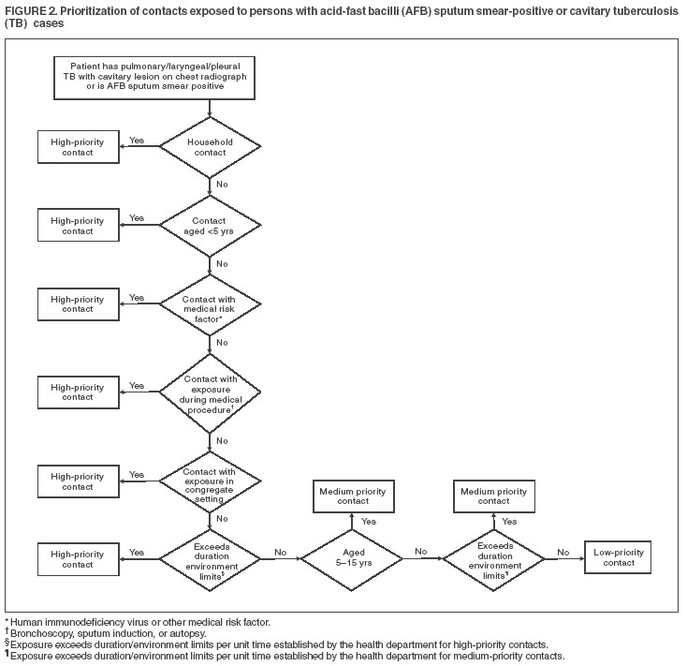
Prioritization of Contacts Exposed to Persons with Acid-Fast Bacilli (AFB) Sputum Smear-Positive or Cavitary Tuberculosis (TB) Cases

Page 47 of 55
Core Clinical Service Guide
Section: TB July 1, 2018

Window-Period Prophylaxis

Primary prophylaxis of high-risk contacts:

Tuberculin skin test results might take 2-10 weeks to become positive after infection with
- tuberculosis. Thus, a contact's initial TST or BAMT result might be negative even if the person is infected. A second TST or BAMT should be performed 8-10 weeks after the contact's last exposure to the infectious patient, so the possibility of LTBI for those persons can be better evaluated. During the 8-10 week window period between a first and second skin test or BAMT, the following contacts with initially negative tuberculin skin test results or negative BAMT results should receive treatment for LTBI after active TB disease has been ruled out by clinical examination and chest radiograph:

  - Contacts aged <5 years (with highest priority given to those aged <3 years) and
  - Contacts with HIV infection or who are otherwise immunocompromised.

If the second TST result is negative (i.e. <5 mm) or the second BAMT is negative, the contact is immunocompetent (including immunocompetent young children) and no longer exposed to an infectious TB case, treatment for LTBI during the window period may be discontinued, and further follow-up is unnecessary.

If the second TST or BAMT result is negative but the contact is immunocompromised (e.g., with HIV infection), and an evaluation for active TB disease is negative, a full course of treatment for LTBI still should be completed.

If the second TST or BAMT result is negative but the person remains in close contact with an infectious TB case, treatment for LTBI should be continued if the contact is:

  - Aged <5 years;
  - Aged 5 through 15 years, at the clinician's discretion; or
  - HIV-infected or otherwise immunocompromised.

The decision to treat individual contacts that have negative skin tests or negative BAMTs should take into consideration two factors:

  - The frequency, duration, and intensity of exposure (even brief exposure to a highly infectious TB patient in a confined space probably warrants the same concern as extended exposure to less infectious TB cases); and
  - Corroborative evidence of transmission from the index patient (e.g. a substantial fraction of contacts having TST or BAMT results classified as “positive” implies infectiousness).

MMWR Guidelines for the Investigation of Contacts of Persons with Infectious Tuberculosis, Recommendations from the National Tuberculosis Controllers Association and CDC, December 16, 2005, Vol. 54, No. RR-15, p 15.

Page 48 of 55
Core Clinical Service Guide
Section: TB July 1, 2018

Evaluation, Treatment, and Follow-Up of Tuberculosis (TB) Contacts Aged < 5 Years
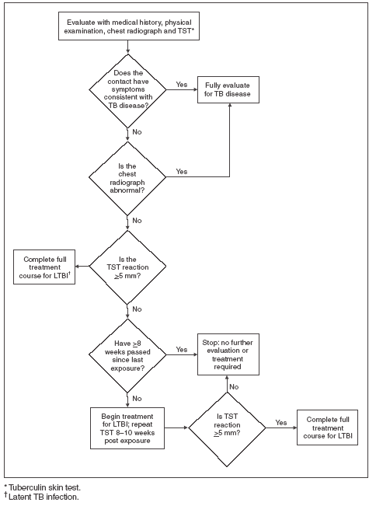
MMWR Guidelines for the Investigation of Contacts of Persons with Infectious Tuberculosis, Recommendations from the National Tuberculosis Controllers Association and CDC, December 16, 2005, Vol. 54, No. RR-15, p 15.

Evaluation, Treatment, and Follow-Up of Immunocompromised Contacts
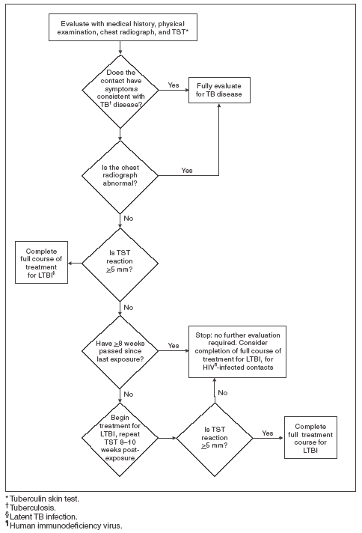

MMWR Guidelines for the Investigation of Contacts of Persons with Infectious Tuberculosis, Recommendations from the National Tuberculosis Controllers Association and CDC, December 16, 2005, Vol. 54, No. RR-15, p 16.

Evaluation, Treatment, and Follow-Up of Contacts with a Documented Previously Positive Tuberculin Skin Test

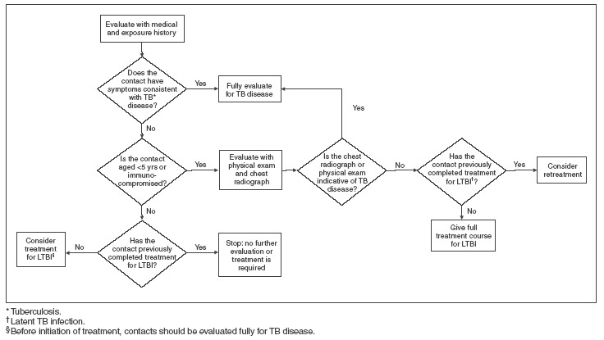

MMWR Guidelines for the Investigation of Contacts of Persons with Infectious Tuberculosis, Recommendations from the National Tuberculosis Controllers Association and CDC, December 16, 2005, Vol. 54, No. RR-15, p 19.

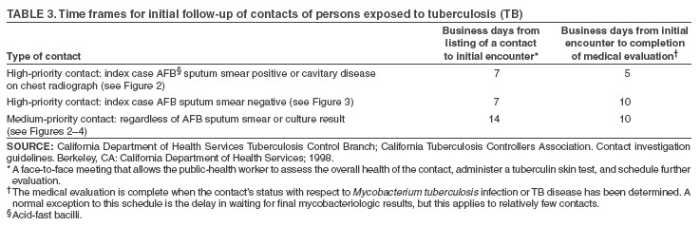

Time Frames for Initial Follow-up of Contacts of Persons Exposed to Tuberculosis (TB)

MMWR Guidelines for the Investigation of Contacts of Persons with Infectious Tuberculosis, Recommendations from the National Tuberculosis Controllers Association and CDC, December 16, 2005, Vol. 54, No. RR-15, p 9.

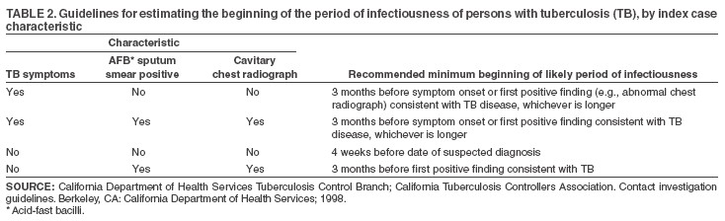
Guidelines for Estimating the Beginning of the Period of Infectiousness of Persons with Tuberculosis (TB), by Index Case Characteristic

MMWR Guidelines for the Investigation of Contacts of Persons with Infectious Tuberculosis, Recommendations from the National Tuberculosis Controllers Association and CDC, December 16, 2005, Vol. 54, No. RR-15, p 7.

REFERENCES

- CDC. Core Curriculum on Tuberculosis: What the Clinician Should Know.
6th Edition. Atlanta, GA: US Department of Health and Human Services, CDC, 2013,
http://www.cdc.gov/tb/education/corecurr/def ault.htm

- CDC Self Study Modules on Tuberculosis (Modules 1 – 5, ) – 2016
CDC Self Study Modules on Tuberculosis (Modules 6 – 9) – 2018
http://www.cdc.gov/tb/education/ssmodules/ default.htm

- Diagnosis of TB in Adults and Children • Clin Infect Dis 2017;64:111-115 https://academic.oup.com/cid/article/64/2/e1/ 2629583/Official-American-Thoracic- Society-Infectious

- Tuberculosis Laws as found in the Kentucky Revised Statues, Chapter 215.511 – 600, http://chfs.ky.gov/dph/epi/tb

- Tuberculosis Regulations:
902 KAR 2:020 – 090 (Surveillance, Control, Detection, Prevention);
902 KAR 20:016 – 200 (Hospital and
Long-Term Care)

- CDC. Treatment of Tuberculosis. MMWR 2003;52(No. RR-11)

- CDC. Recommendations and Reports, Guidelines for Investigation of Contacts of Persons with Infectious TB. MMWR 2005; 54(No. RR-15)

- American Academy of Pediatrics. 2015 Red Book, 30th edition: Report of the Committee on Infectious Disease. Elk Grove Village, IL: American Academy of Pediatrics
- American Thoracic Society/Centers for Disease Control. Diagnostic Standards and Classification of Tuberculosis in Adults and Children. Am J Respir Crit Care Med 1999; 61:1376-95

- CDC Mantoux Tuberculin Skin Testing DVD, 2006,
http://www2c.cdc.gov/podcasts/player.asp?f=
3739 (Podcast) http://www.cdc.gov/tb/education/Mantoux/de fault.htm

- NIOSH Website at:
http://www.cdc.gov/niosh

- CDC. Guidelines for Preventing the Transmission of Mycobacterium tuberculosis in Health-Care Settings 2005. MMWR 2005;54(No. RR-17)

- CDC. Controlling Tuberculosis in the United States. MMWR 2005;54(No. RR-12)

14. Core Clinical Service Guide Forms: http://chfs.ky.gov/dph/Local+Health+De partment.htm

- HIPAA Privacy Rule and Public Health, MMWR, April 11, 2003 / 52;1-12

- Curry International Tuberculosis Center, 2011: Tuberculosis Infection Control: A Practical Manual for Preventing TB, http://www.currytbcenter.ucsf.edu/products/p roduct_details.cfm?productID=WPT-12

- Official American Thoracic Society (ATS)/Centers for Disease Control and Prevention (CDC)/Infectious Diseases Society of America (IDSA) Clinical Practice Guidelines: Treatment of Drug-Susceptible Tuberculosis. Clin Infect Dis. 2016;
63:853-67,
http://cid.oxfordjournals.org/content/63/7/e1 47

CDC TB Guidelines published in MMWR are available online,
http://www.cdc.gov/tb/publications/guidelines/default.htm

World Health Organization Global TB Database Estimated Incidence

This information is listed in the forms and teaching sheets listing of the CCSG at

http://chfs.ky.gov/dph/Local+Health+Department.htm.

