PROTOCOL FOR TUBERCULOSIS

- Each LHD shall have a designated employee responsible for Tuberculosis (TB) services in their county. This person must attend periodic TB updates or keep updated by having the latest educational and scientific materials for the prevention and control of TB from CDC/ATS/ALA, the Southeastern National Tuberculosis Center, and other National Tuberculosis Centers.
- The physician or clinician knowledgeable in the field of mycobacterial diseases shall provide patient care. They shall agree to update themselves through professional meetings, consultations, and review of journal articles. This must be a component of any LHD contract for TB clinician services.

This current classification system of tuberculosis (TB) is based on the pathogenesis of TB. A person with a classification of 3 or 5 should be receiving drug treatment for TB, and should be reported to the LHD.*

Condition | Assessment |  | Education | Follow-up
Classification 0  No TB Exposure  Not Infected | TB Risk Assessment with targeting testing of persons in at-risk groups  Persons at Increased Risk for Mycobacterium tuberculosis Infection  - Close contacts of a person known or suspected to have active TB disease  - Foreign-born persons, including children who have immigrated within the last 5 years from areas where TB is prevalent**  A two-step TST is usually recommended initially for:  Anyone required to have regular TB testing, regardless of age  BAMTs are one-step in-vitro tests that assess for the present of infection with M. tuberculosis.  - Persons who visits areas with a high TB prevalence, especially if visits are frequent or prolonged  - Residents and employees of high-risk congregate settings  - Health care workers (HCWs) who serve high-risk clients  - Medically underserved, low income populations, homeless  - High-risk racial or ethnic minority populations  - Persons who abuse drugs or alcohol  See TST Recommendations for Infants, Children, and Adolescents, p 11 in this reference  - Infants, children, and adolescents exposed to adults at high-risk for latent TB infection or active TB disease | Complete TB Risk Assessment prior to tuberculin skin test (TST) or blood assay for Mycobacterium tuberculosis (BAMT) for all classifications. TSTs are preferred for children aged less than five years.  See procedure for TST in this reference. Review CDC TST Video, 2003  Tuberculin skin test (TST)  with Purified Protein Derivative (PPD) using the Mantoux method (use Tubersol antigen)  The TST must be given and read by a nurse per Kentucky Board of Nursing | Educate on signs and symptoms of active TB disease, risk factors for Latent TB Infection (LTBI), and risk factors for rapid progression from LTBI to active TB disease  Two-step TST:  - If first step TST is positive, consider the person infected.  - If first step TST is negative, give the second step TST  1–3 weeks later.  - If second step TST is positive, consider person infected.  - If second step TST is negative, consider person uninfected.  BAMT reported as positive, consider person infected. | Some groups may need annual TB Risk Assessments. Some groups, e.g. HCWs may need annual TSTs or BAMTs in addition to annual TB Risk Assessments.  All testing activities should be accompanied by a plan for follow-up care.  Patients should return in 48–72 hours for TST reading, interpretation, and recording by nurse.  Anergy Suspects  Do not rule out TB diagnosis based on negative skin test result; consider anergy if immunosuppressed; also see other diseases/conditions that can cause suppression of delayed-type hypersensitivity (DTH) response.  Delayed type hypersensitivity (DTH) antigen tests are not recommended for administration at LHDs.
* See Core Curriculum on Tuberculosis (2011) for TB Classification System. **See tables with international TB incidence and prevalence rates in this reference for more information.
MMWR, Targeted Tuberculin Testing and Treatment of Latent Tuberculosis Infection, June 9, 2000
PROTOCOL FOR TUBERCULOSIS
(Continued)

Condition | Assessment |  | Education | Follow-up
Classification 0  (Continued)  No TB Exposure  Not Infected | Groups that should be TB Tested  (Continued)  Persons at higher risk for developing active TB disease once infected  - Persons with HIV infection  - Infants and children aged less than five (5) years  - Persons recently infected with Mycobacterium tuberculosis (within the past two (2) years.  - Cigarette smokers and persons who abuse drugs or alcohol  Persons with HIV infection  Persons who are receiving immunosuppressive therapy such as tumor necrosis factor--alpha (TNF-α) antagonists, systemic corticosteroids equivalent to ≥15 mg of prednisone per day, or immune suppressive drug therapy following organ transplantation  Silicosis  Diabetes mellitus  Chronic renal disease  Certain hematologic disorders (leukemias and lymphomas)  Cancer of the head, neck, or lung  Gastrectomy or jejunoileal bypass  People receiving immunosuppressive therapy for rheumatoid arthritis or Crohn’s disease  Low body weight (BMI < 19)  - Persons with a history of inadequately treated TB  - Persons with certain medical  conditions  Examples of groups that are not included in the MMWR, June 19, 2000, Targeted Testing are:  Foster care parents, day care workers, firefighters, police, school employees, school children, and food service workers.  Members of these groups should receive individual TB risk assessments, and targeted tuberculosis testing so that TSTs or BAMTs are administered to those at increased risk. | Develop a policy that the LHD will repeat TSTs given by other health care providers not trained by the LHD unless their skill is known and trusted by the LHD.  LHDs DO NOT need a similar policy for repeating BAMTs.  TSTs administered by LHDs can be read by staff in other LHDs and do not usually need to be repeated.

PROTOCOL FOR TUBERCULOSIS
(Continued)

Condition | Assessment | Treatment | Education | Follow-up
Classification 1  TB Exposure (contact), no evidence of infection | Identify contacts within 3 workdays of suspect/case report, using prioritization and the Concentric Circle Approach (p. 44).  Administer TST or draw blood for BAMT and Examine high-risk contacts within 7 workdays of identification (See pages 38 and 49)  Give TST or draw blood for BAMT for medium and low-risk contacts based on findings from the Concentric Circle Approach (See pages 44 and 49)  Do the following:  - Medical History  - TST or BAMT (unless there is previously documented positive reaction)  - Chest x-ray, at the same time those who:  - Have TB symptoms  - Are HIV infected or have other immunosuppressed conditions  - Are < 4 years of age  Posterior–Anterior (PA) chest  x-ray is the standard view used to detect abnormalities  PA and lateral view should be done on those < 5 years of age  Targeted Testing, page 25  If symptomatic, see sputum collection recommendations in this reference and in the TB Forms chapter of the PHPR | Infants and Children <5 years of age, who are high priority contacts and who have a negative TST or negative BAMT, should be started on window period prophylaxis, with therapy administered by Directly Observed Preventive Therapy (DOPT) until retested in 8-10 weeks.  If repeat TST or BAMT is positive, continue medicines by DOPT (see classification 2)  If repeat TST or BAMT is negative, stop medicine unless contact with infectious case has not or cannot be broken.  Contacts with immunocompromising conditions (e.g. HIV-infected) that have a negative TST or negative BAMT should be started on window prophylaxis therapy by DOPT until retested in 8-10 weeks. If the repeat TST or BAMT remains negative, and an evaluation for active TB disease is negative, a full course of treatment for LTBI should still be completed.  See Medications to Treat LTBI in this reference | Discuss:  - How TB is transmitted  - LTBI versus active TB disease  - Importance and significance of repeat skin test in 8-10 weeks  - Treatment of active TB disease or LTBI  - Importance of taking medicine on a regular basis if indicated  Steps for patient producing a sputum specimen at home:  - Clean & thoroughly rinse mouth with water  - Breathe deeply 3 times  (a tickling sensation at end of breath)  - After 3rd breath, cough hard & try to bring up sputum from deep in lungs  - Expectorate sputum into a sterile container collecting at least one teaspoonful  - Perform this in a properly ventilated room, booth, or outdoors  Provide patient information for an informed consent (also cover HIV testing–see PHPR) | If TST or BAMT is negative, must return  8–10 weeks after contact has been broken, for repeat TST or BAMT.  To avoid difficulty with test interpretation in a contact investigation, the follow-up TB test method for a particular contact, whether TST or BAMT, should preferably be the same test method used for the first TB test. Use of the same test method for repeat testing will minimize the number of conversions that occur as a result of test differences.

Self-Study Modules on Tuberculosis, Contact Investigation for Tuberculosis, CDC Core Curriculum on Tuberculosis (2011)
MMWR, Targeted Tuberculin Testing and Treatment of Latent Tuberculosis Infection, June 9, 2000
PROTOCOL FOR TUBERCULOSIS
(Continued)

Condition | Assessment | Treatment | Education | Follow-up
Classification 2  Infection without active TB disease  - Positive TST  (mm induration) or positive BAMT  - Negative bacteriological studies (if done)  - No clinical bacteriological or radiographic evidence of active TB disease. | Candidates for treatment of LTBI  - See TST reaction classification or guidelines for BAMTs, this reference  - Careful assessment to rule out active TB disease is necessary before treatment for LTBI is started  - Immediately get a chest x-ray for patients with symptoms AND a positive TST or positive BAMT  - Others should be given a chest  x-ray as soon as possible. When TB disease is ruled out, treat for LTBI if indicated.  - If chest x-ray abnormal, obtain sputum’s, and consider as a suspect case  - Determine history of prior treatment for LTBI or active TB disease  - Determine if there are any medical conditions that are contraindications to treatment or would increase risk of adverse reactions  - Provide HIV counseling, testing, and referral. If HIV test is refused, reoffer HIV testing monthly while on LTBI treatment.  Baseline hepatic measurements recommended for:  - Patients whose initial evaluation suggests a liver disorder or regular use of alcohol  - Patient with HIV infection  - Pregnant women and those in immediate post-partum period (3 months, especially Black and Hispanic women)  - Patients with history of chronic liver disease (e.g., hepatitis B or hepatitis C) | See LTBI regimens in this reference  The following groups are considered to be high-risk individuals when it comes to being adherent to taking their medications. If found to have LTBI, these groups should be placed on Directly Observed Preventive Therapy (DOPT):  - Children and adolescents  - Contacts to a case with active TB disease  - Homeless individuals  - Persons who abuse substances  - Persons with a history of treatment  non-adherence  - Immunocompromised patients,  especially HIV-infected  For any other persons, DOPT should be used if LTBI treatment is ordered twice weekly (See pages 30 and 31). Call the Kentucky TB Program to discuss twice weekly treatment of LTBI. | Establish rapport with patient and emphasize:  - Benefits of treatment  - Importance of adherence to treatment regimen  - Possible adverse side effects of medicine(s)  - When to stop medication and call the local health department (LHD)  - HIV testing with pre- and post-test counseling  Directly Observed Preventive Therapy (DOPT) for LTBI is recommended for any at risk adults who cannot or will not reliably self-administer drugs  ATTENTION: Medical providers should order daily INH for nine months, administered by DOPT, to treat LTBI in children and adolescents, unless medically contraindicated.  Call the KY TB Program to discuss treatment of LTBI in children and adolescents. | Baseline laboratory testing  - Not routinely indicated  During the course of therapy:  At least monthly, a LHD licensed medical or nursing professional must evaluate for:  - Adherence to prescribed regimen  - Signs/symptoms of active TB disease  (See Classification 3, page 5)  Chest x-ray not recommended at the completion of routine LTBI treatment
Centers for Disease Control and Prevention, Core Curriculum on Tuberculosis (2011)
Targeted Tuberculin Testing and Treatment of Latent Tuberculosis Infection, MMWR, June 9, 2000

PROTOCOL FOR TUBERCULOSIS
(Continued)

Condition | Assessment | Treatment | Education | Follow-up
Classification 3  TB disease, clinically active  Tuberculosis Case Definition:  Positive Lab Test  Mycobacterium tuberculosis culture  M. tuberculosis complex demonstrated in Nucleic Acid Amplification (NAA) test or PCR test  -or-  Clinical Case:  - Positive TST or positive BAMT  - Abnormal changing chest x-ray or clinical evidence of disease  - Placed on 2 or more antitubercular antibiotic drugs  - Completed diagnostic evaluation  Kentucky endorses the 4 drug TB antibiotic therapy initially | See Contact Investigation and the Concentric Circle approach in this reference  Should be seen by local health department (LHD) physician as soon as possible if LHD is supplying TB medications  Case Management  - Assignment of responsibility  - Systematic regular review  - Plans to address barriers to adherence  - Provide HIV counseling, testing, and referral. If HIV test is refused, reoffer HIV testing monthly while on treatment for active TB disease.  Adherence  - Non adherence is a major problem in TB control  - Use case management and directly observed therapy (DOT) to ensure patients complete treatment. If more than 3 doses are missed, contact KY DPH TB staff.  - Initially order AST, ALT, Bilirubin, Alkaline phosphatase, serum creatinine, and platelets for adults. Visual acuity and color vision as baseline if on EMB, question vision status monthly  - Obtain baseline weight and monitor weights monthly  Determine the Patient’s clinical condition:  - Immediately if not hospitalized  - Within 3 days of notification if hospitalized (best to visit in hospital)  - Basic physical exam done within 7 days of notification | Basic Principles of Treatment:  - Provide safest, most effective therapy in shortest time  - Multiple drugs to which the organisms are susceptible  - Never add single drug to failing regimen  - Ensure adherence to therapy  - DOT is the standard of care for all cases of active TB disease  Management of HIV related active TB disease is complex; care should be provided by a consultant expert in both HIV and TB  Pregnant Women  - 9 month regimen - RIF, INH, and EMB  - SM is contraindicated  - In HIV-positive pregnant women, consult an expert, (SNTC Hotline  1-800-4TB-INFO) Notify the State TB Program about the prescribed regimen.  Infants  Treat as soon as tuberculosis is suspected.  See regimens in this reference for treatment of adults, children, and those with extrapulmonary tuberculosis  Tuberculosis caused by Drug Resistant Organisms  Treatment should be done by, or in close consultation, with an expert in the management of these difficult situations  Vitamin B6 10–25mg for those with certain conditions (e.g. HIV infection) | Instruct patient about:  - Active TB disease and how it is spread  - Importance of taking medications on a regular basis  - Medication side effects and instructions to immediately report adverse reactions  - Proper times and way to collect/mail sputum specimens  - The taking of other medications and the potential risks of drug interactions  - Importance of good nutrition  - Tobacco cessation and nicotine replacement therapy  Confinement and/or restriction of activities must be addressed (TB Control Law, KRS 215.540)  KRS 215.531 states drug susceptibility test on initial TB isolates from patient with active TB disease must be ordered by the physician  Ensure that all initial positive TB cultures from independent labs have drug susceptibility studies ordered by private physicians | - Monitor for Adverse Reactions  - See Recommendations for Sputum Collection (p. 7 & PHPR TB Forms)  - Chest x-rays initially, at 2 months after starting therapy, and at 0 to 60 days after completion of therapy. Clinical cases also need chest x-ray after 2 months of multiple drug therapy  - All efforts to follow-up must be documented in the patient’s chart  - A home visit must be done  - Consult with DPH if the patient’s status changes while on treatment  See Kentucky TB Control Law KRS 215  Directly Observed Therapy (DOT)  - Health care worker watches patient swallow each dose of medication  - DOT shall be the Kentucky standard of care for all cases of active TB disease  - DOT must be used with all intermittent regimens  - DOT can lead to reductions in relapse and acquired drug resistance  - Use DOT with other measures to promote adherence  - Court ordered DOT may be necessary  - See DOT in this reference  TB isolate from all specimens with a positive TB culture shall be sent to the Kentucky Department of Laboratory Services (DLS) for drug susceptibility and genotyping tests. LHD TB staff shall contact hospital labs, independent labs, or national reference labs to coordinate shipment of TB isolate to DLS.
Centers for Disease Control and Prevention, Core Curriculum on Tuberculosis (2011)
PROTOCOL FOR TUBERCULOSIS
(Continued)

Condition | Assessment | Treatment | Education | Follow-up
Classification 4 | TB no longer clinically active |  | Teach patient signs and symptoms of possible recurrence of active TB disease
Classification 5 | TB suspected. Diagnosis pending. Should not have this classification for more than three (3) months  Results of a positive Nucleic Acid Amplification (NAA) test, e.g. Gen-Probe, on a sputum sample can help determine active TB disease with Mycobacterium tuberculosis (MTB) | If NAA test on sputum is positive, treatment should begin with a 4-drug regimen until TB is ruled out | Teach patient signs and symptoms of possible recurrence of active TB disease. | As indicated

Centers for Disease Control and Prevention, Core Curriculum on Tuberculosis (2011)

_________________________________________________ _______________________
M.D. Signature Date
(review and sign annually)

Recommendations for Sputum Collection

Purpose | Frequency | Number of Specimens
Baseline for TB suspects | Initial | 3 samples that are collected 8 – 24 hours apart. Recommend at least one sample collection be observed by health care worker.  Obtain sputum samples BEFORE initiating tuberculosis therapy.
NAA testing should be performed on at least one respiratory specimen from each patient with signs and symptoms of pulmonary TB for whom a diagnosis of TB is being considered but has not yet been established, and for whom the test result would alter case management or TB control activities.*
Monitoring for smear conversion  (AFB Smear positive  Culture positive)  (Request that state lab do smears only) | Every 2 weeks after 2 weeks of therapy have been completed,  until 3 consecutive AFB smears are negative  After 2 months of uninterrupted therapy  Note: 3 negative smears are required per 902 KAR 20:200 and 902 KAR 20:016 | 1 sample – Recommend collection be observed by health care worker  3 samples on consecutive days. Recommend collection be observed by health care worker  If still positive, treatment regimen must be  re-evaluated
Monitoring during treatment for culture conversion  (AFB Smear negative  Culture positive) | Monthly until 2 consecutive specimens are negative on culture | 3 samples on consecutive days. Recommend at least one be observed by health care worker  - Patients who have positive cultures after  4 months of treatment should be treated as treatment failures (MMWR, June 20, 2003)
Monitoring after culture conversion to negative  (or a clinical case) | Monthly until treatment is completed. Patient may not be able to produce sputum at this point | 1 sample. Recommend collection be observed by health care worker  Frequency of collections may be increased if there is a recurrence of symptoms or treatment interruption. Patients with MDR-TB or HIV infection and TB may require additional sputum testing to monitor their clinical course  Send specimens to the state lab and instruct private hospitals and physicians to use the state lab
Obtain three (3) consecutive sputum samples for any patient who has evidence of worsening clinical signs / symptoms of active TB disease (i.e. new cough, hemoptysis, fever, sweats, or worsening chest x-ray findings)**

Source: *MMWR 2009; 58(01):7-10
**SNTC Clinical Consultation – July 2010

Managing Laboratory Data

- The LHD will ensure that all culture positive pulmonary and extrapulmonary Mycobacterium tuberculosis isolates from outside laboratories are sent to the State Laboratory for drug susceptibility and genotype testing.

- The LHD will ensure that copies of sputum positive TB culture results, positive TB culture results from any other body site, and positive Nucleic Acid Amplification tests (e.g. MTD positive results and PCR positive results) from outside laboratories will be sent to the State TB Prevention and Control Program.

- It is the responsibility of the LHD to ensure that drug susceptibility testing is performed on initial culture positive pulmonary and extrapulmonary TB isolates. Send a copy of the laboratory report about drug susceptibility testing to the State TB Prevention and Control Program. Outside laboratories that report culture positive pulmonary and extrapulmonary TB isolates may need an additional physician order to perform drug susceptibility testing.

- It is recommended that all sputum samples be sent to the State Lab for testing.

PROCEDURE FOR
THE MANTOUX TUBERCULIN SKIN TEST

Tuberculin skin testing is the standard method of identifying persons infected with tuberculosis. The intradermal Mantoux tuberculin skin test (TST)—not a multiple puncture test—should be used to determine if tuberculosis infection has occurred.

The Mantoux TST is performed by the intradermal injection of 0.1 mL of PPD tuberculin containing 5 TU (tuberculin units) into either the volar (flexor) or dorsal surface of the forearm (the volar area preferred). The injection should be made about 4 inches below the elbow, with a disposable tuberculin syringe, just beneath the surface of the skin, with the needle bevel facing upward, to produce a discrete, pale elevation of the skin (a wheal) 6 mm. to 10 mm. in diameter. A one-quarter-to one-half-inch, 27- gauge needle should be used.

A TST can be administered to individuals of any age who are at increased risk for acquiring LTBI or active TB disease, even to newborn infants.

Standard precautions pertaining to blood exposure and prevention of needle stick injuries should be employed.

The Mantoux TST should be read 48 to 72 hours after the injection. However, if the patient fails to show up for the scheduled reading, positive reactions may still be measurable up to one week after testing. If, however, the delayed reading after 72 hours is negative, any reaction may have waned, and the TST will need to be repeated immediately and read within 48 to 72 hours. The TST reading should be based on measurement of induration, not erythema, using a Mantoux skin test ruler. The diameter of induration should be measured transversely to the long axis of the forearm and recorded in millimeters. Record no induration as zero (0) millimeters.

A negative TST result does not exclude LTBI or active TB disease.

Measure TSTs Transversely

* ATS, Diagnostic Standards and Classification of Tuberculosis in Adults and Children.
Am. J. Respir. Crit. Care Med., 4/00, pages 1388-1389

CLASSIFYING THE TUBERCULIN SKIN TEST REACTION

_{5 or More Millimeters} | _{10 or More Millimeters} | _{15 or More Millimeters}
≥ 5 mm is classified as positive in:  - _{HIV-positive persons}  - Recent contacts of a case with active TB disease  - People who have previously had active TB disease  - Persons with fibrotic changes on chest radiograph consistent with old healed TB  - Patients with organ transplants and other immunosuppressed patients (including patients taking a prolonged course of oral or intravenous corticosteroids or tumor necrosis factor alpha (TNF-alpha) antagonists) | ≥ 10 mm is classified as positive in:  - People who have come to the U.S. within the last 5 years from areas of the world where TB is common *  - _{Injection drug users}  - People who live or work in high-risk congregate settings  - Mycobacteriology laboratory personnel  - _{Children younger than 4 years}  - Infants, children, and adolescents exposed to adults in high-risk categories**  - Persons with clinical conditions that place them at high-risk for TB (silicosis, diabetes mellitus, severe kidney disease, certain types of cancer, and certain intestinal conditions) | ≥ 15 mm is classified as positive in:  - Persons with no known risk factors for TB  - Targeted skin testing programs should only be conducted among high-risk groups
A tuberculin skin test conversion is defined as an increase of ≥ 10 mm of induration within a 2-year period, regardless of age.
ATS Diagnostic Standards and Classification of Tuberculosis in Adults and Children. Am. J. Respir. Care Med., 4/00
Core Curriculum on Tuberculosis; What the Clinician Should Know (2011).
*See tables with international TB incidence and prevalence rates in this reference for more information.
**According to Red Book, 2009, >10 mm induration is considered positive for children with increased exposure to adults who are
HIV-infected, homeless, users of illicit drugs, residents of nursing homes, incarcerated or migrant farm workers, p. 680.

“TUBERCULIN SKIN TEST (TST) RECOMMENDATIONS

FOR INFANTS, CHILDREN, AND ADOLESCENTS¹

Children for whom immediate TST or IGRA is indicated²:
- Contacts of people with confirmed or suspected contagious [active] tuberculosis [disease] (contact investigation)
- Children with radiographic or clinical findings suggesting [active] tuberculosis disease
- Children immigrating from countries with endemic infection (e.g., Asia, Middle East, Africa, Latin America, countries of the former Soviet Union) including international adoptees
- Children with travel histories to countries with endemic infection and substantial contact with indigenous persons from such countries³

Children who should have annual TST or IGRA:
- Children infected with HIV infection (TST only)
- Incarcerated adolescents

Children at increased risk of progression of LTBI to tuberculosis disease: Children with other medical conditions, including diabetes mellitus, chronic renal failure, malnutrition, and congenital or acquired immunodeficiency’s deserve special consideration. Without recent exposure, these people are not at increased risk of acquiring tuberculosis infection. Underlying immune deficiencies associated with these conditions theoretically would enhance the possibility for progression to severe disease. Initial histories of potential exposure to tuberculosis should be included for all of these patients. If these histories or local epidemiologic factors suggest a possibility of exposure, immediate and periodic TST or IGRA should be considered. An initial TST or IGRA should be performed before initiation of immunosuppressive therapy, including prolonged steroid administration, use of tumor necrosis factor-alpha antagonists, or other immunosuppressive therapy in any child requiring these treatments.”

A TST can be administered to individuals of any age who are at increased risk for acquiring LTBI or active TB disease, even to newborn infants (See Congenital Tuberculosis in 2009 Red Book, p. 696.).

___________________
IGRA indicates interferon-gamma release assay; HIV indicates human immunodeficiency virus; LTBI, latent tuberculosis infection.

¹ Bacille Calmette-Guérin immunization is not a contraindication to a TST.
² Beginning as early as 3 months of age.
³ If the child is well, the TST or IGRA should be delayed for up to 10 weeks after return.

Reference: Red Book 2009

GUIDELINES FOR USING BLOOD ASSAYS FOR
Mycobacterium tuberculosis (BAMTs)

Before 2001, the tuberculin skin test (TST) was the only practical and commercially available immunologic test for Mycobacterium tuberculosis infection approved in the United States. Blood assay for M. tuberculosis (BAMT) is a general term to refer to recently developed in vitro diagnostic tests that assess for the presence of infection with M. tuberculosis. This term includes, but is not limited to, interferon-gamma (IFN-γ) release assays (IGRAs).

Since 2001, several IGRAs have been approved by FDA. In the United States, the currently available tests are the QuantiFERON®-TB Gold In-Tube test (QFT-GIT) and the T-SPOT.TB test (T-Spot). The following recommendations are from updated guidelines for using IGRAs in the June 25, 2010 MMWR: (Note that CDC guidelines describe the use of IGRAs instead of the more inclusive BAMT.)

KEY POINTS FOR USING BAMTs

- A BAMT may be used in place of (but not in addition to) a TST in all situations in which CDC recommends tuberculin skin testing as an aid in diagnosing M. tuberculosis infection
- A BAMT is preferred for testing persons from groups that historically have low rates of returning to have TSTs read. For example, use of a BAMT might increase test completion rates for homeless persons and drug-users.
- A BAMT is preferred for testing persons who have received BCG (as a vaccine or for cancer therapy).
- A TST is preferred for testing children aged less than 5 years.
- Two-step testing is not required for BAMTS, because IGRA testing does not boost subsequent test results.
- Neither a BAMT nor TST can distinguish LTBI from active tuberculosis.
- As with TSTs, a negative BAMT result does not exclude LTBI or active TB disease
.

“Recommendations for Use of IGRAs
http://www.cdc.gov/mmwr/PDF/rr/rr5905.pdf

General Recommendations for Use of IGRAs
- TSTs and IGRAs (QFT-G, QFT-GIT, and T-Spot) should be used as aids in diagnosing infection with M. tuberculosis. These tests may be used for surveillance purposes or to identify persons likely to benefit from treatment, including persons who are or will be at increased risk for M. tuberculosis infection (Box 1, below) or for progression to active tuberculosis if infected (Box 2, below).
- IGRAs should be performed and interpreted according to established protocols using FDA-approved test formats. They should be performed in compliance with Clinical Laboratory Improvement Amendment (CLIA) standards.
- Both the standard qualitative test interpretation and the quantitative assay measurements should be reported together with the criteria used for test interpretation. This will permit more refined assessment of results and promote understanding of the tests.
- Arrangement for IGRA testing should be made prior to blood collection to ensure that the blood specimen is collected in the proper tubes, and that testing can be performed within the required timeframe.
- Prior to implementing IGRAs, each institution and tuberculosis-control program should evaluate the availability, overall cost, and benefits of IGRAs for their own setting. In addition, programs should consider the characteristics of the population to be tested.
- As with the TST, IGRAs generally should not be used for testing persons who have a low risk for both infection and progression to active tuberculosis if infected (except for those likely to be at increased risk in the future). Screening such persons diverts resources from higher priority activities and increases the number of false-positive results. Even with a test specificity approaching 99%, when the prevalence of M. tuberculosis infection is ≤1%, the majority of positive results will be false positives. If persons at low risk for both infection and progression are to be tested, selection of the test with the greatest specificity will minimize false-positive results, reduce unnecessary evaluation and treatment, and minimize the potential for adverse events from unnecessary treatment.

Test Selection
- Selection of the most suitable test or combination of tests for detection of M. tuberculosis infection should be made on the basis of the reasons and the context for testing, test availability, and overall cost effectiveness of testing. Results of studies examining sensitivity, specificity, and agreement for IGRAs and TST vary with respect to which test is better. Although data on the accuracy of IGRAs and their ability to predict subsequent active tuberculosis are limited, to date, no major deficiencies have been reported in studies involving various populations. As use of these tests increases, greater understanding of their value and limitations will be gained.
- An IGRA may be used in place of (but not in addition to) a TST in all situations in which CDC recommends tuberculin skin testing as an aid in diagnosing M. tuberculosis infection, with preferences and special considerations noted below. Despite the indication of a preference in these instances, use of the alternative test (FDA-approved IGRA or TST) is acceptable medical and public health practice.

Situations in Which an IGRA Is Preferred But a TST Is Acceptable
- An IGRA is preferred for testing persons from groups that historically have low rates of returning to have TSTs read. For example, use of an IGRA might increase test completion rates for homeless persons and drug-users. The use of IGRAs for such persons can increase test completion rates, so control efforts can focus on those most likely to benefit from further evaluation and treatment.
- An IGRA is preferred for testing persons who have received BCG (as a vaccine or for cancer therapy). Use of IGRAs in this population is expected to increase diagnostic specificity and improve acceptance of treatment for LTBI.

Situations in Which a TST Is Preferred But an IGRA Is Acceptable
- A TST is preferred for testing children aged <5 years. Use of an IGRA in conjunction with TST has been advocated by some experts to increase diagnostic sensitivity in this age group. Recommendations regarding use of IGRAs in children have also been published by the American Academy of Pediatrics.

Situations in Which Either a TST or an IGRA May Be Used Without Preference
- An IGRA or a TST may be used without preference to test recent contacts of persons know or suspected to have active tuberculosis with special considerations for follow-up testing. IGRAs offer the possibility of detecting M. tuberculosis infection with greater specificity than with a TST. Also, unlike TSTs, IGRAs do not boost subsequent test results and can be completed following a single patient visit. However, data on the ability of IGRAs to predict subsequent active tuberculosis are limited. If IGRAs are to be used in contact investigations, negative results obtained prior to 8 weeks after the end of exposure typically should be confirmed by repeat testing 8--10 weeks after the end of exposure. This recommendation is similar to one used for TST, because data on the timing of IGRA conversion after a new infection are not currently available. Use of the same test format for repeat testing will minimize the number of conversions that occur as a result of test differences.
- An IGRA or a TST may be used without preference for periodic screening of persons who might have occupational exposure to M. tuberculosis (e.g., surveillance programs for health-care workers) with special considerations regarding conversions and reversions. For serial and periodic screening, IGRAs offer technical, logistic, and possible economic advantages compared with TSTs but also have potential disadvantages. Advantages include the ability to get results following a single visit. Two-step testing is not required for IGRAs, because IGRA testing does not boost subsequent test results. Disadvantages of IGRAs in this setting include a greater risk of test conversion due to false-positive IGRA results with follow-up testing of low-risk health-care workers who have tested negative at prior screening. CDC has published criteria for identifying conversions for TSTs and IGRAs. TST conversion is defined as a change from negative to positive with an increase of ≥10 mm in induration within 2 years. TST conversion is associated with an increased risk for active tuberculosis. An IGRA conversion is defined as a change from negative to positive within 2 years without any consideration of the magnitude of the change in TB Response. Using this lenient criterion to define IGRA conversion might produce more conversions than are observed with the more stringent criteria applied to TSTs. Furthermore, an association between an IGRA conversion and subsequent disease risk has not been demonstrated. The criteria for interpreting changes in an IGRA that identify new infections remain uncertain. CDC encourages institutions and programs in which IGRAs are used to publish their experiences, particularly in regard to rates of conversion, reversion, and progression to active tuberculosis over time.

Situations in Which Testing with Both an IGRA and a TST May Be Considered
- Although routine testing with both a TST and an IGRA is not generally recommended, results from both tests might be useful when the initial test (TST or IGRA) is negative in the following situations: 1) when the risk for infection, the risk for progression, and the risk for a poor outcome are increased (e.g., when persons with HIV infection or children aged <5 years are at increased risk for M. tuberculosis infection) or 2) when clinical suspicion exists for active tuberculosis (such as in persons with symptoms, signs, and/or radiographic evidence suggestive of active tuberculosis) and confirmation of M. tuberculosis infection is desired. In such patients with an initial test that is negative, taking a positive result from a second test as evidence of infection increases detection sensitivity. However, multiple negative results from any combination of these tests cannot exclude M. tuberculosis infection.
- Using both a TST and an IGRA also might be useful when the initial test is positive in the following situations: 1) when additional evidence of infection is required to encourage compliance (e.g., in foreign-born health-care workers who believe their positive TST result is attributable to BCG) or 2) in healthy persons who have a low risk for both infection and progression. In the first situation, a positive IGRA might prompt greater acceptance of treatment for LTBI as compared with a positive TST alone. In the latter situation, requiring a positive result from the second test as evidence of infection increases the likelihood that the test result reflects infection. For the second situation, an alternative is to assume, without additional testing, that the initial result is a false positive or that the risk for disease does not warrant additional evaluation or treatment, regardless of test results. Steps should be taken to minimize unnecessary and misleading testing of persons at low risk.
- Repeating an IGRA or performing a TST might be useful when the initial IGRA result is indeterminate, borderline, or invalid and a reason for testing persists. A second test also might be useful when assay measurements from the initial test are unusual, such as when the Nil value is higher than typical for the population being tested (e.g., IFN-γ concentration for Nil by QFT-G or QFT-GIT >0.7 IU/mL for most of the U.S. populations), the Nil value is appreciably greater than the value obtained with M. tuberculosis antigen stimulation (e.g. when IFN-γ concentration for Nil by QFT-G is 0.35 IU/mL greater than the concentration obtained with either ESAT-6 or CFP-10 stimulation, or when the number of spots for Nil by T-Spot is four spots greater than the number with either ESAT-6 or CFP-10 stimulation), or the Mitogen value is lower than is expected for the population being tested (e.g., the Mitogen Response by QFT-G or
QFT-GIT is <0.5 IU/mL, or the number of spots in the mitogen well by T-Spot is <20). If an IGRA is to be repeated, a new blood sample should be used. In such situations, repeat testing with another blood sample usually provides interpretable results.

Medical Management After Testing
- Diagnoses of M. tuberculosis infection and decisions about medical or public health management should not be based on IGRA or TST results alone, but should include consideration of epidemiologic and medical history as well as other clinical information.
- Persons with a positive TST or IGRA result should be evaluated for the likelihood of M tuberculosis infection, for risks for progression to active tuberculosis if infected, and for symptoms and signs of active tuberculosis. If risks, symptoms, or signs are present, additional evaluation is indicated to determine if the person has LTBI or active tuberculosis.
- A diagnosis of LTBI requires that active tuberculosis be excluded by medical evaluation, which should include taking a medical history and a physical examination to check for suggestive symptoms and signs, a chest radiograph, and, when indicated, testing of sputum or other clinical samples for the presence of M. tuberculosis. Neither an IGRA nor TST can distinguish LTBI from active tuberculosis.
- In persons who have symptoms, signs, or radiographic evidence of active tuberculosis or who are at increased risk for progression to active tuberculosis if infected, a positive result with either an IGRA or TST should be taken as evidence of M. tuberculosis infection. However, negative IGRA or TST results are not sufficient to exclude infection in these persons, especially in those at increased risk for a poor outcome if disease develops, and clinical judgment dictates when and if further diagnostic evaluation and treatment are indicated.
- In healthy persons who have a low likelihood both of M. tuberculosis infection and of progression to active tuberculosis if infected, a single positive IGRA or TST result should not be taken as reliable evidence of M. tuberculosis infection. Because of the low probability of infection, a false-positive result is more likely. In such situations, the likelihood of M. tuberculosis infection and of disease progression should be reassessed, and the initial test results should be confirmed. Repeat testing, with either the initial test or a different test, may be considered on a case-by-case basis. For such persons, an alternative is to assume, without additional testing, that the initial result is a false positive.
- In persons with discordant test results (i.e., one positive and the other negative), decisions about medical or public health management require individualized judgment in assessing the quality and magnitude of each test result (e.g., size of induration and presence of blistering for a TST; and the TB Response, Nil, and Mitogen values for an IGRA), the probability of infection, the risk for disease if infected, and the risk for a poor outcome if disease occurs.
- Taking a positive result from either of two tests as evidence of infection is reasonable when 1) clinical suspicion exists for active tuberculosis (e.g., in persons with symptoms, signs, and/or radiographic evidence of active tuberculosis) or 2) the risks for infection, progression, and a poor outcome are increased (e.g., when persons with HIV infection or children aged <5 years are at increased risk for M. tuberculosis infection).
- For healthy persons who have a low risk for both infection and progression, discounting an isolated positive result as a false positive is reasonable. This will increase detection specificity and decrease unnecessary treatment.
- For persons who have received BCG and who are not at increased risk for a poor outcome if infected (Box 2, below), TST reactions of <15 mm in size may reasonably be discounted as false positives when an IGRA is clearly negative.
- In other situations, inadequate evidence exists on which to base recommendations for dealing with discordant results. However, in the absence of convincing evidence of infection, diagnostic decisions may reasonably be deferred unless an increased risk exists for progression if infected and/or a high risk exists for a poor outcome if disease develops.”

BOX 1. Risk factors for Mycobacterium tuberculosis infection
Persons at increased risk* for M. tuberculosis infection
- close contacts of persons known or suspected to have active tuberculosis;
- foreign-born persons from areas that have a high incidence of active tuberculosis
(e.g., Africa, Asia, Eastern Europe, Latin America, and Russia);
- persons who visit areas with a high prevalence of active tuberculosis, especially if visits are frequent or prolonged;
- residents and employees of congregate settings whose clients are at increased risk for active tuberculosis (e.g., correctional facilities, long-term care facilities, and homeless shelters);
- health-care workers who serve clients who are at increased risk for active tuberculosis [disease];
- populations defined locally as having an increased incidence of latent M. tuberculosis infection or active tuberculosis, possibly including medically underserved, low-income populations, or persons who abuse drugs or alcohol; and
- infants, children, and adolescents exposed to adults who are at increased risk for latent M. tuberculosis infection or active tuberculosis.

_______________
Source: Based on CDC. Targeted tuberculin testing and treatment of latent tuberculosis infection. MMWR 2000;49(No. RR-6).
* Persons with these characteristics have an increased risk for M. tuberculosis infection compared with persons without these characteristics.

BOX 2. Risk factors for progression of infection to active tuberculosis
Persons at increased risk* for progression of infection to active tuberculosis include
- persons with human immunodeficiency virus (HIV) infection;†
- infants and children aged <5 years;†
- persons who are receiving immunosuppressive therapy such as tumor necrosis factor--alpha (TNF-α) antagonists, systemic corticosteroids equivalent to
≥15 mg of prednisone per day, or immune suppressive drug therapy following organ transplantation;†
- persons who were recently infected with M. tuberculosis (within the past 2 years);
- persons with a history of untreated or inadequately treated active tuberculosis, including persons with fibrotic changes on chest radiograph consistent with prior active tuberculosis;
- persons with silicosis, diabetes mellitus, chronic renal failure, leukemia, lymphoma, or cancer of the head, neck, or lung;
- persons who have had a gastrectomy or jejunoileal bypass;
- persons who weigh <90% of their ideal body weight;
- cigarette smokers and persons who abuse drugs or alcohol; and
- populations defined locally as having an increased incidence of active tuberculosis, possibly including medically underserved or low-income populations

_______________
Source: Based on CDC. Targeted tuberculin testing and treatment of latent tuberculosis infection.
MMWR 2000;49(No. RR-6).
* Persons with these characteristics have an increased risk for progression of infection to active tuberculosis compared with persons without these characteristics.
† Indicates persons at increased risk for a poor outcome (e.g., meningitis, disseminated disease, or death) if active tuberculosis occurs.

TABLE 1. Interpretation criteria for the
QuantiFERON-TB Gold Test (QFT-G)
Interpretation | Nil* | TB Response† | Mitogen Response§
Positive¶ | Any | ≥0.35 IU/ml and ≥50% of Nil | Any
Negative** | ≤0.7 | <0.35 IU/ml | ≥0.5
Indeterminate†† | ≤0.7 | <0.35 IU/ml | <0.5
Indeterminate†† | >0.7 | <50% of Nil | Any
Source: Based on Cellestis Limited. QuantiFERON-TB Gold [Package insert]. Available at http://www.cellestis.com/IRM/Company/ShowPage.aspx?CPID=1247
* The interferon gamma (IFN-γ) concentration in plasma from blood incubated with saline.
† The higher IFN-γ concentration in plasma from blood stimulated with a cocktail of peptides representing early secretory antigenic target-6 (ESAT-6) or a cocktail of peptides representing culture filtrate protein 10 (CFP-10) minus Nil.
§ The IFN-γ concentration in plasma from blood stimulated with mitogen minus Nil.
¶ Interpretation indicating that Mycobacterium tuberculosis infection is likely.
** Interpretation indicating that M. tuberculosis infection is not likely.
†† Interpretation indicating an uncertain likelihood of M. tuberculosis infection.

TABLE 2. Interpretation criteria for the
QuantiFERON-TB Gold In-Tube Test (QFT-GIT)
Interpretation | Nil* | TB Response† | Mitogen Response§
Positive¶ | ≤8.0 | ≥0.35 IU/ml and ≥25% of Nil | Any
Negative** | ≤8.0 | <0.35 IU/ml or <25% of Nil | ≥0.5
Indeterminate†† | ≤8.0 | <0.35 IU/ml or <25% of Nil | <0.5
Indeterminate†† | >8.0 | Any | Any
Source: Based on Cellestis Limited. QuantiFERON-TB Gold In-Tube [Package insert]. Available at http://www.cellestis.com/IRM/content/pdf/QuantiFeron%20US%20VerG--Jan2010%20NO%20TRIMS.pdf.
* The interferon gamma (IFN-γ) concentration in plasma from blood incubated without antigen.
† The IFN-γ concentration in plasma from blood stimulated with a single cocktail of peptides representing early secretory antigenic target-6 (ESAT-6), culture filtrate protein-10 (CFP-10), and part of TB 7.7 minus Nil.
§ The IFN-γ concentration in plasma from blood stimulated with mitogen minus Nil.
¶ Interpretation indicating that Mycobacterium tuberculosis infection is likely.
** Interpretation indicating that M. tuberculosis infection is not likely.
†† Interpretation indicating an uncertain likelihood of M. tuberculosis infection.

TABLE 3. Interpretation criteria for the T-SPOT.TB Test (T-SPOT)
Interpretation | Nil* | TB Response† | Mitogen§
Positive¶ | ≤10 spots | ≥8 spots | Any
Borderline** | ≤10 spots | 5, 6, or 7 spots | Any
Negative†† | ≤10 spots | ≤4 spots
Indeterminate** | >10 spots | Any | Any
Indeterminate** | ≤10 spots | <5 spots | <20 spots
Source: Based on Oxford Immunotec Limited. T-SPOT.TB [Package insert]. Available at http://www.oxfordimmunotec.com/USpageInsert .
* The number of spots resulting from incubation of PBMCs in culture media without antigens.
† The greater number of spots resulting from stimulation of peripheral blood mononuclear cells (PBMCs) with two separate cocktails of peptides representing early secretory antigenic target-6 (ESAT-6) or
culture filtrate protein-10 (CFP-10) minus Nil.
§ The number of spots resulting from stimulation of PBMCs with mitogen without adjustment for the number of spots resulting from incubation of PBMCs without antigens.
¶ Interpretation indicating that Mycobacterium tuberculosis infection is likely.
** Interpretation indicating an uncertain likelihood of M. tuberculosis infection.
†† Interpretation indicating that M. tuberculosis infection is not likely.

Centers for Disease Control and Prevention. Updated Guidelines for Using Interferon Gamma Release Assays to Detect Mycobacterium tuberculosis Infection --- United States, 2010. MMWR 2010;59(No. RR-5):1-25
TREATMENT ALGORITHM FOR TUBERCULOSIS
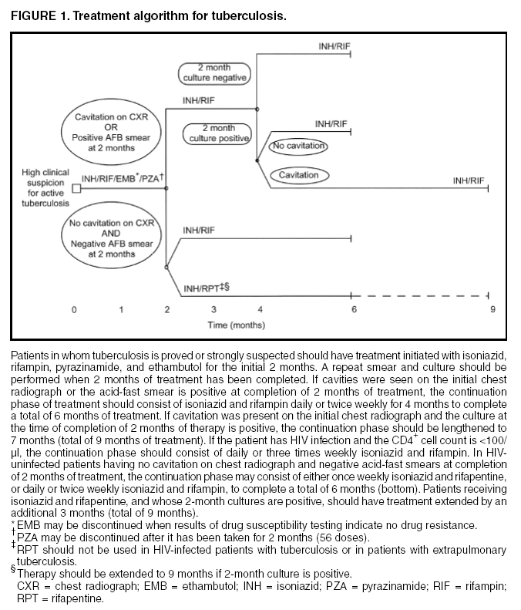

Centers for Disease Control and Prevention. Treatment of Tuberculosis, American Thoracic Society, CDC,
and Infectious Diseases Society of America. MMWR 2003;52(No. RR-11): 6.

Treatment Algorithm for Active, Culture-negative
Pulmonary Tuberculosis and Inactive Tuberculosis
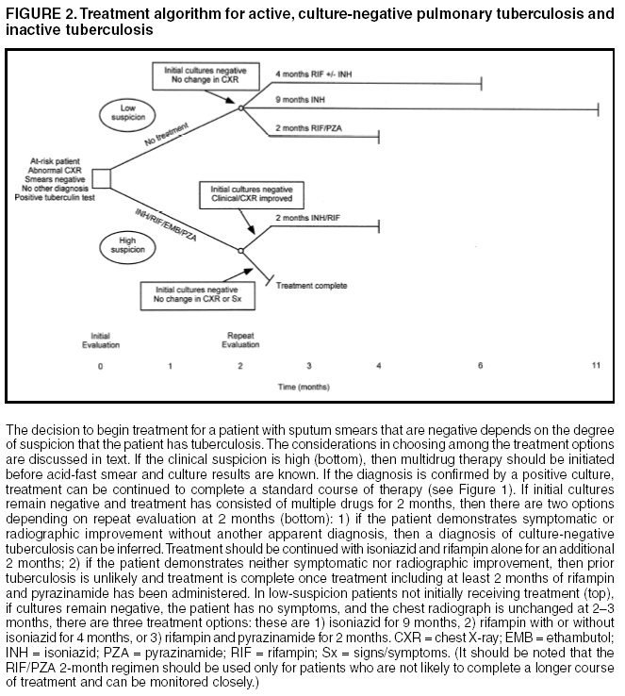
WARNING: Fatal and severe liver injuries have been associated with rifampin (RIF) and pyrazinamide (PZA) for treating LTBI.

CONSULT TB EXPERTS AT SNTC (800-4TB-INFO) BEFORE USING. RIF/PZA.

Centers for Disease Control and Prevention. Treatment of Tuberculosis, American Thoracic Society, CDC,
and Infectious Diseases Society of America. MMWR 2003;52(No. RR-11): 7.

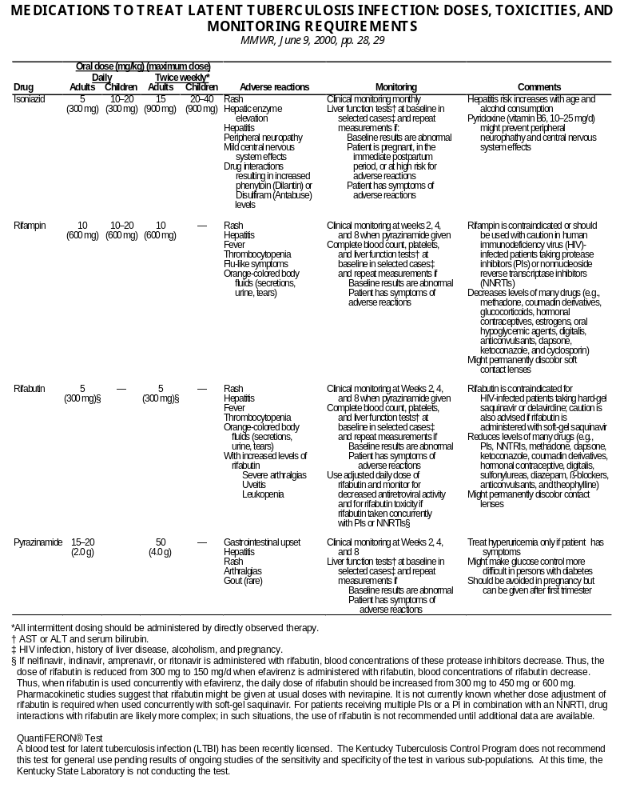

QuantiFERON®-TB Gold In-Tube and T-SPOT®.TB
These two blood assays for Mycobacterium tuberculosis (BAMT) have been licensed by the FDA. The Kentucky Tuberculosis Program does not recommend either of these tests for general use pending results of ongoing studies of the sensitivity and specificity of these tests in various sub-populations. At this time, the Kentucky State Laboratory is not performing BAMT tests with either assay.

Centers for Disease Control and Prevention. Targeted tuberculin testing and treatment of latent tuberculosis infection. MMWR 2000;49(No. RR-6):28-29.

DRUG REGIMENS FOR CULTURE-POSITIVE PULMONARY
TUBERCULOSIS CAUSED BY DRUG-SUSCEPTIBLE ORGANISMS
MMWR, June 20, 2003, p. 3
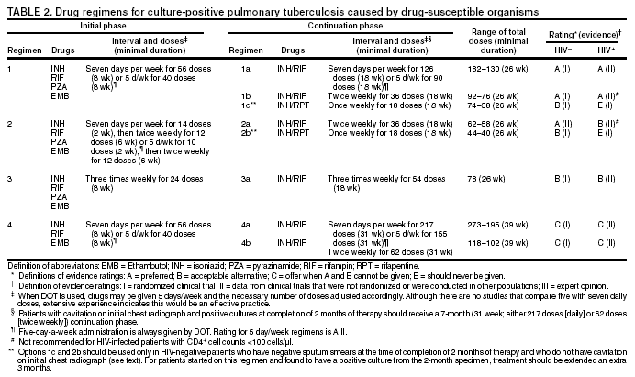

Centers for Disease Control and Prevention. Treatment of Tuberculosis, American Thoracic Society, CDC, and Infectious Diseases Society of America.
MMWR 2003;52(No. RR-11): 3.

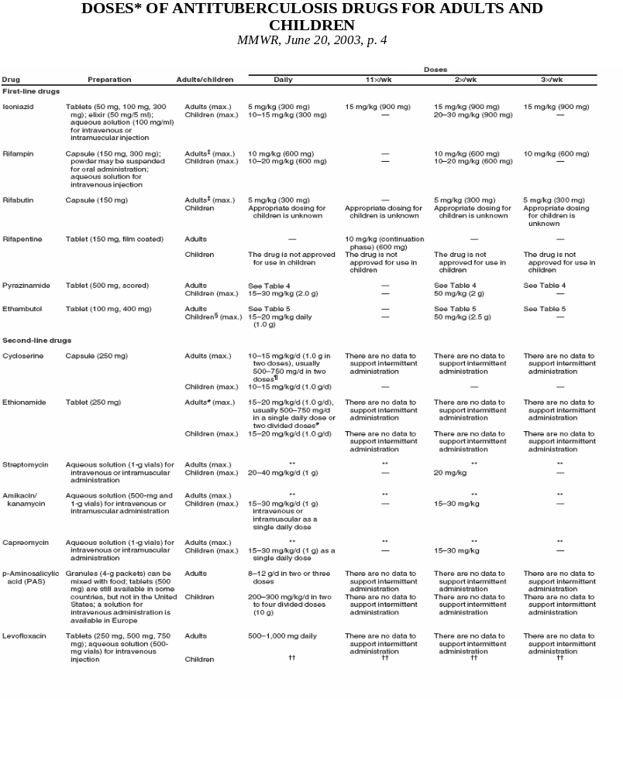

Centers for Disease Control and Prevention. Treatment of Tuberculosis, American Thoracic Society, CDC,
and Infectious Diseases Society of America. MMWR 2003;52(No. RR-11): 4.

DOSES* OF ANTITUBERCULOSIS DRUGS FOR ADULTS AND CHILDREN†
(Continued)
MMWR, June 20, 2003, p. 5
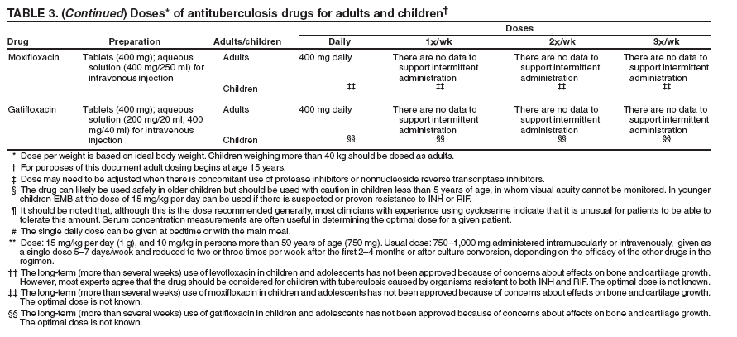

Centers for Disease Control and Prevention. Treatment of Tuberculosis, American Thoracic Society, CDC, and Infectious Diseases Society of America.
MMWR 2003;52(No. RR-11): 5.

PYRIDOXINE (VITAMIN B6) SUPPLEMENTATION
DURING TREATMENT OF LTBI OR ACTIVE TB DISEASE

Prevention of Peripheral Neuropathy and Central Nervous Symptom Effects of INH

Indications for pyridoxine when INH is ordered to treat LTBI or active TB disease:

Adults: Pyridoxine supplementation can be ordered for any adult being treated with INH, unless there is a medical contraindication. Pyridoxine (vitamin B6) supplementation is particularly recommended when INH is used for treatment of LTBI or active TB disease in some adults with medical conditions were peripheral neuropathy is common, such as^{1,2,3}:

- Nutritional deficiencies
- Diabetes
- HIV infection
- Chronic renal failure
- Alcoholism
- Persons with seizure disorders
- Pregnant women
- Breastfeeding women

Infants, children, and adolescents^{1,2,3,4,5,6}: Routine administration of pyridoxine is not recommended for most children and adolescents taking INH⁴. Pyridoxine is recommended when INH is used for treatment of LTBI or active TB disease in some infants, children, and adolescents at increased risk for peripheral neuritis or other INH adverse effects, such as:

- Breastfed infants, particularly those who are exclusively breastfed
- Children and adolescents on meat- and milk-deficient diets
- Children and adolescents with nutritional deficiencies
- Children who experience paresthesias while taking isoniazid
- HIV infection, particularly symptomatic HIV-infected individuals
- Pregnant adolescents
- Breastfeeding adolescents

Dose of pyridoxine when INH is ordered to treat LTBI or active TB disease:

Adults:

- CDC guidelines – 25 mg/day¹
- Wisconsin TB Program guidelines – 10 to 50 mg/day²
- The Harriet Lane Handbook⁵ – 25 to 100 mg/day

Infants, children, and adolescents:

- The Harriet Lane Handbook⁵: Child – 1-2 mg/kg/day. Pyridoxine injectable can be compounded with simple syrup to make an oral solution containing 1 mg/mL⁶.
- 10 mg/day to 25 mg/day¹

Prevention of Neurotoxic Effects of Cycloserine (A Second-line TB drug) in Adults: Pyridoxine may help prevent and treat neurotoxic side effects of cycloserine in the treatment of active TB disease and is usually given in a dosage of 100--200 mg/day.¹

Recommended Daily Allowances and Recommended Maximum Daily Intake⁷:
“The daily recommended dietary allowances (RDAs) of vitamin B6 are: Infants 0-6 months, 0.1 mg; Infants 7-12 months, 0.3 mg; Children 1-3 years, 0.5 mg; Children 4-8 years, 0.6 mg; Children 9-13 years, 1 mg; Males 14-50 years, 1.3 mg; Males over 50 years, 1.7 mg; Females 14-18 years, 1.2 mg; Females 19-50 years, 1.3 mg; Females over 50 years, 1.5 mg; Pregnant women, 1.9 mg; and breast-feeding women, 2 mg. Some researchers think the RDA for women 19-50 years should be increased to 1.5-1.7 mg per day. The recommended maximum daily intake is: Children 1-3 years, 30 mg; Children
4-8 years, 40 mg; Children 9-13 years, 60 mg; Adults, pregnant and breast-feeding women, 14-18 years, 80 mg; and Adults, pregnant and breast-feeding women, over 18 years, 100 mg.”
____________________________
¹ Centers for Disease Control and Prevention. Treatment of Tuberculosis. MMWR 2003;52 (No. RR-11), http://www.cdc.gov/MMWR/PDF/rr/rr5211.pdf
² Centers for Disease Control and Prevention. Targeted Tuberculin Testing and Treatment of Latent Tuberculosis Infection. MMWR2000;49(No. RR-6), http://www.cdc.gov/MMWR/PDF/rr/rr4906.pdf
³ Wisconsin TB Program. “Frequently Asked Questions about Pyridoxine (Vitamin B-6),” http://www.dhs.wisconsin.gov/tb/resources/guidelines/pyridoxine_faq.pdf
⁴ American Academy of Pediatrics. 2009 Red Book: Report of the Committee on Infectious Disease. Elk Grove Village, IL: American Academy of Pediatrics, p. 687.
⁵ Robertson J, Shilkofski, N, editors. The Harriet Lane Handbook: A Manual for Pediatric House Officers, 17th Edition, Elsevier Mosby, 2005 p. 949.
⁶ Nationwide Children’s Hospital, Columbus OH. Pyridoxine Hydrochloride Oral Solution, http://www.nationwidechildrens.org/Document/Get/79362, accessed Nov 08, 2010.
⁷ National Institutes of Health. Medline Plus: Pyridoxine (Vitamin B6), http://www.nlm.nih.gov/medlineplus/druginfo/natural/934.html, accessed Nov 08, 2010.

DOSAGE CHART*
Weight in Pounds | Weight in Kilograms | Dosage at 5 mg/kg | Dosage at 10 mg/kg | Dosage at 15 mg/kg | Dosage at 20 mg/kg | Dosage at 25 mg/kg | Dosage at 30 mg/kg
5 | 2.3 | 11.3 | 22.7 | 34.0 | 45.4 | 56.7 | 68.0
10 | 4.5 | 22.7 | 45.4 | 68.0 | 90.7 | 113.4 | 136.1
15 | 6.8 | 34.0 | 68.0 | 102.1 | 136.1 | 170.1 | 204.1
20 | 9.1 | 45.4 | 90.7 | 136.1 | 181.4 | 226.8 | 272.2
25 | 11.3 | 57 | 113 | 170 | 227 | 283 | 340
30 | 13.6 | 68 | 136 | 204 | 272 | 340 | 408
35 | 15.9 | 79 | 159 | 238 | 318 | 397 | 476
40 | 18.1 | 91 | 181 | 272 | 363 | 454 | 544
45 | 20.4 | 102 | 204 | 306 | 408 | 510 | 612
50 | 22.7 | 113 | 227 | 340 | 454 | 567 | 680
55 | 24.9 | 125 | 249 | 374 | 499 | 624 | 748
60 | 27.2 | 136 | 272 | 408 | 544 | 680 | 816
65 | 29.5 | 147 | 295 | 442 | 590 | 737 | 885
70 | 31.8 | 159 | 318 | 476 | 635 | 794 | 953
75 | 34.0 | 170 | 340 | 510 | 680 | 850 | 1021
80 | 36.3 | 181 | 363 | 544 | 726 | 907 | 1089
85 | 38.6 | 193 | 386 | 578 | 771 | 964 | 1157
90 | 40.8 | 204 | 408 | 612 | 816 | 1021 | 1225
95 | 43.1 | 215 | 431 | 646 | 862 | 1077 | 1293
100 | 45.4 | 227 | 454 | 680 | 907 | 1134 | 1361
105 | 47.6 | 238 | 476 | 714 | 953 | 1191 | 1429
110 | 49.9 | 249 | 499 | 748 | 998 | 1247 | 1497
115 | 52.2 | 261 | 522 | 782 | 1043 | 1304 | 1565
120 | 54.4 | 272 | 544 | 816 | 1089 | 1361 | 1633
125 | 56.7 | 283 | 567 | 850 | 1134 | 1417 | 1701
130 | 59.0 | 295 | 590 | 885 | 1179 | 1474 | 1769
135 | 61.2 | 306 | 612 | 919 | 1225 | 1531 | 1837
140 | 63.5 | 318 | 635 | 953 | 1270 | 1588 | 1905
145 | 65.8 | 329 | 658 | 987 | 1315 | 1644 | 1973
150 | 68.0 | 340 | 680 | 1021 | 1361 | 1701 | 2041
155 | 70.3 | 352 | 703 | 1055 | 1406 | 1758 | 2109
160 | 72.6 | 363 | 726 | 1089 | 1451 | 1814 | 2177
165 | 74.8 | 374 | 748 | 1123 | 1497 | 1871 | 2245
170 | 77.1 | 386 | 771 | 1157 | 1542 | 1928 | 2313
175 | 79.4 | 397 | 794 | 1191 | 1588 | 1984 | 2381
180 | 81.6 | 408 | 816 | 1225 | 1633 | 2041 | 2449
185 | 83.9 | 420 | 839 | 1259 | 1678 | 2098 | 2517
190 | 86.2 | 431 | 862 | 1293 | 1724 | 2155 | 2585
195 | 88.5 | 442 | 885 | 1327 | 1769 | 2211 | 2654
200 | 90.7 | 454 | 907 | 1361 | 1814 | 2268 | 2722
205 | 93.0 | 465 | 930 | 1395 | 1860 | 2325 | 2790
210 | 95.3 | 476 | 953 | 1429 | 1905 | 2381 | 2858
215 | 97.5 | 488 | 975 | 1463 | 1950 | 2438 | 2926
220 | 99.8 | 499 | 998 | 1497 | 1996 | 2495 | 2994
225 | 102.1 | 510 | 1021 | 1531 | 2041 | 2551 | 3062
230 | 104.3 | 522 | 1043 | 1565 | 2087 | 2608 | 3130
235 | 106.6 | 533 | 1066 | 1599 | 2132 | 2665 | 3198
240 | 108.9 | 544 | 1089 | 1633 | 2177 | 2722 | 3266
245 | 111.1 | 556 | 1111 | 1667 | 2223 | 2778 | 3334
250 | 113.4 | 567 | 1134 | 1701 | 2268 | 2835 | 3402
*Dosage calculated may have to be adjusted in order not to exceed the maximum dose for any drug being used.
Table recalculated in November 2010 with conversion factor of “1 pound = 0.45359237 kilograms.”
Regimen Options for Treatment of Latent TB Infection in HIV-Negative Persons

Drug | Regimens |  |  |  | Comments
Drug | Daily |  | Twice Weekly |  | Comments
Drug | Children | Adults | Children | Adults | Comments
Drug | Duration | Duration | Duration | Duration | Comments
INH | 9 months | 9 months | 9 months | 9 months | Minimum of 270 doses administered within 12 months  Twice-weekly regimens should consist of at least 76 doses administered within 12 months.  Recommended regimen for pregnant women  Contraindicated for persons who have active hepatitis and end-stage liver disease
INH | ________ | 6 months | ________ | 6 months | Minimum of 180 doses administered within 9 months  Twice-weekly regimens should consist of at least 52 doses within 9 months.  Recommended regimen for pregnant women  6-month regimen not recommended for those with fibrotic lesions on chest radiographs or children  Contraindicated for persons who have active hepatitis and end-stage liver disease
RIF | 4 months | 4 months | Not recommended |  | Minimum of 120 doses administered within 6 months  For persons who are contacts of patients with INH-resistant, RIF-susceptible TB  May be used for patients who cannot tolerate INH or PZA
WARNING: Fatal and Severe Liver Injuries Have Been Associated With Rifampin (RIF) and Pyrazinamide (PZA) Treatment for LTBI
RIF  and  PZA | Not recommended | 2 months | Not recommended | 2 or 3 months | CONSULT TB EXPERTS AT SNTC (800-4TB-INFO) BEFORE USING.  Contraindicated for persons who have active hepatitis and end-stage liver disease. Avoid PZA for pregnant women because of the risk of adverse effects to the fetus.  Minimum of 60 doses to be administered within 3 months. Twice-weekly regimens should consist of at least 16 doses to be administered for 2 months or 24 doses to be administered for 3 months.  May be used for INH-intolerant patients. This regimen has not been evaluated in HIV-negative persons.

INH – isoniazid, RIF – rifampin, RFB – rifabutin, PZA – pyrazinamide, EMB – ethambutol
 Directly observed treatment of LTBI should be used.
Centers for Disease Control and Prevention, Core Curriculum on Tuberculosis (2011)
Morbidity and Mortality, August 31, 2009, Vol. 50 / No. 34
Regimen Options for Treatment of Latent TB Infection for Persons with HIV Infection

Drug | Regimens |  |  |  | Comments | Contraindications
Drug | Daily |  | Twice Weekly |  | Comments | Contraindications
Drug | Children | Adults | Children | Adults | Comments | Contraindications
Drug | Duration | Duration | Duration | Duration | Comments | Contraindications
INH | 9 months | 9 months | 9 months | 9 months | Minimum of 270 doses administered within 12 months  Twice-weekly regimens should consist of at least 76 doses administered within 12 months.  INH can be administered concurrently with NRTIs, PIs, or NNRTIs  Directly observed treatment of latent TB infection should be used when twice-weekly dosing is used | History of INH-induced reaction, including hepatic, skin or other allergic reactions, or neuropathy  Known exposure to person who has INH-resistant TB  Chronic severe liver disease
RIF  and  PZA* | Not recommended  WARNING: Fatal and Severe Liver Injuries Have Been Associated With Rifampin (RIF) and Pyrazinamide (PZA) Treatment for LTBI | 2 months | Not recommended | 2-3 months | Minimum of 60 doses to be administered within 3 months  Twice-weekly regimens should consist of at least 16 doses to be administered for 2 months or 24 doses to be administered for 3 months.  IF RFB is administered, patient should be monitored carefully for potential RFB drug toxicity and potential decreased antiretroviral drug activity.  Dose adjustments, alternative therapies, or other precautions might be needed when rifamycins are used (e.g., patient using hormonal contraceptives must be advised to use barrier methods, and patients using methadone require dose adjustments).  PIs or NNRTIs should generally not be administered concurrently with RIF; in this situation, an alternative is the use of RFB and PZA. | History of a rifamycin-induced reaction, including hepatic, skin or other allergic reaction, or thrombocytopenia  Pregnancy  Chronic severe hyperuricemia  Chronic severe liver disease
RFB  and  PZA* | Not recommended | 2 months | Not recommended | 2-3 months

INH – isoniazid; PZA- pyrazinamide; RFB- rifabutin; RIF- rifampin; DOPT- directly observed preventive therapy; PIs – protease inhibitors; NNRTIs – nonnucleoside reverse transcriptase inhibitors; NRTIs – nucleoside reverse transcriptase inhibitors
*For patients with intolerance to PZA, some experts recommend the use of a rifamycin (RIF or RFB) alone for preventive treatment. Most experts agree that available data support the recommendation that this treatment can be administered for a short a duration as 4 months, although some experts would treat for 6 months.
The concurrent administration of rifabutin is contraindicated with hard-gel saquinavir and delavirdine. An alternative is the use of rifabutin with indinavir, nelfinavir, amprenavir, ritonavir, efavirenz, and possible soft-gel saquinavir and nevirapine. Caution is advised when using rifabutin with soft-gel saquinavir and nevirapine, because data regarding the use of rifabutin with soft-gel saquinavir and nevirapine are limited.
Note: For patients whose organisms are resistant to 1 or more drugs, administer at least 2 drugs to which there is demonstrated susceptibility and consult a TB medical expert. Clinicians should review the drug-susceptibility pattern of the M. tuberculosis strain isolated from the infecting source-patient before choosing a preventive therapy regimen.

Centers for Disease Control and Prevention, Core Curriculum on Tuberculosis (2011)
MANAGEMENT OF TREATMENT INTERRUPTIONS
MMWR, June 20, 2003 41
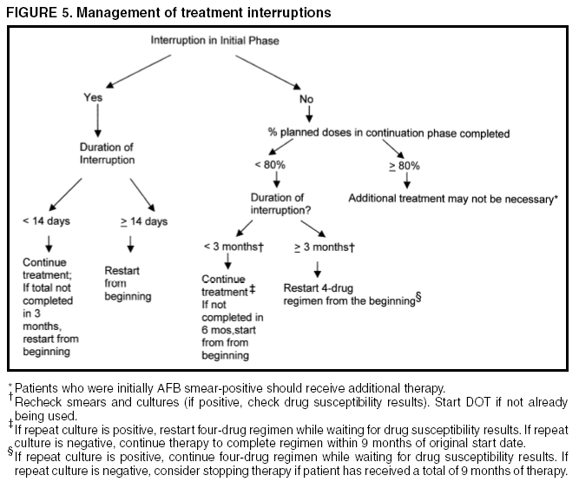

Centers for Disease Control and Prevention. Treatment of Tuberculosis, American Thoracic Society, CDC, and Infectious Diseases Society of America.
MMWR 2003;52(No. RR-11): 5.
POTENTIAL REGIMENS FOR THE MANAGEMENT OF PATIENTS WITH
DRUG-RESISTANT PULMONARY TUBERCULOSIS
MMWR, June 20, 2003, p. 69
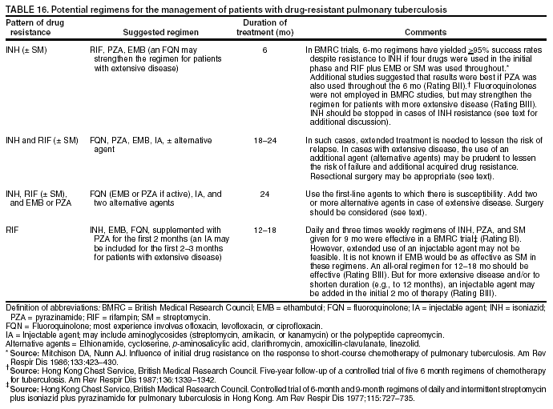

Centers for Disease Control and Prevention. Treatment of Tuberculosis, American Thoracic Society, CDC, and Infectious Diseases Society of America.
MMWR 2003;52(No. RR-11): 69.
CONSULT TB EXPERTS AT SNTC (800-4TB-INFO) about treatment recommendations for drug-resistant tuberculosis.

DIRECTLY OBSERVED THERAPY (DOT)

DOT is a method of ensuring patients’ adherence to therapy. DOT means that a health care professional or other responsible person, not related to the patient, watches the patient swallow each dose of TB medication. LHD staff must recognize DOT as the Kentucky standard of care. All active TB disease, whether pulmonary or extrapulmonary, should be treated by DOT. The DOT method should be conveyed with confidence to patients. Always respect the patient’s confidentiality.

The Centers for Disease Control and Prevention (CDC) and the American Thoracic Society (ATS) recommends that all TB patients be considered for DOT because of the difficulty in predicting who will adhere to the treatment regimen.

The following persons must be placed on DOT:
- All patients with TB that is resistant to either isoniazid (INH) or rifampin (RIF)
- All patients receiving intermittent therapy
- Persons with HIV related tuberculosis

The following patients are considered at high risk for non-adherence and should receive DOT:
- Persons who abuse substances
- Persons with mental, emotional, or certain physical impairments that interfere with their ability to self-administer medications
- Children and adolescents
- Persons with a history of treatment non-adherence

Sometimes LHD staff may designate another person to watch the patient take the TB medicines. DOT should not be delegated to a family member. Others such as school or employee health nurses or clergy may provide DOT. Kentucky’s TB Control Program does not consider it as DOT if a family observes the patient taking the medication.

Be aware of techniques a patient may use to avoid swallowing the medication such as hiding the pills in the mouth, spitting the pills into the fluid used to take them with, or vomiting the pills after leaving the treatment site.

DOT reduces the frequency of treatment failures, of acquiring drug resistance, and in suffering relapse of the disease. Most treatment regimens for TB can be given intermittently if DOT is used. Intermittent DOT reduces the total number of doses a patient must take and the number of encounters with health department personnel. If the patient cannot go to a treatment center, LHD staff can arrange another site that is safe, convenient, and agreeable to both patient and staff.

Besides being cost effective, DOT has many other benefits. DOT is a patient-focused service that also provides the health care worker with a better understanding of the patient’s needs, thus placing the worker in position to assist with needed health or social services, and making the appropriate referrals. DOT provides an effective opportunity for education, not only of the patient but also of the patient’s support system. DOT is also advantageous to the community because a patient on DOT becomes noninfectious much more quickly. This reduces the time that a patient is able to spread the disease in the community.
DIRECTLY OBSERVED PREVENTIVE THERAPY (DOPT)
FOR LATENT TB INFECTION

A major step in controlling TB in a community is to make sure that a patient who is being treated for latent TB infection (LTBI) completes a course of treatment. DOPT is the only way to ensure that these patients are adherent to the medication. As Kentucky is experiencing a decline in the number of TB cases, it is time to put a stronger focus on treating latent TB infection.

The TB Control Program is advocating that the LHDs provide DOPT to some higher risk patients, as well as to children. Children can be the most difficult clients when it comes to taking their medication. By providing DOPT, the health department not only prevents future cases of TB but also provides a valuable service to families.

Members of the groups below are considered to be high-risk individuals when it comes to being adherent to taking their medications. If found to have latent TB infection, members of these groups should be placed on DOPT:
- Children and adolescents
- Contacts to a case with active TB disease
- Homeless individuals
- Persons who abuse substances
- Persons with a history of treatment non-adherence
- Immunocompromised patients, especially HIV-infected

Directly Observed Therapy Agreement

To: D.O.B.:
Patient Name

Address:

Contact Phone:

It is very important that you follow the physician’s orders so that you are cured of tuberculosis (TB). Therefore, you are being placed in a supervised treatment program by your physician and the county.

This program requires that you take your TB medicine while being observed by the public health nurse or other designated person as indicated below (e.g./days, time, and location):

Location:

Days: Monday Tuesday Wednesday Thursday Friday

Time: am / pm

(*On Friday, a package of TB medicines for Saturday and Sunday will be left for you to take on the appropriate day if treatment doses are given seven days a week)

We want to help you get better as quickly as possible and to protect those around you from getting TB. If you do not follow these directions for treatment, your condition could worsen, and you could spread the disease to others. You or the designated person may change the days/time IF both parties agree to the change ahead of time. If you do not continue supervised treatment, the county may pursue legal action against you, which if convicted, may result in court ordered detainment for your treatment.

Tuberculosis Control Staff Person Signature Date

Designated Person Date

I have read the above information, understand it, and agree to the conditions.

Patient’s Signature Date

Interpreter Signature Date

11/2010
Decision to Initiate a Tuberculosis (TB) Contact Investigation
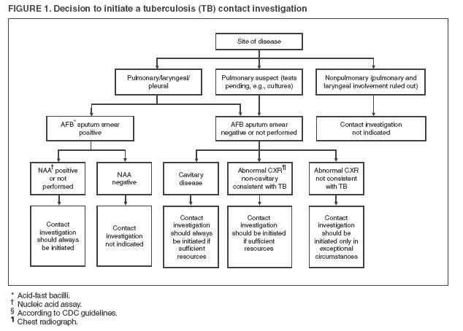

MMWR Guidelines for the Investigation of Contacts of Persons with Infectious Tuberculosis, Recommendations from the National Tuberculosis Controllers Association and CDC, December 16, 2005, Vol.54, No. RR-15, p 5.

Prioritization of Contacts Exposed to Persons with Acid-Fast Bacilli (AFB) Sputum Smear-Positive or Cavitary Tuberculosis (TB) Cases
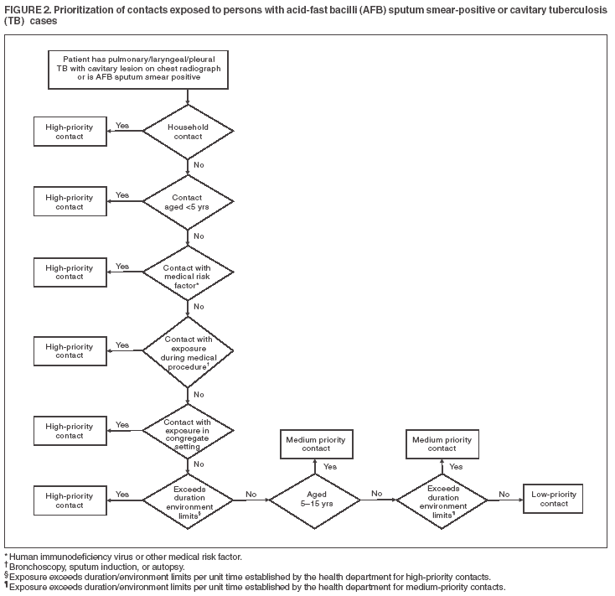

MMWR Guidelines for the Investigation of Contacts of Persons with Infectious Tuberculosis, Recommendations from the National Tuberculosis Controllers Association and CDC, December 16, 2005, Vol.54, No. RR-15, p 12.

PLANNING A CONTACT INVESTIGATION

Consult the State TB Program if you are planning a contact investigation for more than 10 people (e.g. a school, college, or large company). For complete guidelines on structuring a contact investigation see the “Guidelines for the Investigation of Contacts of Persons with Infectious Tuberculosis,” MMWR 2005:54 (No. RR-14). The goals of a contact investigation are 1) rapid identification of individuals who are high priority contacts to a known or suspected case of pulmonary, laryngeal, or pleural TB; 2) timely initiation of appropriate treatment for those persons determined to be recently infected or exposed with a significant risk for progression to disease; and 3) identification and treatment of additional individuals found to have suspected TB disease in order to prevent further spread of disease.

Determining the Infectious Period for a Patient with Active TB Disease

Determining the infectious period for a case with active TB disease focuses the investigation on those contacts most likely to be at risk for infection and sets the timeframe for testing contacts. Because the start of the infectious period cannot be determined with precision by available methods, a practical estimation is necessary. Per CDC guidelines, an assigned start date, that is 3 months before symptom onset or first positive finding consistent with active TB disease, is recommended (Table, p. 50). In certain circumstances, an even earlier start date should be used. For example, a patient (or the patient's associates) might have been aware of protracted illness (in extreme cases, >1 year). Information from the patient interview and from other sources should be assembled to assist in estimating the infectious period. Helpful details are the approximate dates that TB symptoms were noticed, mycobacteriologic results, and extent of disease (especially the presence of large lung cavities, which imply prolonged illness and infectiousness).
The infectious period is closed when the following criteria are satisfied: 1) effective treatment (as demonstrated by M. tuberculosis susceptibility results) for >2 weeks; 2) diminished symptoms; and 3) mycobacteriologic response (e.g., decrease in grade of sputum smear positivity detected on sputum-smear microscopy). The exposure period for individual contacts is determined by how much time they spent with the index patient during the infectious period. Multidrug-resistant TB (MDR TB) can extend infectiousness if the treatment regimen is ineffective. Any index patient with signs of extended infectiousness should be continually reassessed for recent contacts.
More stringent criteria should be applied for setting the end of the infectious period if particularly susceptible contacts are involved. A patient returning to a congregate living setting or to any setting in which susceptible persons might be exposed should have at least three consecutive negative sputum AFB smear results from sputum collected >8 hours apart (with one specimen collected during the early morning) before being considered noninfectious.

MMWR Guidelines for the Investigation of Contacts of Persons with Infectious Tuberculosis, Recommendations from the National Tuberculosis Controllers Association and CDC, December 16, 2005, Vol.54, No. RR-15, p 12.

Initial Assessment of Contacts

During the initial contact encounter, which should be accomplished within 3 working days of the contact having been listed in the investigation, the investigator gathers background health information and makes a face-to-face assessment of the person's health. Performing a TB Risk Assessment and administering a TST or drawing blood for a BAMT at this time accelerates the diagnostic evaluation.
The health department record should include:
- Previous M. tuberculosis infection or active TB disease and related treatment;
- Contact's verbal report and documentation of previous TST or BAMT results;
- Current symptoms of active TB disease (e.g., cough, chest pain, hemoptysis, fever, chills, night sweats, appetite loss, weight loss, malaise, or easy fatigability);
- Medical conditions or risk factors making active TB disease more likely
  - HIV infection
  - Infants and children aged less than five years;
  - Persons who are receiving immunosuppressive therapy such as tumor necrosis factor--alpha (TNF-α) antagonists, systemic corticosteroids equivalent to ≥15 mg of prednisone per day, or immune suppressive drug therapy following organ transplantation;
  - Persons recently infected with Mycobacterium tuberculosis (within the past two (2) years;
  - Persons with a history of inadequately treated active TB disease;
  - Persons with silicosis, diabetes mellitus, chronic renal failure, leukemia, lymphoma, cancer of the head, neck, or lung;
  - Persons who have had a gastrectomy, or jejunoileal bypass;
  - Persons with low body weight (BMI < 19);
  - Cigarette smokers and persons who abuse drugs or alcohol.
- Mental health disorders (e.g., psychiatric illnesses and substance abuse disorders)
- Type, duration, and intensity of TB exposure; and
- Sociodemographic factors (e.g., age, race or ethnicity, residence, and country of birth) (see Data Management and Evaluation of Contact Investigations).

Prioritization of contacts

Prioritization of contacts is based on the characteristics of the case, the individual risk factors of the contact, and the environment in which the exposure occurred.

- Case Characteristics to consider:
  - Pulmonary, laryngeal, or pleural TB disease
  - Suspected pulmonary, laryngeal, or pleural TB disease
  - Positive AFB Sputum smear
  - NAA positive or not done
  - Negative AFB Sputum smear with abnormal chest x-ray, consistent with active TB disease
  - Cavitary lesion on chest x-ray
  - Chest x-ray consistent with TB disease

- Contact Risk Factors:
    - High priority contacts:
  - HIV-infected
  - Household contacts
  - Contacts living in congregate settings
  - Contacts aged less than 5 years
  - Contacts during medical procedures, e.g., bronchoscopy, sputum induction, or autopsy
  - Contacts with medical risk factors that increase the likelihood for progression to active TB disease, e.g. silicosis, diabetes mellitus, a history of gastrectomy or jejunoileal bypass surgery.
  - Contacts receiving >15mg of Prednisone or its equivalent for > 4 weeks.
  - Contacts receiving other immunosuppressive agents, including chemotherapy,
anti-rejection therapy, tumor necrosis factor alpha (TNF-alpha) antagonists
  - Contacts who exceed the environmental exposure limits for high-priority contacts.

- Medium priority contacts:
  - Contacts aged 5 through 14 years
  - Contacts who exceed the environmental exposure limits for medium-priority contacts.

- Low priority contacts:
- Contacts who are below the threshold for classification as medium-priority contacts

- Environmental exposure limits for classification of contacts

- High priority Contacts
- > 8 hours in a small poorly ventilated space
- > 16 hours in a small well ventilated space
- > 24 hours in a classroom size space
- > 100 hours in a large open area

- Medium Priority Contacts
  - > 4 hours in a small poorly ventilated space
  - > 8 hours in a small well ventilated space
  - > 12 hours in a classroom size space
  - > 50 hours in a large open area

Responsibility:
The TB coordinator or Public Health Nurse responsible for the case management of the TB case is responsible for the overall coordination and management of the contact investigation. Regional Epidemiologists, school nurses, and others may assist in the contact investigation. These activities include

1. The identification and classification of all contacts as high-priority, medium-priority, and low-priority for the contact investigation,
2. Meeting the timeframes for initial follow-up of contacts of persons exposed to active TB disease (Table p. 49),
3. TB Risk Assessment, placement of TSTs or drawing blood for BAMTs, and contact education beginning with high-priority contacts and proceeding to medium-priority contacts,
4. Reading of TSTs and classification of TST results, or interpreting BAMT results
5. Medical evaluation and chest x-rays for contacts with TSTs or BAMTs classified as “positive”,
6. Obtaining sputum specimens on any contact with suspected active TB disease,
7. DOT for any contact with suspected active TB disease,
8. The initiation of treatment for LTBI for any contact with a TST or BAMT classified as “positive” who did not have active TB disease,
9. Repeat TSTs or BAMTs in 8 to 10 weeks for those contacts whose TST or BAMT initially was classified as “negative”, and
10. Promotion of completion of treatment for LTBI for those contacts started on LTBI treatment.

Contact investigation by other healthcare facilities:
Local health departments should monitor other healthcare facilities to:
  - Assist in identifying high and medium-priority contacts
  - Ensure complete and accurate collection of data
- Collect and evaluate data for TST or BAMT results
- Provide standardized forms
- Provide medication if indicated
- Ensure monthly monitoring of those on treatment for LTBI
- Provide expert guidance for treatment and management issues

Documentation / Reporting:
The contact investigation roster should be completed for all initiated contact investigations. A linking identification (ID) number should be assigned to the contact roster and documented in the medical record of the index case and all identified contacts. A recommended format for the contents of the linking ID number is “county code plus year (2 digits) plus local TB case number for the year, e.g. 001-10-001 would be the code for the first TB case for 2010 in Adair County. County codes that should be used are on page 46.

A copy of the Contact Investigation Summary should be completed and maintained in the medical record of the index case. The Contact Investigation Summary form is in the TB Forms chapter. The contact investigation roster should be kept in a separate file and should not be placed in the medical record of the index case or the medical record of any of the identified contacts.

A copy of the contact investigation roster and contact investigation summary shall be sent to the state TB Program 30 days after initiating the contact investigation.

Initiation of contact investigation:
Initiate a contact investigation within one business day of becoming aware of a new active TB case. Start with a face to face interview with the active TB case and/or family members, whenever possible. Additional steps in the investigation should meet the timeframes for initial follow-up of contacts of persons exposed to active TB disease (see, Table p. 49).

Evaluation of contacts:
  - Evaluate high-priority contacts to laryngeal, pulmonary, or pleural active TB disease within 7 days of notification.
  - Evaluate medium-priority contacts to laryngeal, pulmonary, or pleural active TB disease within 14 days of notification.
  - Low priority contacts should not be tested unless objectives for high and medium-priority contacts are being met. If a decision to do a TST or BAMT on a low-priority contact has been made, the initial test can be delayed until 8-10 weeks after the most recent exposure.
  - Complete initial investigation of contacts within 30 days.
  - Infants, children aged less than 5 years and HIV positive individuals have highest priority for immediate evaluation and initiation of LTBI treatment as indicated.
  - Provide HIV counseling, testing, and referral on all contacts.

MMWR Guidelines for the Investigation of Contacts of Persons with Infectious Tuberculosis, Recommendations from the National Tuberculosis Controllers Association and CDC, December 16, 2005, Vol.54, No. RR-15, p 12.

KENTUCKY COUNTY CODES

COUNTY | COUNTY | COUNTY
001 ADAIR | 041 GRANT | 081 MASON
002 ALLEN | 042 GRAVES | 082 MEADE
003 ANDERSON | 043 GRAYSON | 083 MENIFEE
004 BALLARD | 044 GREEN | 084 MERCER
005 BARREN | 045 GREENUP | 085 METCALFE
006 BATH | 046 HANCOCK | 086 MONROE
007 BELL | 047 HARDIN | 087 MONTGOMERY
008 BOONE | 048 HARLAN | 088 MORGAN
009 BOURBON | 049 HARRISON | 089 MUHLENBERG
010 BOYD | 050 HART | 090 NELSON
011 BOYLE | 051 HENDERSON | 091 NICHOLAS
012 BRACKEN | 052 HENRY | 092 OHIO
013 BREATHITT | 053 HICKMAN | 093 OLDHAM
014 BRECKINRIDGE | 054 HOPKINS | 094 OWEN
015 BULLITT | 055 JACKSON | 095 OWSLEY
016 BUTLER | 056 JEFFERSON | 096 PENDLETON
017 CALDWELL | 057 JESSAMINE | 097 PERRY
018 CALLOWAY | 058 JOHNSON | 098 PIKE
019 CAMPBELL | 059 KENTON | 099 POWELL
020 CARLISLE | 060 KNOTT | 100 PULASKI
021 CARROLL | 061 KNOX | 101 ROBERTSON
022 CARTER | 062 LARUE | 102 ROCKCASTLE
023 CASEY | 063 LAUREL | 103 ROWAN
024 CHRISTIAN | 064 LAWRENCE | 104 RUSSELL
025 CLARK | 065 LEE | 105 SCOTT
026 CLAY | 066 LESLIE | 106 SHELBY
027 CLINTON | 067 LETCHER | 107 SIMPSON
028 CRITTENDEN | 068 LEWIS | 108 SPENCER
029 CUMBERLAND | 069 LINCOLN | 109 TAYLOR
030 DAVIESS | 070 LIVINGSTON | 110 TODD
031 EDMONSON | 071 LOGAN | 111 TRIGG
032 ELLIOTT | 072 LYON | 112 TRIMBLE
033 ESTILL | 073 MCCRACKEN | 113 UNION
034 FAYETTE | 074 MCCREARY | 114 WARREN
035 FLEMING | 075 MCLEAN | 115 WASHINGTON
036 FLOYD | 076 MADISON | 116 WAYNE
037 FRANKLIN | 077 MAGOFFIN | 117 WEBSTER
038 FULTON | 078 MARION | 118 WHITLEY
039 GALLATIN | 079 MARSHALL | 119 WOLFE
040 GARRARD | 080 MARTIN | 120 WOODFORD

Contact Investigation and the Concentric Circle Approach

Steps in a Contact
Investigation

The first step in a contact investigation is to review the TB patient’s medical records and ask the clinician for information to determine whether the patient has been infectious, and if so, when. Knowing the index patient’s infectiousness helps decide which contacts to focus on and which contacts are at risk.

Collect basic data:
The site of active TB disease
TB symptoms and date symptoms began
AFB Smear/ TB culture results
CXR date and results
DOT or self-administered treatment
TB treatment (drugs, dosage, and date treatment started)
Work or School Environment
Leisure or
Recreational
Environment
High Priority Contacts
Medium Priority Contacts
Low Priority Contacts
Household / Residence Environment
Medium Priority
Low Priority
High Priority
Index
Patient

10 Tips on the Concentric Circle Approach

- Start ASAP
- Work in the field (not just the office)
- Begin in the center ring and work outward
- Proceed simultaneously on all three fronts
- Don’t be pressured easily to expand your circles; keep control. We know there can be panic when a group or community of people find out about a case of TB being investigated among them
- Don’t forget that there are circles in time as well as space
- Evaluate your data every step of the way. What are they telling you about the source case? What needs to be done next?
- If stymied, let people know you must and will proceed with or without them.
- Call for reinforcement if necessary
- Don’t forget the follow-up TST or BAMT at 8 to 10 weeks. Some contacts will not have converted until then.

Remember: Because priority assignments are practical approximations derived from imperfect information, priority classifications should be reconsidered throughout the investigation as findings are analyzed.

See: Contact Investigation for Tuberculosis; CDC Self-Study Module #6, p 91.

Window-Period Prophylaxis

Primary prophylaxis of high-risk contacts:
Tuberculin skin test results might take 2-10 weeks to become positive after infection with M. tuberculosis. Thus, a contact's initial TST or BAMT result might be negative even if the person is infected. A second TST or BAMT should be performed 8-10 weeks after the contact's last exposure to the infectious patient, so the possibility of LTBI for those persons can be better evaluated. During the 8-10 week window period between a first and second skin test or BAMT, the following contacts with initially negative tuberculin skin test results or negative BAMT results should receive treatment for LTBI after active TB disease has been ruled out by clinical examination and chest radiograph:
- Contacts aged <5 years (with highest priority given to those aged <3 years) and
- Contacts with HIV infection or who are otherwise immunocompromised.
If the second TST result is negative (i.e. <5 mm) or the second BAMT is negative, the contact is immunocompetent (including immunocompetent young children) and no longer exposed to an infectious TB case, treatment for LTBI during the window period may be discontinued, and further follow-up is unnecessary.
If the second TST or BAMT result is negative but the contact is immunocompromised (e.g., with HIV infection), and an evaluation for active TB disease is negative, a full course of treatment for LTBI still should be completed.
If the second TST or BAMT result is negative but the person remains in close contact with an infectious TB case, treatment for LTBI should be continued if the contact is:
- Aged <5 years;
- Aged 5 through 15 years, at the clinician's discretion; or
- HIV-infected or otherwise immunocompromised.

The decision to treat individual contacts that have negative skin tests or negative BAMTs should take into consideration two factors:
- The frequency, duration, and intensity of exposure (even brief exposure to a highly infectious TB patient in a confined space probably warrants the same concern as extended exposure to less infectious TB cases); and
- Corroborative evidence of transmission from the index patient (e.g. a substantial fraction of contacts having TST or BAMT results classified as “positive” implies infectiousness).

MMWR Guidelines for the Investigation of Contacts of Persons with Infectious Tuberculosis, Recommendations from the National Tuberculosis Controllers Association and CDC, December 16, 2005, Vol.54, No. RR-15, p 15.
Evaluation, Treatment, and Follow-Up of Tuberculosis (TB) Contacts
Aged < 5 Years

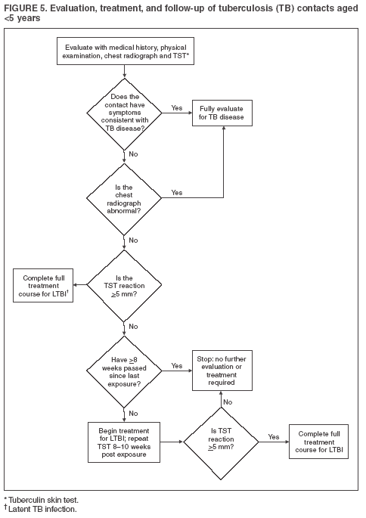

MMWR Guidelines for the Investigation of Contacts of Persons with Infectious Tuberculosis, Recommendations from the National Tuberculosis Controllers Association and CDC, December 16, 2005, Vol.54, No. RR-15, p 15.

Evaluation, Treatment, and Follow-Up of Immunocompromised Contacts

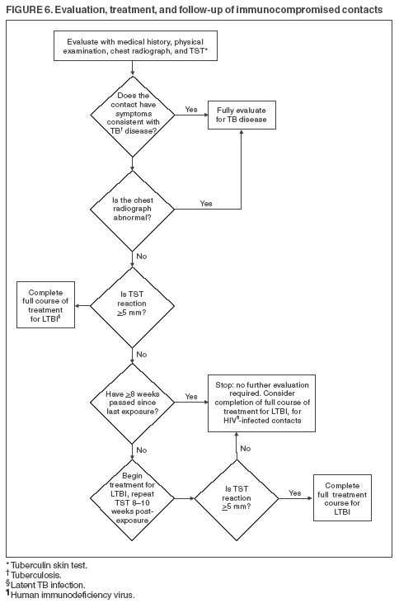

MMWR Guidelines for the Investigation of Contacts of Persons with Infectious Tuberculosis, Recommendations from the National Tuberculosis Controllers Association and CDC, December 16, 2005, Vol.54, No. RR-15, p 16.

Evaluation, Treatment, and Follow-Up of Contacts with a
Documented Previously Positive Tuberculin Skin Test

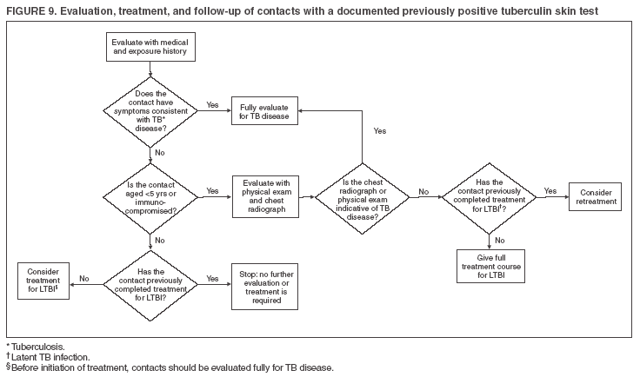

MMWR Guidelines for the Investigation of Contacts of Persons with Infectious Tuberculosis, Recommendations from the National Tuberculosis Controllers Association and CDC, December 16, 2005, Vol.54, No. RR-15, p 19.

Time Frames for Initial Follow-up of Contacts of
Persons Exposed to Tuberculosis (TB)
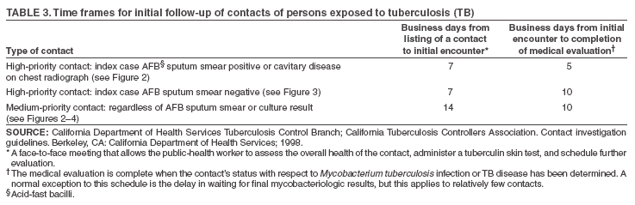

MMWR Guidelines for the Investigation of Contacts of Persons with Infectious Tuberculosis, Recommendations from the National Tuberculosis Controllers Association and CDC, December 16, 2005, Vol.54, No. RR-15, p 9.

Guidelines for Estimating the Beginning of the Period of Infectiousness of
Persons with Tuberculosis (TB), by Index Case Characteristic

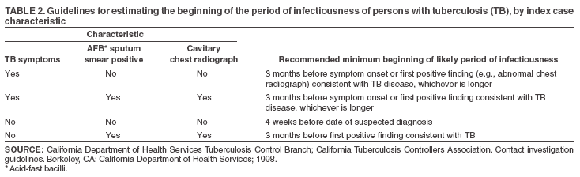

MMWR Guidelines for the Investigation of Contacts of Persons with Infectious Tuberculosis, Recommendations from the National Tuberculosis Controllers Association and CDC, December 16, 2005, Vol.54, No. RR-15, p 7.
STEPS FOR DEVELOPING A RESPIRATOR PROGRAM
http://www.cdc.gov/niosh/docs/99-143/pdfs/99-143.pdf

Step 1: Conduct a TB risk assessment

Conduct a TB risk assessment for the entire facility and for specific areas within the facility. Follow-up risk assessment should be performed at the interval indicated by the most recent risk assessment.

Step 2: Select Respirators

Select the proper NIOSH-approved respirator for each area on the basis of the risk assessment.

Step 3: Write Standard Operating Procedures (SOPs)

Write SOPs for all aspects of the respiratory protection program, including:
- Management responsibility
- Worker responsibility
- Selection, fit-checking and fit testing, use, care, storage, and inspection of respirators

Step 4: Medically screen all users

Medically screen anyone who must wear a respirator.

Step 5: Provide training

Train staff in respiratory protection program procedures and respirator use.

Step 6: User seal check, fit-test, and issue respirators

User seal check and fit-test respirators to determine which brand and size of respirator fits the user best. Issue appropriate respirators.

Step 7: Inspect, clean, maintain, and store respirators

Periodically observe the respirator users to determine whether the respirators are worn correctly, fit-checked before each use, and properly maintained.

Step 8: Evaluate the program

Completely evaluate the program at least once a year. Revise the written SOPs, program administration, etc., based on the evaluation.

Note: Visitors to TB patients should be given an N-95 respirator to wear and general instructions for using the respirator (See p. 17 in Reference 13).

For more information on this or other occupational safety and health issues, contact NIOSH at
1-800-CDC-INFO (1-800-232-4636) or visit the NIOSH Web site at www.cdc.gov/niosh.

INDICATIONS FOR TWO-STEP TUBERCULIN SKIN TESTS (TSTs)
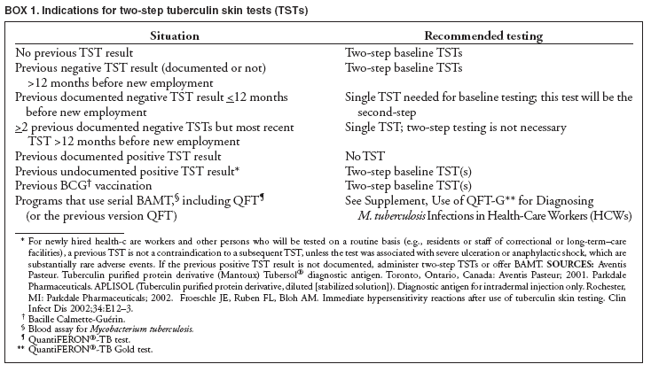

MMWR, December 30, 2005, p. 29

MMWR Guidelines for Preventing the Transmission of Mycobacterium tuberculosis in Health-Care settings, 2005, p 29.

World Health Organization Global Tuberculosis Database
Estimated TB Incidence, All Forms
(per 100 000 population per year, as of 24 March 2009)
http://apps.who.int/globalatlas/dataQuery/default.asp

Country | 2007 | Ratio to TB Incidence in USA
Afghanistan | 168 | 42
Albania | 17 | 4
Algeria | 57 | 14
American Samoa | 5 | 1
Andorra | 19 | 5
Angola | 287 | 72
Anguilla | 22 | 6
Antigua and Barbuda | 5 | 1
Argentina | 31 | 8
Armenia | 72 | 18
Australia | 6 | 2
Austria | 12 | 3
Azerbaijan | 77 | 19
Bahamas | 44 | 11
Bahrain | 40 | 10
Bangladesh | 223 | 56
Barbados | 4 | 1
Belarus | 61 | 15
Belgium | 12 | 3
Belize | 40 | 10
Benin | 91 | 23
Bermuda | 4 | 1
Bhutan | 246 | 62
Bolivia | 155 | 39
Bosnia and Herzegovina | 51 | 13
Botswana | 731 | 183
Brazil | 48 | 12
British Virgin Islands | 10 | 3
Brunei Darussalam | 59 | 15
Bulgaria | 39 | 10
Burkina Faso | 226 | 57
Burundi | 367 | 92
Cambodia | 495 | 124
Cameroon | 192 | 48
Canada | 5 | 1
Cape Verde | 151 | 38
Cayman Islands | 4 | 1
Central African Republic | 345 | 86
Chad | 299 | 75
Chile | 12 | 3
China | 98 | 25
Colombia | 35 | 9
Comoros | 42 | 11
Congo | 403 | 101
Cook Islands | 15 | 4
Costa Rica | 11 | 3
Croatia | 40 | 10
Cuba | 6 | 2
Cyprus | 5 | 1
Czech Republic | 9 | 2
Côte d'Ivoire | 420 | 105
Democratic People's Republic of Korea | 344 | 86
Democratic Republic of the Congo | 392 | 98
Denmark | 8 | 2
Djibouti | 813 | 203
Dominica | 13 | 3
Dominican Republic | 69 | 17
Ecuador | 101 | 25
Egypt | 21 | 5
El Salvador | 40 | 10
Equatorial Guinea | 256 | 64
Eritrea | 95 | 24
Estonia | 38 | 10
Ethiopia | 378 | 95
Fiji | 21 | 5
Finland | 6 | 2
France | 14 | 4
French Polynesia | 27 | 7
Gabon | 406 | 102
Gambia | 258 | 65
Georgia | 84 | 21
Germany | 6 | 2
Ghana | 203 | 51
Greece | 18 | 5
Grenada | 4 | 1
Guam | 34 | 9
Guatemala | 63 | 16
Guinea | 287 | 72
Guinea-Bissau | 220 | 55
Guyana | 122 | 31
Haiti | 306 | 77
Honduras | 59 | 15
Hungary | 17 | 4
Iceland | 4 | 1
India | 168 | 42
Indonesia | 228 | 57
Iran (Islamic Republic of) | 22 | 6
Iraq | 56 | 14
Ireland | 13 | 3
Israel | 8 | 2
Italy | 7 | 2
Jamaica | 7 | 2
Japan | 21 | 5
Jordan | 7 | 2
Kazakhstan | 129 | 32
Kenya | 353 | 88
Kiribati | 365 | 91
Kuwait | 24 | 6
Kyrgyzstan | 121 | 30
Lao People's Democratic Republic | 151 | 38
Latvia | 53 | 13
Lebanon | 19 | 5
Lesotho | 637 | 159
Liberia | 277 | 69
Libyan Arab Jamahiriya | 17 | 4
Lithuania | 68 | 17
Luxembourg | 12 | 3
Madagascar | 251 | 63
Malawi | 346 | 87
Malaysia | 103 | 26
Maldives | 47 | 12
Mali | 319 | 80
Malta | 6 | 2
Mauritania | 318 | 80
Mauritius | 22 | 6
Mexico | 20 | 5
Micronesia (Federated States of ) | 97 | 24
Monaco | 2 | 1
Mongolia | 205 | 51
Montenegro | n/a
Montserrat | 8 | 2
Morocco | 92 | 23
Mozambique | 431 | 108
Myanmar | 171 | 43
Namibia | 767 | 192
Nauru | 33 | 8
Nepal | 173 | 43
Netherlands | 8 | 2
Netherlands Antilles | 7 | 2
New Caledonia | 22 | 6
New Zealand | 7 | 2
Nicaragua | 49 | 12
Niger | 174 | 44
Nigeria | 311 | 78
Niue | 0 | 0
Northern Mariana Islands | 58 | 15
Norway | 6 | 2
Oman | 13 | 3
Pakistan | 181 | 45
Palau | 60 | 15
Panama | 47 | 12
Papua New Guinea | 250 | 63
Paraguay | 58 | 15
Peru | 126 | 32
Philippines | 290 | 73
Poland | 25 | 6
Portugal | 30 | 8
Puerto Rico | 4 | 1
Qatar | 70 | 18
Republic of Korea | 90 | 23
Republic of Moldova | 141 | 35
Romania | 115 | 29
Russian Federation | 110 | 28
Rwanda | 397 | 99
Saint Kitts and Nevis | 9 | 2
Saint Lucia | 14 | 4
Saint Vincent and the Grenadines | 25 | 6
Samoa | 19 | 5
San Marino | 6 | 2
Sao Tome and Principe | 101 | 25
Saudi Arabia | 46 | 12
Senegal | 272 | 68
Seychelles | 32 | 8
Sierra Leone | 574 | 144
Singapore | 27 | 7
Slovakia | 17 | 4
Slovenia | 13 | 3
Solomon Islands | 128 | 32
Somalia | 249 | 62
South Africa | 948 | 237
Spain | 30 | 8
Sri Lanka | 60 | 15
Sudan | 243 | 61
Suriname | 116 | 29
Swaziland | 1,198 | 300
Sweden | 6 | 2
Switzerland | 6 | 2
Syrian Arab Republic | 24 | 6
Tajikistan | 231 | 58
Thailand | 142 | 36
The former Yugoslav Republic of Macedonia | 29 | 7
Timor-Leste | 322 | 81
Togo | 429 | 107
Tokelau | 0 | 0
Tonga | 24 | 6
Trinidad and Tobago | 11 | 3
Tunisia | 26 | 7
Turkey | 30 | 8
Turkmenistan | 68 | 17
Turks and Caicos Islands | 14 | 4
Tuvalu | 166 | 42
Uganda | 330 | 83
Ukraine | 102 | 26
United Arab Emirates | 16 | 4
United Kingdom of Great Britain and Northern Ireland | 15 | 4
United Republic of Tanzania | 297 | 74
United States Virgin Islands | 10 | 3
United States of America | 4 | 1
Uruguay | 22 | 6
Uzbekistan | 113 | 28
Vanuatu | 77 | 19
Venezuela | 34 | 9
Viet Nam | 171 | 43
Wallis and Futuna Islands | 15 | 4
West Bank and Gaza Strip | 20 | 5
Yemen | 76 | 19
Zambia | 506 | 127
Zimbabwe | 782 | 196

World Health Organization Global Tuberculosis Database
Estimated TB Prevalence, All Forms
(per 100 000 population per year, as of 24 March 2009)
http://apps.who.int/globalatlas/dataQuery/default.asp

Country | 2007 | Ratio to TB Prevalence in USA
Afghanistan | 238 | 79
Albania | 22 | 7
Algeria | 56 | 19
American Samoa | 5 | 2
Andorra | 19 | 6
Angola | 294 | 98
Anguilla | 34 | 11
Antigua and Barbuda | 9 | 3
Argentina | 35 | 12
Armenia | 81 | 27
Australia | 6 | 2
Austria | 10 | 3
Azerbaijan | 86 | 29
Bahamas | 51 | 17
Bahrain | 60 | 20
Bangladesh | 387 | 129
Barbados | 3 | 1
Belarus | 69 | 23
Belgium | 9 | 3
Belize | 46 | 15
Benin | 135 | 45
Bermuda | 6 | 2
Bhutan | 363 | 121
Bolivia | 198 | 66
Bosnia and Herzegovina | 55 | 18
Botswana | 622 | 207
Brazil | 60 | 20
British Virgin Islands | 16 | 5
Brunei Darussalam | 65 | 22
Bulgaria | 41 | 14
Burkina Faso | 403 | 134
Burundi | 647 | 216
Cambodia | 664 | 221
Cameroon | 195 | 65
Canada | 4 | 1
Cape Verde | 280 | 93
Cayman Islands | 5 | 2
Central African Republic | 425 | 142
Chad | 497 | 166
Chile | 12 | 4
China | 194 | 65
Colombia | 43 | 14
Comoros | 83 | 28
Congo | 485 | 162
Cook Islands | 31 | 10
Costa Rica | 11 | 4
Croatia | 54 | 18
Cuba | 7 | 2
Cyprus | 6 | 2
Czech Republic | 9 | 3
Côte d'Ivoire | 582 | 194
Democratic People's Republic of Korea | 441 | 147
Democratic Republic of the Congo | 666 | 222
Denmark | 6 | 2
Djibouti | 1,104 | 368
Dominica | 19 | 6
Dominican Republic | 82 | 27
Ecuador | 140 | 47
Egypt | 27 | 9
El Salvador | 48 | 16
Equatorial Guinea | 469 | 156
Eritrea | 134 | 45
Estonia | 39 | 13
Ethiopia | 579 | 193
Fiji | 30 | 10
Finland | 5 | 2
France | 11 | 4
French Polynesia | 32 | 11
Gabon | 379 | 126
Gambia | 404 | 135
Georgia | 83 | 28
Germany | 5 | 2
Ghana | 353 | 118
Greece | 16 | 5
Grenada | 6 | 2
Guam | 36 | 12
Guatemala | 87 | 29
Guinea | 448 | 149
Guinea-Bissau | 276 | 92
Guyana | 136 | 45
Haiti | 366 | 122
Honduras | 71 | 24
Hungary | 19 | 6
Iceland | 3 | 1
India | 283 | 94
Indonesia | 244 | 81
Iran (Islamic Republic of) | 27 | 9
Iraq | 79 | 26
Ireland | 11 | 4
Israel | 6 | 2
Italy | 6 | 2
Jamaica | 7 | 2
Japan | 28 | 9
Jordan | 9 | 3
Kazakhstan | 139 | 46
Kenya | 319 | 106
Kiribati | 423 | 141
Kuwait | 25 | 8
Kyrgyzstan | 134 | 45
Lao People's Democratic Republic | 289 | 96
Latvia | 55 | 18
Lebanon | 23 | 8
Lesotho | 568 | 189
Liberia | 398 | 133
Libyan Arab Jamahiriya | 17 | 6
Lithuania | 69 | 23
Luxembourg | 9 | 3
Madagascar | 417 | 139
Malawi | 305 | 102
Malaysia | 121 | 40
Maldives | 48 | 16
Mali | 599 | 200
Malta | 5 | 2
Mauritania | 559 | 186
Mauritius | 39 | 13
Mexico | 23 | 8
Micronesia (Federated States of ) | 100 | 33
Monaco | 2 | 1
Mongolia | 234 | 78
Montserrat | 8 | 3
Morocco | 80 | 27
Mozambique | 504 | 168
Myanmar | 162 | 54
Namibia | 532 | 177
Nauru | 33 | 11
Nepal | 240 | 80
Netherlands | 6 | 2
Netherlands Antilles | 15 | 5
New Caledonia | 25 | 8
New Zealand | 7 | 2
Nicaragua | 56 | 19
Niger | 292 | 97
Nigeria | 521 | 174
Niue | 0 | 0
Northern Mariana Islands | 72 | 24
Norway | 4 | 1
Oman | 14 | 5
Pakistan | 223 | 74
Palau | 71 | 24
Panama | 45 | 15
Papua New Guinea | 430 | 143
Paraguay | 73 | 24
Peru | 136 | 45
Philippines | 500 | 167
Poland | 28 | 9
Portugal | 23 | 8
Puerto Rico | 5 | 2
Qatar | 81 | 27
Republic of Korea | 126 | 42
Republic of Moldova | 151 | 50
Romania | 128 | 43
Russian Federation | 115 | 38
Rwanda | 590 | 197
Saint Kitts and Nevis | 12 | 4
Saint Lucia | 18 | 6
Saint Vincent and the Grenadines | 39 | 13
Samoa | 25 | 8
San Marino | 5 | 2
Sao Tome and Principe | 240 | 80
Saudi Arabia | 65 | 22
Senegal | 468 | 156
Seychelles | 55 | 18
Sierra Leone | 941 | 314
Singapore | 27 | 9
Slovakia | 20 | 7
Slovenia | 15 | 5
Solomon Islands | 180 | 60
Somalia | 352 | 117
South Africa | 692 | 231
Spain | 23 | 8
Sri Lanka | 79 | 26
Sudan | 402 | 134
Suriname | 155 | 52
Swaziland | 812 | 271
Sweden | 5 | 2
Switzerland | 5 | 2
Syrian Arab Republic | 27 | 9
Tajikistan | 322 | 107
Thailand | 192 | 64
The former Yugoslav Republic of Macedonia | 33 | 11
Timor-Leste | 378 | 126
Togo | 750 | 250
Tokelau | 0 | 0
Tonga | 28 | 9
Trinidad and Tobago | 15 | 5
Tunisia | 28 | 9
Turkey | 34 | 11
Turkmenistan | 75 | 25
Turks and Caicos Islands | 17 | 6
Tuvalu | 203 | 68
Uganda | 426 | 142
Ukraine | 102 | 34
United Arab Emirates | 24 | 8
United Kingdom of Great Britain and Northern Ireland | 12 | 4
United Republic of Tanzania | 337 | 112
United States Virgin Islands | 16 | 5
United States of America | 3 | 1
Uruguay | 23 | 8
Uzbekistan | 140 | 47
Vanuatu | 102 | 34
Venezuela | 39 | 13
Viet Nam | 220 | 73
Wallis and Futuna Islands | 25 | 8
West Bank and Gaza Strip | 31 | 10
Yemen | 130 | 43
Zambia | 387 | 129
Zimbabwe | 714 | 238

REFERENCES

- CDC. Core Curriculum on Tuberculosis: What the Clinician Should Know. 5th Edition. Atlanta, GA: US Department of Health and Human Services, CDC, 2011, http://www.cdc.gov/tb/education/corecurr/default.htm .

- CDC Self Study Modules on Tuberculosis (Modules 1 – 5, ) – 2008
CDC Self Study Modules on Tuberculosis (Modules 6 – 9) – 2000
http://www.cdc.gov/tb/education/ssmodules/default.htm

- CDC. Targeted Tuberculin Testing and Treatment of Latent Tuberculosis Infection, MMWR 2000;49(No. RR-6).

- Tuberculosis Laws as found in the Kentucky Revised Statues, Chapter 215.511 – 600, http://chfs.ky.gov/dph/epi/tb.

- Tuberculosis Regulations:
902 KAR 2:020 – 090 (Surveillance, Control, Detection, Prevention);
902 KAR 20:016 – 200 (Hospital and
Long-Term Care).

- CDC. Treatment of Tuberculosis. MMWR 2003;52(No. RR-11).

- CDC. Recommendations and Reports, Guidelines for Investigation of Contacts of Persons with Infectious TB. MMWR 2005; 54(No. RR-15).

- American Academy of Pediatrics. 2009 Red Book, 28th edition: Report of the Committee on Infectious Disease. Elk Grove Village, IL: American Academy of Pediatrics

- American Thoracic Society/Centers for Disease Control. Diagnostic Standards and Classification of Tuberculosis in Adults and Children. Am J Respir Crit Care Med 1999; 61:1376-95

- CDC Mantoux Tuberculin Skin Testing DVD, 2006, http://www2c.cdc.gov/podcasts/player.asp?f=3739 (Podcast) http://www.cdc.gov/tb/education/Mantoux/default.htm

- NIOSH Website at: http://www.cdc.gov/niosh.

- CDC. Guidelines for Preventing the Transmission of Mycobacterium tuberculosis in Health-Care Settings 2005. MMWR 2005;54(No. RR-17).

- CDC. Controlling Tuberculosis in the United States. MMWR 2005;54(No. RR-12).

- PHPR Forms: http://chfs.ky.gov/dph/info/dpqi/PHPR+Forms+and+Teaching+Sheets.htm

- HIPAA Privacy Rule and Public Health, MMWR, April 11, 2003 / 52;1-12.

- Curry International Tuberculosis Center, 2011: Tuberculosis Infection Control: A Practical Manual for Preventing TB, http://www.currytbcenter.ucsf.edu/products/product_details.cfm?productID=WPT-12

CDC TB Guidelines published in MMWR are available online, http://www.cdc.gov/tb/
publications/guidelines/default.htm.

