KENTUCKY PRESCRIPTION ASSISTANCE PROGRAM (KPAP)
Health Care Access Branch
1-800-633-8100

The Kentucky Prescription Assistance Program (KPAP) was created by the Kentucky General Assembly within the Department for Public Health to assist Kentuckians in more readily accessing free or reduced cost medications through pharmaceutical manufacturers’ prescription assistance programs (PAPs).

Community consultants are regionally located to identify and train community advocates to assist Kentuckians with accessing PAPs and other resources to access medications. *Please call the Community Consultant listed below from your area for further assistance.*

KPAP Community Consultant Contact Information by ADD

Bryant Hileman, Western Kentucky Community Consultant
BryantHileman@comcast.net (270) 254-1541

BARREN RIVER: Allen, Barren, Butler, Edmonson, Hart, Logan, Metcalfe, Monroe, Simpson & Warren
GREEN RIVER: Daviess, Hancock, Henderson, McLean, Ohio, Union, & Webster
LAKE CUMBERLAND: Adair, Clinton, Cumberland, Green, Russell, & Taylor
PENNYRILE: Caldwell, Christian, Crittenden, Hopkins, Livingston, Lyon, Muhlenberg, Todd, & Trigg
PURCHASE: Ballard, Calloway, Carlisle, Fulton, Graves, Hickman, Marshall, & McCracken

Carol Baldwin, Central Kentucky Community Consultant
Carol.Baldwin@ky.gov (270) 401-3842

LINCOLN TRAIL: Breckinridge, Grayson, Hardin, Larue, Marion, Meade, Nelson & Washington
BLUEGRASS: Anderson, Bourbon, Boyle, Clark, Estill, Fayette, Franklin, Garrard, Harrison, Jessamine,
Lincoln, Madison, Mercer, Nicholas, Powell, Scott, & Woodford
KIPDA: Bullitt, Henry, Jefferson, Oldham, Shelby, Spencer, & Trimble
NORTHERN KY: Boone, Campbell, Carroll, Gallatin, Grant, Kenton, Owen & Pendleton

Deanna Jessie, Eastern Kentucky Community Consultant
Deanna.Jessie@ky.gov (606) 264-2819 or (606) 286-4754

BIG SANDY: Floyd, Johnson, Magoffin, Martin & Pike.
BUFFALO TRACE: Bath, Bracken, Fleming, Lewis, & Robertson
CUMBERLAND VALLEY: Bell, Clay, Harlan, Jackson, Knox, Laurel, Rockcastle, & Whitley
FIVCO: Boyd, Carter, Elliott, Greenup & Lawrence
GATEWAY: Bath, Menifee, Montgomery, Morgan & Rowan
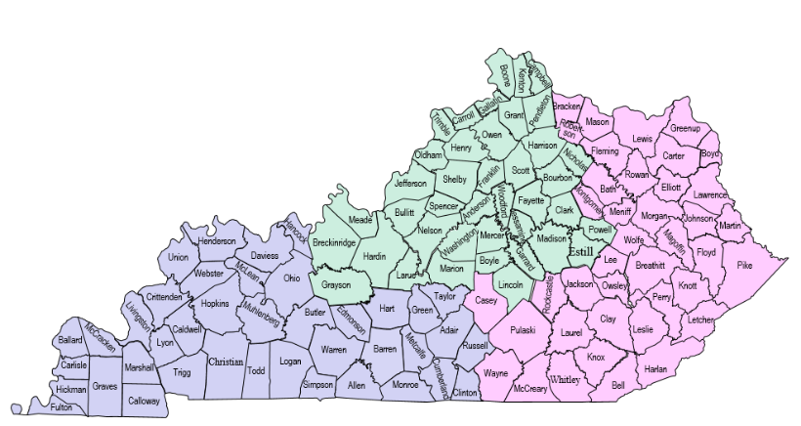
KENTUCKY RIVER: Breathitt, Knott, Lee, Leslie, Letcher, Owsley, Perry & Wolfe
LAKE CUMBERLAND: Casey, McCreary, Pulaski & Wayne

