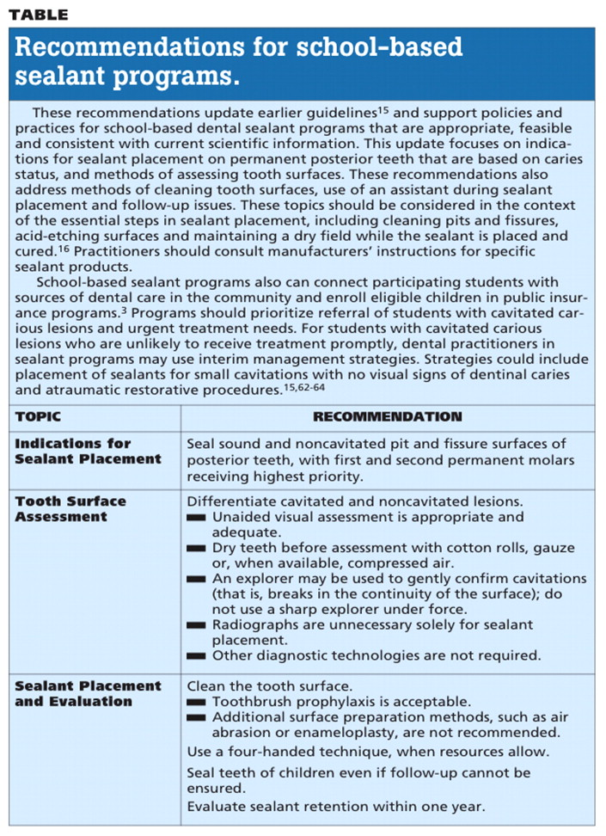
http://jada.ada.org/content/140/11/1356/T1.large.jpg

