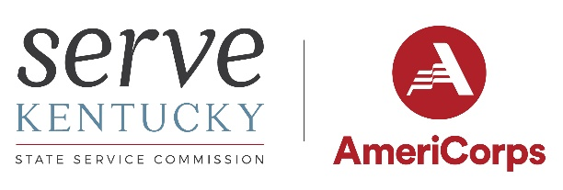

Serve Kentucky Announces Request for Applications Process Open for Volunteer Connector Grants
Issue Date: Tuesday, November 30, 2021
Serve Kentucky is pleased to announce the request for applications process is open for Volunteer Generation Fund (VGF) grants. VGF grant funds will support the development and strengthening of the volunteer infrastructure in Kentucky through its partners hosting online Volunteer Connector portals.
Organizations that have the capacity and funding to support Volunteer Connector functions are eligible to apply. Applying non-governmental entities must be IRS 501(c)(3) designated non-profits in good standing. The following are encouraged to apply: non-profit organizations, state agencies and local governments, elementary and secondary schools, colleges and universities, community and faith-based organizations, labor organizations, partnerships and consortia, and/or intermediary organizations representing a combination of these or similar groups working together.
All organizations funded will be expected to support functions of an online Volunteer Connector for opportunities external to their own organization and that will have dedicated staff focused on: a) connecting people with opportunities to volunteer and serve; b) increasing the capacity for organizations to engage volunteers in meaningful service; c) promoting volunteering generally and use of the online volunteer connector in particular; and, d) working with external support partners in developing local programming/projects designed to utilize volunteerism as a solution to community problems, including disaster preparedness, response and recovery. Use of Serve Kentucky’s volunteer management software under the umbrella account of Serve Kentucky is encouraged and provided.
AGREEMENT PERIOD: April 1, 2022* – September 30, 2023**
GRANTS AWARD RANGE: $5,000 – $20,000
GRANT OPERATIONS: Regional or Local Areas in Kentucky
APPLICATION & MATERIALS DUE: Monday, January 31, 2022
*May be earlier depending on state contracting timetables / ** Close of the federal fiscal year
Proposals and associated attachments must be submitted to the Cabinet for Health and Family Services, Division of Procurement and Grant Oversight. Application documents can be found at the following website: Cabinet for Health and Family Services (ky.gov) under Current Grant Opportunities / Volunteer Generation RFA. If there are any issues obtaining the application documents please refer all questions to Mason Roberts at mason.roberts@ky.gov.

