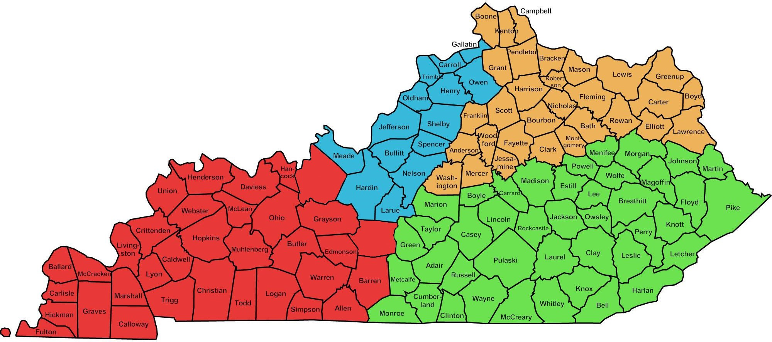

Breckinridge

Hart

WESTERN ENFORCEMENT  Regional Program Manager Felisa Coleman  Branch Manager  Janaire Watkins  (270) 889-6052 | NORTHERN ENFORCEMENT  Regional Program Manager  Theresa Harvey  Branch Manager  Christy Troxell  Human Srvs Supervisor  Sara Dutschke  (502) 595-5781 | SOUTHERN ENFORCEMENT  Regional Program Manager Tammie Dozier  Branch Manager  Jennifer Swafford  (606) 330-2030 | EASTERN ENFORCEMENT  Regional Program Manager  Branch Manager  Courtney Stamper  Branch Manager  OPEN  Human Srvs Supervisor  OPEN  (859) 246-2301

