HART-SUPPORTED LIVING
GRANT APPLICATION

This packet is for applicant requesting:
NEW ON-GOING OR ONE-TIME grants

Application Due Date: April 1 of each year

Funding Date: July 1 of each year
Funding of any application is contingent upon availability of funds.

This document is available in alternate formats upon request.

A BRIEF DESCRIPTION OF HART-SUPPORTED LIVING
Hart-Supported Living is a program that is based on individually designed plans for support. These plans provide people with disabilities the help they need to live successfully in a home of their choice. The individual with a disability (and the people who support them) plan and design a set of services which meets the individual’s needs and is consistent with the principles of Supported Living. If the individual’s request for funding is recommended, then a Supported Living plan is developed, and funds are granted to implement the plan.

Eligibility:
Only a person with a disability who is a resident of Kentucky or whose family or guardian is a resident of Kentucky is eligible to apply for a Hart-Supported Living Program grant. The person may be living with a family member, independently, or be in a congregate setting and be eligible to apply for a grant. If funded, the applicant must maintain Kentucky residency as a condition of receiving grant funds or for the duration of the grant (KRS 210.790).
The Hart-Supported Living statute utilizes the definition of disability found in the Americans with Disabilities Act (ADA): A person who has a physical or mental impairment that substantially limits one or more major life activity. This includes people who have a record of such an impairment, even if they do not currently have a disability (KRS 210.770).

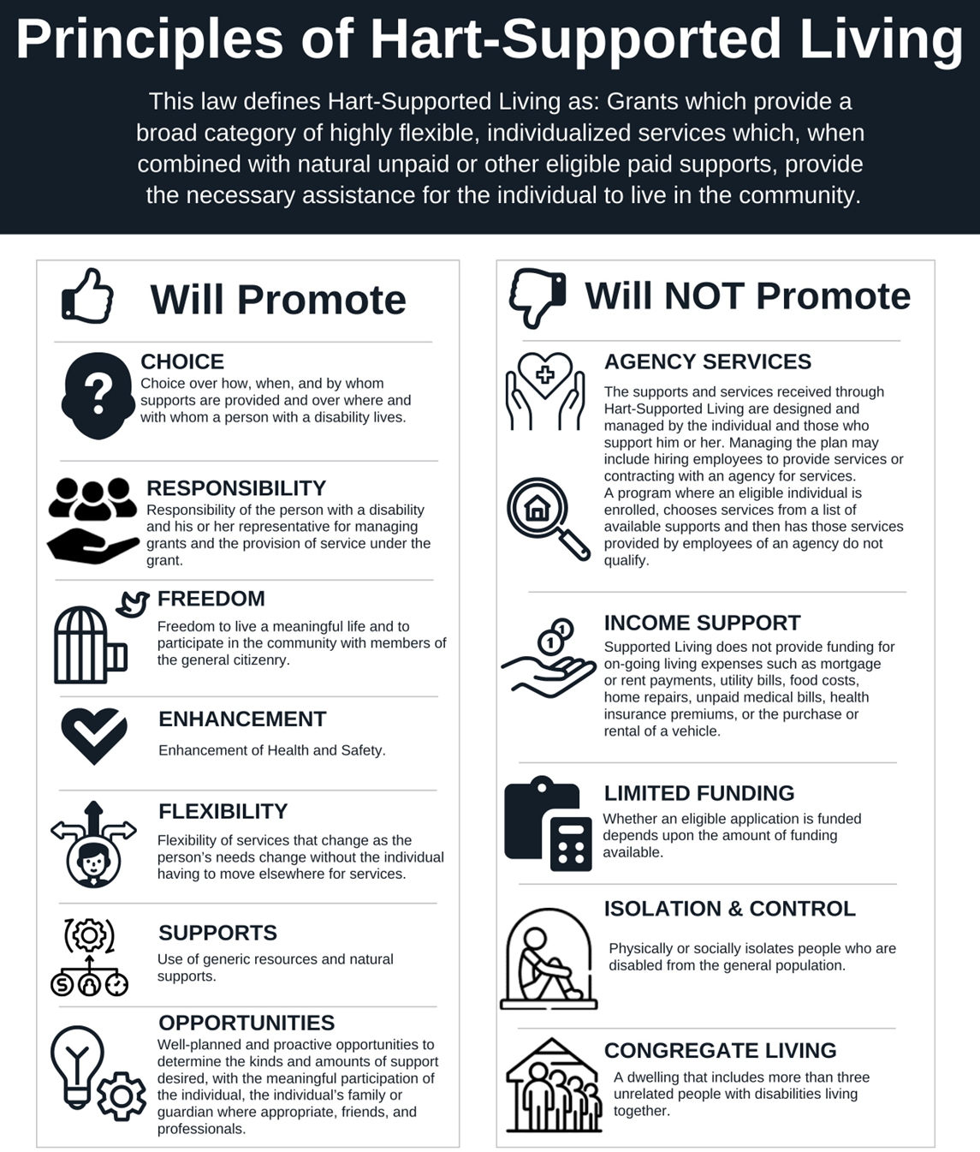What may be requested?

An applicant may request a grant for supports that meet individual needs and are consistent with the principles of Hart-Supported Living. The supports requested shall be based on an individualized, person-centered plan.

There are two types of supports that can be requested:
- One-time: supports that are needed just one time.
- On-going: supports that will continue to be needed.

What may be requested?
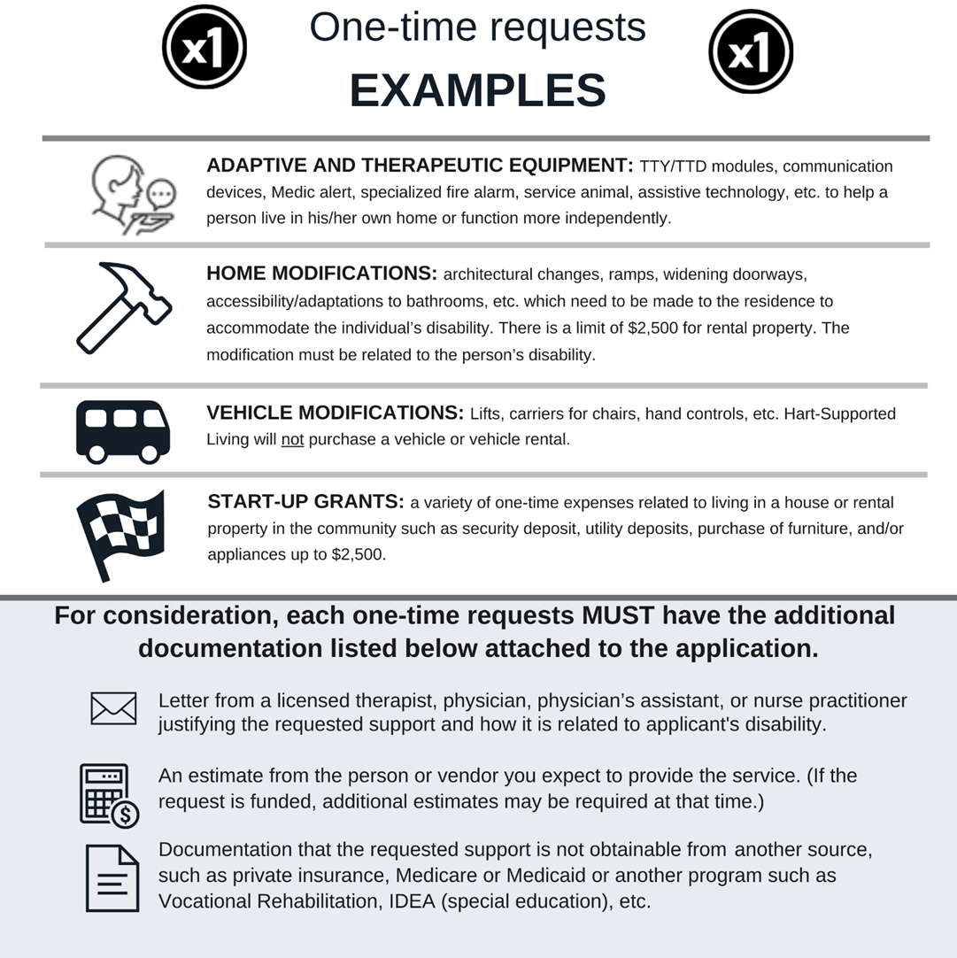

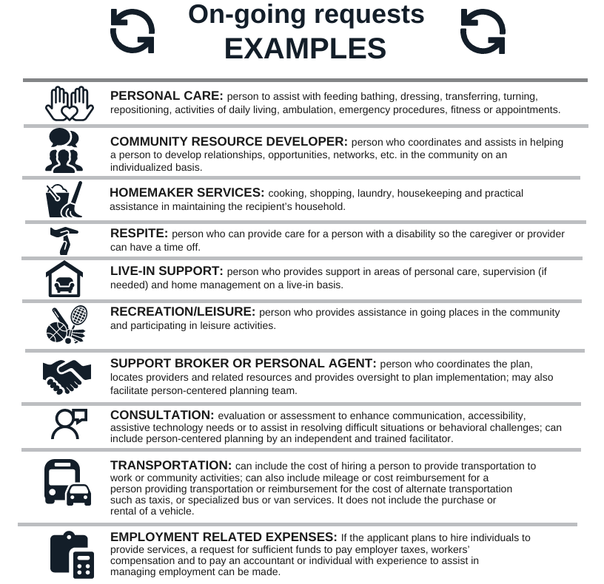

What CANNOT be funded

- On going rent or mortgage payments.
- Payment of medical insurance premiums, regardless of insurance type or medical expense.
- Providing additional financial support to staff who work for publicly funded programs or agencies.
- Home modifications of rental property without written permission from the property owner.
- Home modifications of rental property costing over $2,500.
- Home modifications not related to the applicant's disability.
- Purchase of a vehicle.
- Rental of a vehicle.
- Utility or ongoing household expenses such as internet, phone, electric, etc.
- Supports or services for applicants in living arrangements that include more than three (3) people with disabilities.
- Equipment or service which is obtainable from anther program for which the applicant qualifies; and
- Any duplication of services or supports.
It is important to know, Hart-Supported Living program CANNOT fund a service/support which is obtainable by another funding source for which an applicant qualifies; therefore, documentation that the service/support requested was denied or not obtainable shall be attached to the application when necessary.

SUBMITTING YOUR APPLICATION

The deadline for submitting a complete application is APRIL 1st.

Regional Hart- Supported Living Coordinators are available to assist you in the completion and submission of your application prior to the April 1st deadline. Submitting your application prior to the deadline allows the Regional Coordinator time to review your application and request additional information. Having a Regional Coordinator verify the completeness and compliance of the application before the Review Team evaluation can provide accuracy in the assessment process.

The application MUST be received in by the Regional Hart-Supported Living Coordinator or postmarked by the end of business on April 1st. If April 1st falls on a weekend day, then the application deadline is the following Monday. The application is for funding that may be available at the start of the next fiscal year, which begins on July 1st.

An application received or postmarked after April 1st will not be considered for the upcoming fiscal year.

Applications must be complete to be considered. Funding recommendations are made by the Review Team after ALL applications submitted have been evaluated. The review process does not prioritize early submissions.

If you were not previously awarded on-going funding, you must submit a new application for each fiscal year. Applications that are not funded are kept on file for possible funding only for the fiscal year for which they were submitted.

This application packet is for both ongoing and one-time requests.

Make sure to complete the general section first and then proceed with the either the ongoing section, the one-time section, or both. Do not forget to fill out the budget page for both on-going and one-time requests.

INSTRUCTIONS FOR COMPLETING THE APPLICATION

- Complete the entire application; applicants who do not answer all required questions and do not have completed budget page(s) will not be considered. Any required estimates or letters of justification must also be attached for the application to be complete.

- Anyone, except a State Hart-Supported Living Coordinator, can assist you in completing this application. The Regional Hart-Supported Living Coordinator will provide assistance upon request. It is strongly recommended that you contact the Regional Coordinator for information about the application process. The coordinator may also be able to let you know of other supports that may be available in your region.

- The application may be written by the individual with a disability, a family member, or another individual on his or her behalf.
  - If written by another, using language about the individual (“My son is . . .” “My sister has . . .”) is acceptable. It is not required that another person completing the application write as if he or she were the individual with the disability, although this is permitted. Remember that the plan for supports should be specific to the wants and needs of the individual and be person-centered.

- Feel free to write a cover letter about yourself and to ask other people to write letters for you. These letters should all be sent in together with your application.

- If you intend to hire an agency to provide on-going supports, indicate this on the budget page.

- If you intend to hire one or more individuals as employees to provide on-going supports, the budget page must include payroll taxes and worker’s compensation (if required).
  - Contact the coordinator for assistance in understanding employer requirements and what must be requested. You may need to contact an accountant or other professional for guidance on calculating payroll tax.

  - Worker’s Compensation insurance may be required and is recommended if you have household employees.

  - Applicants may request a budget item to hire an accountant, fiscal intermediary, or individual with knowledge to assist in employer responsibilities. This could be a one-time expense if you will only need assistance in setting up or an on-going expense if on-going assistance will be required.

- On-going requests will require: a letter from a physician, physician’s assistant, nurse practitioner, or licensed therapist documenting that the on-going support requested is related to the applicant’s disability.

- One-time requests will require: 1) a letter from a physician, physician’s assistant, nurse practitioner, or therapist documenting that the home modification requested is related to the applicant’s disability and 2) one estimate from contractor or supplier. (If you are funded, additional estimates may be required.) Attach the letter and estimate to the application. Applications without the required letter and estimate cannot be considered.

- When appropriate, all applicants must provide documentation that the support or service requested is not available through another program for which the applicant qualifies (ex: Medicare, Medicaid, private insurance, Vocational Rehabilitation, Supports for Community Living, Home and Community based waivers, IDEA, etc.)

- Submit a copy of each member of the household’s income. This can be accomplished by submitting either: 1) Each member’s most recent year’s income tax returns disclosing the adjusted gross income; 2) Each member past three (3) months’ paystubs; or 3) Any other official verification of income for the past year.

- The application has three sections: general, on-going, and one-time. Complete the general and then either the on-going or the one-time, or both. Complete the on-going budget page and/or the one-time budget page.

- The Review Team will assess your application based on the information submitted in the application. Make sure you include all the information that you want the Team to take into consideration.

- To submit your application: Remove the instructions so the Checklist/Cover Page is on the front. Use the Checklist to make sure your application is complete. Mail, email, fax or hand deliver the application to the Regional Coordinator. The fax, or email must be received by April 1. If April 1 falls on a weekend day, then the application deadline is the following Monday.

SAMPLE BUDGET PAGES
This is a sample budget page for on-going expenses. The applicant must develop an individualized budget and research costs for the specific support(s) requested.
A  On-going support and Description | B  Agency OR  Individual | C  Hours  per week | D  Cost  per hour | E  Cost  per week (C X D) | F  Cost  per year  (E X 52)
Community Resource Developer (CRD) | 2 Individuals | 20 | $10.00 | $200.00 | $10,400.00
Payroll taxes and  Unemployment insurance  (gross wages x .1115) |  |  | $ | $22.30 | $1,159.60
Worker’s compensation insurance for CRDs |  |  | $ | $ | $250.00
CPA services for tax preparation |  |  | $ | $ | $500.00
Transportation  100 miles/week for CRD  $0.46/mile |  |  | $ | $46.00 | $2,392.00
 |  |  | $ | $ | $
 |  |  | $ | $ | $
 |  |  | $ | $ | $
TOTAL Amount requested for  On-going Support(s) |  |  |  |  | $14,701.60

SAMPLE

This is a sample budget page for one-time expenses. Amounts should be based on estimates received from the contractor or supplier expected to supply the support.
ONE-TIME EXPENSES (e.g., equipment, home modifications) | NAME OF SUPPLIER OR/  CONTRACTOR ON ESTIMATE | TOTAL  COST
Ramp for front door | AAA Builders | $1000.00
TOTAL REQUESTED FOR ONE-TIME EXPENSES |  | $1000.00
THIS IS A SAMPLE ONLY

__________________________________
Name of Applicant

COVER PAGE AND CHECKLIST
After you have completed your application and have all the attachments, use this cover page and checklist to make sure your application is complete. Applications that are not complete cannot be considered.

___ ALL REQUIRED QUESTIONS HAVE BEEN ANSWERED.

___ BUDGET PAGE(s): for either on-going, one-time supports OR both are complete.

___ IF ON-GOING SUPPORT(s) HAS BEEN REQUESTED: a letter from a physician, physician assistant, nurse practitioner, or licensed therapist justifying the request(s) is attached.

___ IF EMPLOYEES WILL BE HIRED AND YOU ARE AN EMPLOYER: include taxes and employment related expenses on the budget page.

___ IF ONE-TIME SUPPORTS HAVE BEEN REQUESTED: minimum of one estimate or quote for each request is attached.

___ IF ONE TIME SUPPORT(s), HAVE BEEN REQUESTED: a letter from a doctor, nurse practitioner, or licensed therapist justifying each request, and how the request(s) relates to the person’s disability is attached.

___ IF A HOME MODIFICATION IS REQUESTED ON A RENTAL PROPERTY: a letter from the landlord or property owner including approval of the request is attached.

___ IF A CURRENT RECIPIENT IS REQUESTING ADDITIONAL FUNDS: a copy of the current plan is attached.

___ INCOME VERIFICATION IS ATTACHED.

___ IF CLAIMING DISABILITY RELATED EXPENSES: proof of these expenses is attached.

Mail, email, fax, or hand deliver your completed application to the
Regional Coordinator where you reside or wish to reside if you are funded.
Make sure that your application is received or postmarked no later than April 1.

HSL ID#_________________________ (Assigned by Regional Coordinator)

HART-SUPPORTED LIVING APPLICATION
Please provide all the following information.
You may print or type your answers. If you print, please use dark blue or black ink.

____________________________________________________ ____________________
Name of person requesting Supported Living funds Date of Birth

Social Security # __________________________ Gender Male Female Other __________

Race (mark all that apply) American Indian or Alaska Native Asian Black or African American Hispanic or Latino White Other___________________________

Address ___________________________________________ City ______________________

County ________________________ State ______________ Zip code ___________________

Telephone (_______)___________________ Alternate phone (_______)__________________

E-mail address (optional) _________________________________________________________

Parent(s)/Guardian (if applicable) __________________________________________________

Address ______________________________________________________________________

City ___________________________ State ______________ Zip code ___________________

Telephone (_______)___________________ Alternate phone (_______)__________________

How did you hear about the HSL grant?______________________________________________

_____________________________________________________________________________

I declare that the information contained in this application is true and I understand the Hart-Supported Living review team can confirm this information to make a determination about funding my application.

______________________________________________ _____________________
Applicant Signature Date

______________________________________________ ______________________
Parent(s)/Guardian (if applicable) Date

______________________________________________ ______________________
Person preparing application (other than applicant) Date

______________________________________________ ______________________
Relationship to Applicant Telephone #

SECTION ONE: GENERAL
QUESTIONS FOR ALL APPLICANTS

Answer ALL the questions below in the spaces provided.
If you need additional room, you may attach additional sheets.

- Have you ever received a grant for Hart-Supported Living? ____Yes ____No
If YES, list supports and year received or, if current recipient, attach a copy of your current plan.

SUPPORTS RECEIVED YEAR RECEIVED
___________________________________________ _____________________
___________________________________________ _____________________
___________________________________________ _____________________
___________________________________________ _____________________

- What kind of assistance or services do you receive now? Check all that apply.
____ Supplemental Security Income (SSI)
____ Medicare
____ Medicaid (Medicaid # ___________________________)

____ HOME AND COMMUNITY BASED WAIVERS (HCBW, SCL, MPW, ABI, ABI LTC, MODEL II)
Services Provided ________________________________________________________________
Case Manager/Support Broker __________________________ Telephone (____)_____________

____ FIRST STEPS EARLY INTERVENTION PROGRAM
Contact Person ____________________________________ Telephone (___)________________

____ REGIONAL COMMUNITY MENTAL HEALTH CENTER (CMHC) PROGRAM
Services Provided ________________________________________________________________
Case Manager/Support Broker __________________________ Telephone (____)_____________

____ PERSONAL CARE ATTENDANT PROGRAM (PCAP) Hours per week _______________
Program Coordinator _________________________________Telephone (___)_______________

____ TRAUMATIC BRAIN INJURY (TBI) TRUST FUND
Case Manager _____________________________________ Telephone (___)________________

____ DEPARTMENT FOR THE BLIND AND/OR
COMMISSION ON THE DEAF AND HARD OF HEARING
Contact Person ____________________________________ Telephone (___)________________

____ DEPARTMENT OF VOCATIONAL REHABILITATION
Counselor_________________________________________ Telephone (___)________________

____ PRE-SCHOOL OR SCHOOL SPECIAL EDUCATION
Services Provided ________________________________________________________________
Teacher/Contact Person _____________________________ Telephone (____)_______________

____ VETERANS SERVICES AND PROGRAMS
Services Provided ________________________________________________________________
Contact Person ____________________________________ Telephone (____)_______________

____ PRIVATE INSURANCE Carrier_____________________________
Services (other than medical) _______________________________________________________

____ OTHER PROFESSIONAL SUPPORTS (Home Health, Center for Independent Living, or social service supports though the Area Agencies on Aging, such as Homecare Program, Meals on Wheels, etc.)

Services Provided ________________________________________________________________
Agency/Contact______________________________________ Telephone (____)_____________

Services Provided ________________________________________________________________
Agency/Contact______________________________________ Telephone (____)_____________

Services Provided ________________________________________________________________
Agency/Contact______________________________________ Telephone (____)______________

____ OTHER INFORMAL SUPPORTS (Family, friends, community supports, etc.)
Support Provided __________________________________________________________________
Support Provided __________________________________________________________________
Support Provided __________________________________________________________________

- Have you tried to obtain the requested support(s) through another source?
If so, what have you applied for?
If requesting ongoing services, have you applied for Medicaid waiver?

- Please list your disability(s).

- How does your disability(s) affect your overall life?
(List any physical, emotional, and mental health concerns and effects.)

IF YOU ARE REQUESTING ONE-TIME ONLY, SKIP TO SECTION THREE

SECTION TWO:
QUESTIONS FOR ON-GOING SUPPORT APPLICANTS

If you are requesting on-going support(s), answer the questions below in the space provided.
If you need additional room attach additional sheets.

- How would the ongoing funding you are requesting help increase your involvement with your community and/or increase choices you make for yourself?

- Do you plan on hiring an individual or agency to provide services?

a.) Individual(s) name(s): _____________________________________________________________
Agency Name: ___________________________________________________________________

b.) If unknown, how do you plan on finding employees?
___ Word of mouth
___ Newspaper ads
___ Online
___ Community partners
___ Other (please list) ______________________________________________________

c.) How will employer legal requirements be met (taxes, workers comp, etc.)?
_________________________________________________________________________________________________________________________________________________________________________________________________________________________________

d.) List CPA or professional financial service/provider. __________________________________________________________________________________
__________________________________________________________________________________
__________________________________________________________________________________

COMPLETE THE BUDGET PAGE FOR ON-GOING SUPPORTS
SUPPORTED LIVING BUDGET PAGE
ON-GOING EXPENSES
- Give a description of the on-going supports you are requesting and the dollar amount of the grant you are requesting to fund the supports.
- You are required to complete Columns A, B & F. Complete C, D & E, if applicable

A  On-going support and Description | B  Agency OR  Individual | C  Hours  per week | D  Cost  per hour | E  Cost  per week (C X D) | F  Cost  per year  (E X 52)
 |  |  | $ | $ | $
 |  |  | $ | $ | $
 |  |  | $ | $ | $
 |  |  | $ | $ | $
 |  |  | $ | $ | $
 |  |  | $ | $ | $
 |  |  | $ | $ | $
 |  |  | $ | $ | $
TOTAL Amount requested for  On-going Support(s) |  |  |  |  | $

COMPLETING YOUR APPLICATION FOR ON-GOING SUPPORTS
- Attach the signed statement of justification for your ongoing request(s) on letterhead from a physician, physician assistant, nurse practitioner or licensed therapist.
- If you are requesting on-going supports only, complete the Cover Page/Checklist to make sure your application is complete and mail, deliver or send the completed application with Cover Page to the Regional Coordinator

IF YOU ARE ALSO REQUESTING ONE-TIME SUPPORTS
Continue and complete SECTION THREE
SECTION THREE:
QUESTIONS FOR ONE-TIME SUPPORTS APPLICANTS

If you are requesting one-time support(s),
answer ALL the questions below in the spaces provided.
If additional space is needed, attach additional sheets.

- List the name of the company/vendor(s) who is providing the detailed estimate/quote(s) for the one-time support(s)? (Please make sure to attach estimate/quote with the application.)

- Are home modifications requested? (Check one) ____ YES, if YES answer questions below
____ NO

- The home is (check one) ____ OWNED ____ RENTED

- If owned or rented, what is the relationship of the owner or renter to the applicant?
____ Self
____ Family: relationship ____________________________________________
____ Other: relationship _____________________________________________

- Attach the statement of justification on letterhead from a physician, APRN, PCA, or licensed therapist.

- If renting, a letter from landlord approving modification to be done is attached.

- Please list each one time support you are requesting, how it relates to your disability and how it will improve your life.

1. One Time Support:

How it relates to your disability:

How it will improve your life:

2. One Time Support:

How it relates to your disability:

How it will improve your life:

3. One Time Support:

How it relates to your disability:

How it will improve your life:

4. One Time Support:

How it relates to your disability:

How it will improve your life:

5. One Time Support:

How it relates to your disability:

How it will improve your life:

COMPLETE THE BUDGET PAGE FOR ONE-TIME SUPPORTS
SUPPORTED LIVING BUDGET PAGE
ONE-TIME EXPENSES
- List each one-time support separately.

ONE-TIME EXPENSES  (e.g., equipment, home modifications) | NAME OF SUPPLIER OR  CONTRACTOR ON ESTIMATE | TOTAL COST  (as shown on estimate or quote)
 |  | $
 |  | $
 |  | $
 |  | $
 |  | $
 |  | $
 |  | $
 |  | $
TOTAL REQUESTED FOR ALL ONE-TIME EXPENSES |  | $

COMPLETING YOUR APPLICATION FOR ONE-TIME SUPPORTS
    - Attach any required estimates from vendor or contractor.
- Attach the signed statement of justification for request, on letterhead, from a physician, physician assistant, nurse practitioner or licensed therapist.
    - If rented attach letter from landlord verifying modification can be done on property.
    - If owned a copy of deed may be requested by regional coordinator.

COMPLETING YOUR APPLICATION
Complete the Cover Page Checklist and mail, email, fax, or hand deliver your application to the Regional Supported Living Coordinator.

