Data Standard Family Resource and Youth Services Centers (FRYSC)

Rev. 2/27/2019

Ownership and History

  - Standard prepared by:

Tonya Cookendorfer
  - Data steward(s)
Tonya Cookendorfer, Cabinet for Health and Family Services
  - Revision history
February 27, 2019
- Center setup added to standard. Requests for FRYSC additions, closures, or name edits may be sent to tonya.cookendorfer@ky.gov.
February 14, 2018
- FRYSC records outside of the Active Year are now read-only for both State and District users.
- Individual Intervention categories on the FRYSC > Individual Intervention editor have been replaced by multi-select dropdown lists. Users can now select multiple codes per Individual Intervention category.
- FRYSC Program Categories have become a single dropdown list on the FRYSC Group Programs tab.

May 21, 2018
- Converted to accessible format and updated training hyperlinks due to CHFS website changes.

Contents
Ownership and History 1
Overview 3
Section A – Center Setup 4
Section B – Individual Interventions 5
Section C – Group Programs 6

Overview
  - Description
The Kentucky Family Resource and Youth Services Centers were established as a component of the historic Kentucky Education Reform Act (KERA) of 1990. The mission of these school-based centers is to help academically at-risk students succeed in school by helping to minimize or eliminate noncognitive barriers to learning.
  - Regulation citation(s)
Family Resource Centers serve children under school age and in elementary school and coordinate:
- preschool child care;
- after-school child daycare;
- families in training;
- family literacy services; and,
- health services and referrals.
Youth Services Centers serve students in middle and high school and coordinate:
- referrals to health and social services;
- career exploration and development;
- summer and part-time job development (high school only);
- substance abuse education and counseling; and
- family crisis and mental health counseling.
  - Data use
- This data is used to track services provided by each center.
- Reported to Kentucky Center for Education and Workforce Statistics (P20 data collaborative).
  - Related ad-hoc filters and reports
- KY State Reporting / FRYSC Group Program Report
- KY State Reporting / FRYSC State Report
  - Training
Cabinet for Health and Family Services, Division of FRYSC resources:
FRYSC Administrators Guidebook;
Training by can be found here.
Campus Community Articles:
FRYSC; FRYSC Group Programs; FRYSC Program Participation Wizard; FRYSC Group Program Report; FRYSC State Report

Section A – Center Setup
  - Campus Path: System Administration / Resources / School

Schools served by FRYSC must have the correct center specified in Infinite Campus to ensure accurate reporting and group program entry.

Select the appropriate school from the list.
Select the FRYSC center from the dropdown list.

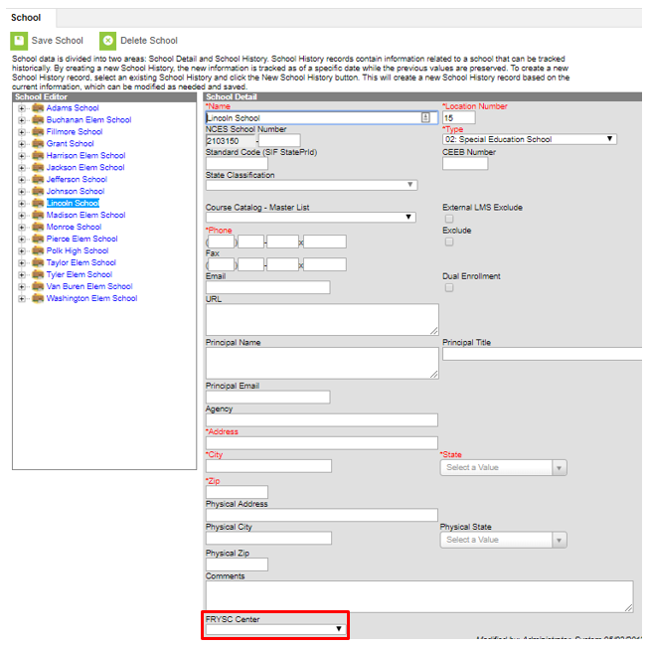

The Division of FRYSC is responsible for the addition of FRYSCs to Infinite Campus. FRYSC District Contacts may send requests for center additions or center name edits to tonya.cookendorfer@ky.gov.

Section B – Individual Interventions
  - Campus Path: Student Information / General / FRYSC tab
Select Add Intervention
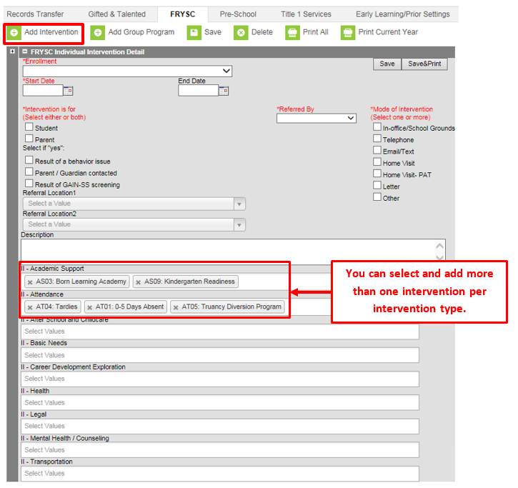
Enrollment: This field will auto populate to the current enrollment. If needed, select a different enrollment.
Start Date: Enter the intervention Start Date in mmddyyyy format
Intervention is for: Select whom the intervention is for Student or Parent
Referred By: Select the person who referred the student for intervention from the dropdown list
Result of a Behavior Issue: Check if applicable
Parent/Guardian Contacted: Check if applicable
Result of a GAIN-SS screening: Check if applicable
Referral Location 1 & 2: Select the agency or agencies to which the student or parent was referred
Select the reason(s) for intervention under the appropriate intervention heading.
Click the Save button when finished. To also print the FRYSC record upon saving, select the Save & Print button. The student will now have an Intervention listed in the FRYSC editor.

Section C – Group Programs
  - Campus Path: Student Information / General / FRYSC tab
Select Add Group Program
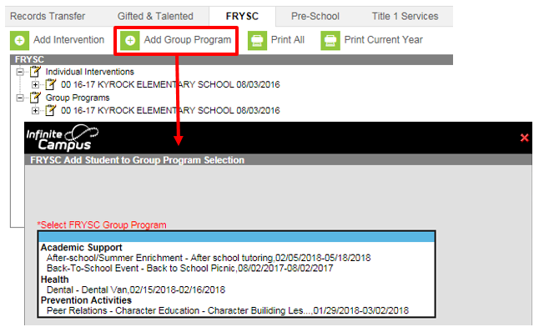
Select the appropriate Group Program from the dropdown list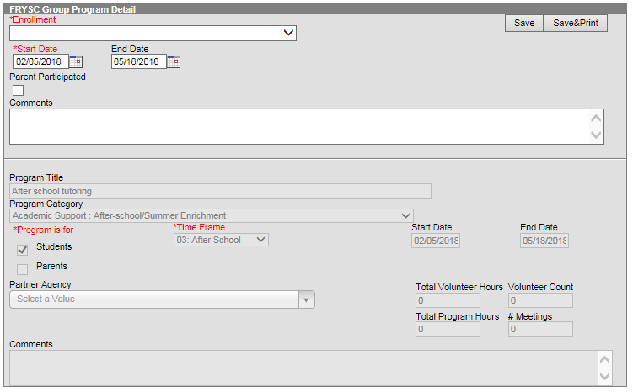
Enrollment: This field will auto populate to the current enrollment. If needed, select a different enrollment.
Start Date: This field will auto populate from the program information, change if appropriate.
End Date: This field will auto populate from the program information, change if appropriate.
Parent Participated: Check if applicable
Click the Save button when finished. To print the FRYSC Group Program record upon saving, select the Save & Print button. The student will now have a Group Program listed in the FRYSC editor

