HOMELESSNESS IN SCHOOL SETTINGS: Homelessness is known to adversely affect child development and family functioning in a number of important ways. Children who experience periods of homelessness often must change schools, cope with traumatic experiences, and struggle with material deprivation. These challenges often negatively affect academic achievement, rendering young people ill equipped to transition into adulthood (i.e., career or college-ready). School-based FRYSC offices are unique resources to serve this population of Kentucky students.

HOW THIS INVESTIGATION ADDRESSES THIS SUBJECT FOR KENTUCKY: Using data from the Infinite Campus system, analyses were performed on student homelessness – specifically how that population accessed FRYSC services from 2016-2018 school years.

On any given school day in Kentucky, approximately 489 homeless students received a service from a FRYSC.

Introduction
The Family Resource and Youth Services Centers (FRYSCs) were created by the enactment of the Kentucky Educational Reform Act (KERA) in 1990. They are primarily operated within or near school settings, and are funded based on the economic conditions of the students at the school in which they are located (i.e., % free and reduced lunch). Central to their functioning is the recognition that children living in poverty and other forms of deprivation and hardship face challenges that impede their ability to reap the full benefit of their education. Students that experience homelessness and other forms of housing instability are particularly vulnerable to several forms of extreme stress and adverse educational outcomes. This brief outlines the results of a set analyses based on questions related to how FRYSCs in Kentucky served students that experienced homelessness during the 2016, 2017, and 2018 academic years.

Question #1 – How many homeless students were served by a FRYSC during the 2016, 2017, & 2018 academic years?

There were a total of 54,815 students in Kentucky who were both: (1) identified as homeless at some point between 2016-2018 academic years, and (2) also received services at a FRYSC at least once during that period.
Table 1 outlines how this number was broken down by academic year.
Table 1
FRYSC Students Experiencing Homelessness in KY, 2016-2018
Academic Year | 2016 | 2017 | 2018 | Total Unique Individuals*
# Homeless Students | 26,016 | 25,400 | 22,396 | 54,815
*Because some students were identified as homeless during only one academic year, while others experienced homeless during two or three academic years, the total # of students is not a mere sum of the three years.

FRYSCs served 741,957 individual Kentucky students during the period between 2016-2018 academic years (approximately 75% of all children residing in Kentucky). This suggests that, during this period, approximately 7.4%, or 1 out of every 14 students that received services at a FRYSC had experienced homelessness at least once during that three-year period. Of these 54,815 students, 40,104 (73%) were homeless during one academic year, 10,425 (19%) were homeless in two, and 4,286 (8%) were homeless during all three academic years.

Table 2
Nighttime Residence of FRYSC Students Experiencing Homelessness
Nighttime Residence Category | Academic Year |  |  | Total
 | 2016 | 2017 | 2018
Awaiting Foster Care Placement | 615 | 421 | -* | 1,036
Doubled up | 20,435 | 19,864 | 16,812 | 57,111
Hotels/Motels | 975 | 997 | 966 | 2,938
Shelters and Transitional Housing | 1,599 | 1,230 | 2,245 | 5,074
Special Care Facilities | 875 | 395 | 1* | 1,271
Unsheltered  (inadequate housing) | 1,731 | 2,634 | 2,561 | 6,926
Missing Data | 3 | 130 | 3 | 136
Total | 26,233 | 25,671 | 22,588 | 74,492
*Reporting practices changed in response to changes in Federal regulation.
Note: This table describes instances of homelessness rather than unduplicated individual students. For example, this includes cases where a student moved school districts, and consequently was counted twice in the same year.

Homelessness has many forms. Table 2 details the nighttime residence among students experiencing homelessness. Of this population, approximately 76% were identified as ‘doubled up’ in the year they were determined to be homeless. This term refers to a student who was sharing a housing arrangement with others due to loss of primary housing or other economic hardship.
(Continued on next page →)
The second and third most common overall nighttime residence categories for these students were ‘unsheltered’ (9%), followed by ‘shelters and transitional housing’ (6.8%). Broadly, these values are consistent with national estimates of student homelessness by the U.S. Department of Education – with one notable exception. During this three-year period, the proportion of unsheltered students in Kentucky was more than twice the national 2016-2017 rate of 4% (U.S. Dept. of Education – National Center for Homeless Education).

Table 3
Unaccompanied Youths among Homeless Students
Receiving FRYSC Services
 | Academic Year
 | 2017 | 2018
# Unaccompanied Youths | 2,522 | 2,149
% of Total Homeless Students | 9.9% | 9.6%
Note: The McKinney-Vento Act defines unaccompanied youth as “a homeless child or youth not in the physical custody of a parent or guardian” [42 USC § 11434a(6)]
Question #2 – Out of the total population of Kentucky students experiencing homelessness, how many were served by a FRYSC during the 2016, 2017, & 2018 academic years?

When comparing these results against the official reported counts from the Kentucky Department of Education’s ‘Statewide Homeless Student Count’, it appears that FRYSCs served a very significant proportion of the homeless student population in Kentucky during this period. In other words, more than 8 out of every 10 students experiencing homelessness in Kentucky received at least one service from a FRYSC from 2016-2018 (see Table 4). This result must be considered in light of the reality that there are schools in Kentucky that do not have a FRYSC. Considering the needs of these students and the hardships they face, this level of contact with a support system is a favorable finding.

Table 4
How Many of Kentucky’s Total Homeless Students
Were Served by a FRYSC?
Academic Year | 2016 | 2017 | 2018
Homeless Students  Served by a FRYSC | 24,216 | 23,380 | 20,408
Total Homeless Students* | 27,657 | 26,752 | 23,968
Total % Served | 87.6% | 87.4% | 85.2%
*As reported by the Kentucky Department of Education

Question #3 – Which FRYSC services were provided to students experiencing homelessness during the 2016, 2017, & 2018 academic years? Which were the most frequently utilized services?

Supportive, encouraging relationships between caring adults and students in need are of immense value. To capture this dynamic, Table 5 describes analyses of FRYSC services provided to individual students (FRYSCs provide services in group settings as well as individually). The most prominently utilized service was the provision of clothing to a student, accounting for 19.5% of such services. Table 5 illustrates the most frequently utilized types of FRYSC services provided to individual students experiencing homelessness.

Table 5
FRYSC Service Provision, by Type
(Individual-Level Services Only)
Rank | Service | %
#1 | Basic Needs – Clothing (Regular) | 19.5%
#2 | Basic Needs – Food Assistance | 13.2%
#3 | Academic Support – School Supplies | 13.1%
#4 | Mental Health/Counseling –  Other Mental Health/Counseling | 5.6%

Question #4 – What was the average number of FRYSC services provided to this student population per student per year during the 2016, 2017, & 2018 academic years?

On average, a student visited a FRYSC approximately 3-4 times per academic year. Out of 3,570,321 total FRYSC encounters between 2016-2018, 436,081 involved providing services to a homeless student. Put another way, a population that consisted of 7.4% of all students who received FRYSC services utilized 12.2% of total visits during this period. This disproportionality suggests that homeless students visited FRYSCs to a greater degree than their mere representation in the broader FRYSC population would suggest.

Table 6
Mean Number of FRYSC Encounters per Student per Year
Academic Year
 | 2016 | 2017 | 2018
Mean # of Encounters | 3.70 | 3.55 | 3.78
Note: This table describes encounters, which is defined here as any instance where a student was served by a FRYSC – this is irrespective of how many individual services were provided during any given encounter. Students could receive multiple services per encounter (e.g., school supplies + food assistance).

A simple, unadjusted estimation suggests that, between 2016-2018, FRYSCs in Kentucky schools provided a service to a homeless student in need 489 times per school day:

$$\frac{249,546}{(170 x 3)}=489 homeless student encounters per day$$

249,546 = total FRYSC encounters by a homeless student
170 = approximate school days per academic year
3 = total academic years (2016, 2017, 2018)

Supplemental Materials & Insights from Other States
Executive Summary:
FRYSC Services and Students Experiencing Homelessness

- There were almost 55,000 homeless students served by FRYSCs in Kentucky between academic years 2016-2018 (about 1 out of every 14 students that FRYSCs served during that period). Most of these students were found to be ‘doubled-up’ with others due to loss of primary housing for their family.

- On any given school day in Kentucky from 2016-2018, approximately 489 homeless students received a service from a FRYSC. About one out of every three individual-level services provided for these students was to address a need for clothing or because they were hungry.

- Between 2016-2018, FRYSCs in Kentucky provided more than 900,000 documented services during almost 250,000 encounters with a student experiencing homelessness.

Student Homelessness in Kentucky, by Grade Levels

FRYSC Service Utilization, by Type (All Services)
Rank | Service | Individual vs. Group Service | %
#1 | Health – Other Health Program | Group | 8.3%
#2 | Health – Obesity-Nutrition | Group | 5.9%
#3 | Academic Support – Back to School Event | Group | 4.2%
#4 | Prevention Activities – Red Ribbon Week (Substance Abuse) | Group | 3.9%
#5 | Basic Needs – Clothing (Regular) | Individual | 3.7%
Note: This table describes the percentage of students identified as homeless at any point 2016-2018 who received a given FRYSC service during that same period. For this reason, percentages in the rightmost column describe a different feature of the data than Table 5 in the companion report. Table 5 describes only the percentage of services provided in the individual format (177,748 services over three academic years); whereas this table describes the percentage of services provided in any format (a much larger sum of 909,342 services). Approximately 7% of students experiencing homelessness received a FRYSC newsletter during this period. To more accurately reflect the full scope of direct (i.e., face to face) services provided to students, that service is excluded from this table.

Housing Status is Related to Educational Outcomes in Louisianna:

Math and English Language Arts Scores in Louisianna by Poverty and Homeless Status, Grades 3-8 (2019)
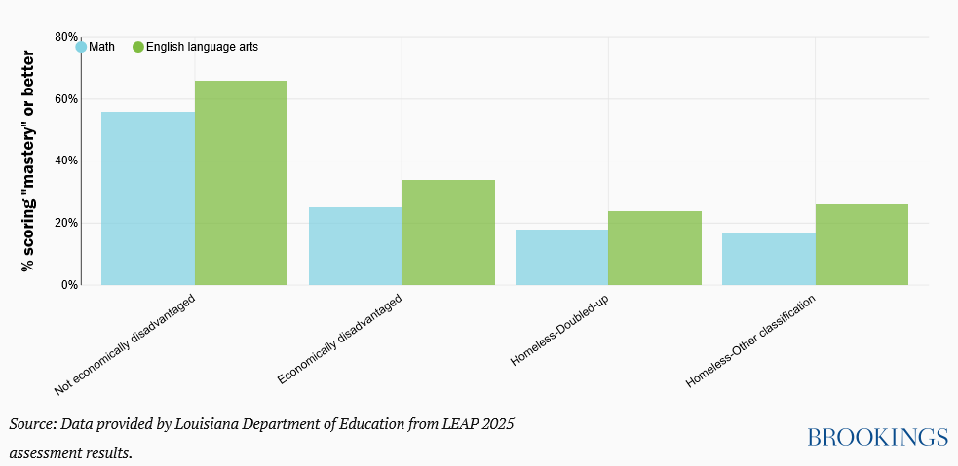
Figure from: Meltzer, A., Quintero, D., & Valant, J. (Oct. 2019). Better serving the needs of America’s homeless students. Brookings Institute. https://www.brookings.edu/blog/brown-center-chalkboard/2019/10/24/better-serving-the-needs-of-americas-homeless-students/

Federal McKinney-Vento Funding for Homeless Students ($ per student; 2016-2017):

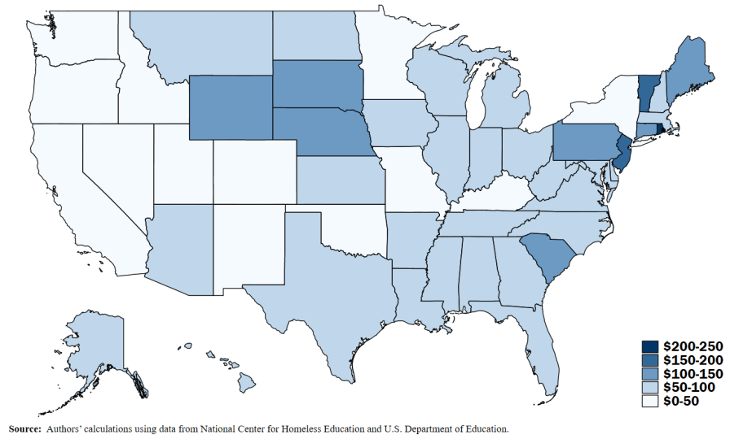
Figure from: Meltzer, A., Quintero, D., & Valant, J. (Oct. 2019). Better serving the needs of America’s homeless students. Brookings Institute. (Figure 4). https://www.brookings.edu/blog/brown-center-chalkboard/2019/10/24/better-serving-the-needs-of-americas-homeless-students/

Housing Status is Related to School Attendance in Washington State:
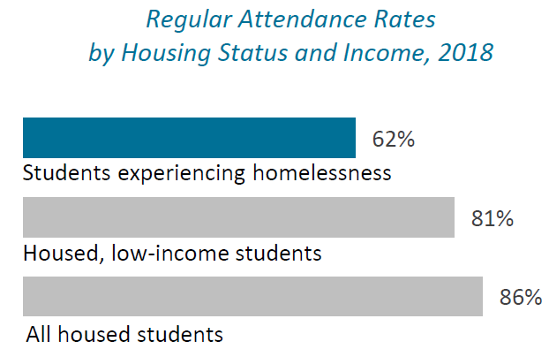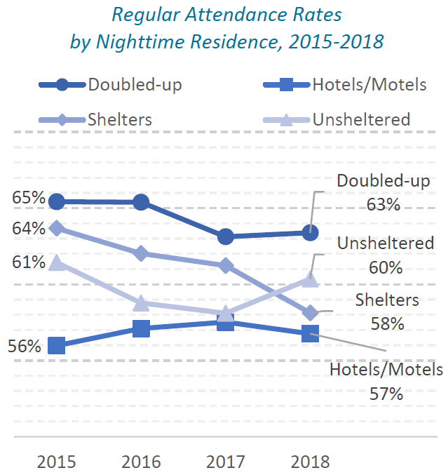

Figures from: Lemon, M. (2019). Students Experiencing Homelessness in Washington’s K-12 Public Schools: 2015-2018 Trends, Characteristics, and Academic Outcomes. Schoolhouse Washington, a project of Building Changes: Seattle, WA. (Figures 26 & 27, p. 26). https://schoolhousewa.org/wp-content/uploads/SchoolhouseWA_OutcomesReport_2019.pdf

In Washington State, Most Homeless Students Live in Cities – But Rates of Homelessness were Highest in Rural Schools:
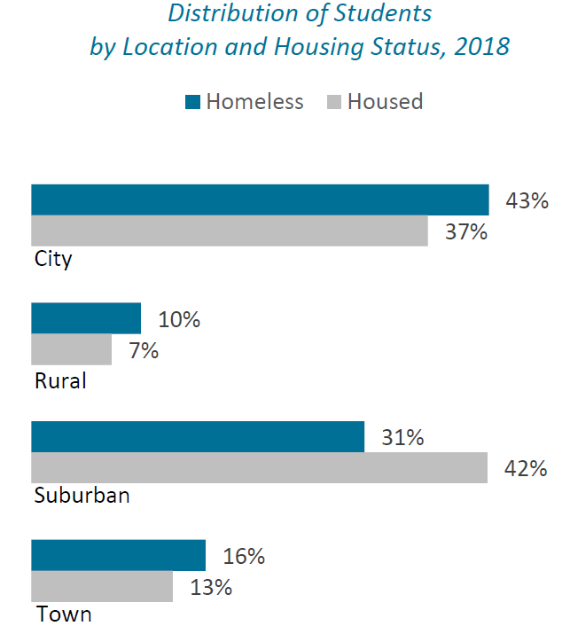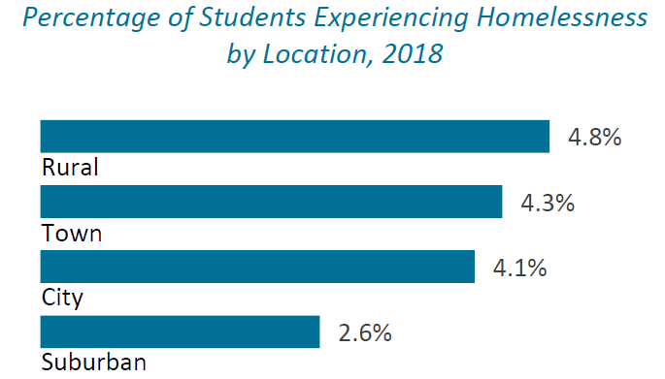

Figures from: Lemon, M. (2019). Students Experiencing Homelessness in Washington’s K-12 Public Schools: 2015-2018 Trends, Characteristics, and Academic Outcomes. Schoolhouse Washington, a project of Building Changes: Seattle, WA. (Figures 16 & 18, p. 20). https://schoolhousewa.org/wp-content/uploads/SchoolhouseWA_OutcomesReport_2019.pdf

Kentucky has the Sixth Highest Percentage of Student Homelessness in the Nation

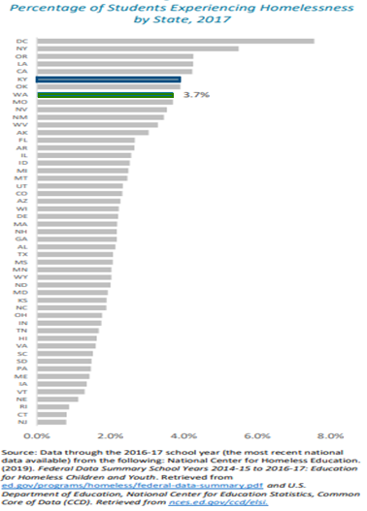
Kentucky
Figure from: Lemon, M. (2019). Students Experiencing Homelessness in Washington’s K-12 Public Schools: 2015-2018 Trends, Characteristics, and Academic Outcomes. Schoolhouse Washington, a project of Building Changes: Seattle, WA. (Figure 6, p. 20)
https://schoolhousewa.org/wp-content/uploads/SchoolhouseWA_OutcomesReport_2019.pdf
[Image has minor modification to draw attention to Kentucky data]

Academic References

Hallett, R. E., Skrla, L., & Low, J. (2015). That is not what homeless is: A school district’s journey toward serving homeless, doubled-up, and economically displaced children and youth. International Journal of Qualitative Studies in Education, 28(6), 671-692.

Canfield, J. P., & Teasley, M. L. (2015). The McKinney–Vento Homeless Assistance Act: School-based Practitioners' Place in Shaping the Policy's Future. Children & Schools, 37(2), 67-70.

Hallett, R. E., Low, J. A., & Skrla, L. (2015). Beyond backpacks and bus tokens: Next steps for a district homeless student initiative. International Journal of Qualitative Studies in Education, 28(6), 693-713.

Page 1 │ January 2020

